Final Report
Level 4

VibeCheck: Post-Hoc Formal Conformance Certification of LLM-Generated Workflow Code Against BPMN 2.0 Specifications

Group Name : Epsilon
Group Number : 25

Index Number | Name
214063M | FERNANDO WKD
214248K | WELMILLA CN
214077J | HETTIARACHCHI HTV

Faculty of Information Technology
University of Moratuwa
2026

Final Report
Level 4

VibeCheck: Post-Hoc Formal Conformance Certification of LLM-Generated Workflow Code Against BPMN 2.0 Specifications

Group Name : Epsilon
Group Number : 25

Group Members

Index Number | Name
214063M | FERNANDO WKD
214248K | WELMILLA CN
214077J | HETTIARACHCHI HTV

Supervisor: Dr. Thilina Thanthriwatta

Faculty of Information Technology
University of Moratuwa
2026
Declaration
We declare that this thesis is our own work and has not been submitted in any form for another degree or diploma at any university or other institution of tertiary education. Information derived from the published or unpublished work of others has been acknowledged in the text and a list of references is given.

Date: [30.07.2026]

Index Number | Name | Signature
214063M | FERNANDO WKD
214248K | WELMILLA CN
214077J | HETTIARACHCHI HTV

Supervised by: Dr. Thilina Thanthriwatta

Date: [31.07.2026]

Name of the supervisor | Signature of the supervisor
Dr. Thilina Thanthriwatta | …………………………………….

Dedication
This research project is dedicated to our supervisor Dr. Thilina Thanthriwatta, whose unwavering support and guidance have been instrumental in the successful completion of this study. The authors also extend their heartfelt dedication to their parents, siblings, batchmates, lecturers, and faculty staff, along with every individual who has contributed to this research endeavor through their valuable advice, knowledge, support, and well wishes. Their collective contributions have played a significant role in the realization of this research, for which the authors express their sincere appreciation and gratitude.

Acknowledgements
We would like to express our heartfelt appreciation to Dr. Thilina Thanthriwatta, our supervisor, for her invaluable guidance and support throughout the duration of the research project. We would also like to extend our gratitude to the esteemed lecturers of the Faculty of Information Technology at the University of Moratuwa for imparting the necessary knowledge and skills that were instrumental in the successful completion of this project. Furthermore, we would like to express our thanks to the contributors who developed the datasets incorporated in this study. Lastly, we would like to convey their deep gratitude to all individuals who contributed, encouraged, and provided the essential support needed to bring this project to a successful conclusion.

Abstract
Large language models now write substantial amounts of workflow code from informal or semi-formal process descriptions. Business processes, however, carry hard ordering, exclusivity and termination requirements that plausible-looking code can silently violate: an approval step quietly dropped, two branches transposed, a retry loop that never terminates. Testing samples behaviour rather than establishing it, code review depends on human attention, and asking the generating model to check its own output is circular. This project asks a narrower and more tractable question: given a BPMN 2.0 specification and a Python program that was supposedly generated from it, can conformance be certified after the fact, without any cooperation from the generator?
VibeCheck answers that question with a four-module pipeline built on a single architectural commitment, which we call dual-track independence. The specification track reads only the BPMN diagram and derives a tiered suite of finite-trace linear temporal logic (LTLf) properties from it. The code track reads only the Python source and derives a Workflow Intermediate Representation (WIR), a control-flow graph in JSON, together with a three-layer confidence certificate obtained from structural validation, bounded symbolic execution and dynamic differential tracing. Neither track can see the other's input. The two meet only at the equivalence engine, which lifts the WIR into a labelled transition system, reduces it under divergence-sensitive stuttering bisimulation, clusters behaviourally identical implementations, and model-checks the specification's properties against the result, returning a conformance verdict, a violation with a readable counterexample, or an explicit refusal to decide.
VibeCheck does not make an absolute mathematical claim for the whole neuro-symbolic pipeline, but sets a clear epistemic limit. The system returns a counterexample trace if the certificate fails under a low extraction confidence, a deterministic PASS certificate or a FAIL certificate with a quantified counterexample trace. This thesis outlines the entire methodology, real evaluation, and architectural development of the pipeline and offers a strong, non-circular basis for auditing workflow code generated by AI.

Contents
CHAPTER 1 – INTRODUCTION 1
1.1 Introduction 1
1.2 Background and motivation 1
1.3 Problem in brief 3
1.4 Aim and objectives 4
1.4.1 Aim 4
1.4.2 Objectives 4
1.5 Proposed solution 5
1.5.1 The core design decision: dual-track independence 6
1.5.2 Module 01 — Specification analysis 6
1.5.3 Module 02 — Verified intermediate representation extraction 6
1.5.4 Module 03 — Equivalence engine 7
1.5.5 Module 04 — Verification portal 7
1.6 Summary 7
CHAPTER 2 – REVIEW OF OTHERS' WORK 9
2.1 Introduction 9
2.2 Assurance for LLM-generated code 9
2.2.1 What the benchmarks establish, and what they do not 9
2.2.2 Hallucination and the circularity of self-review 10
2.2.3 FLOW-BENCH 10
2.3 Formal verification of business process models 11
2.4 Temporal logic, finite traces, and automata-theoretic model checking 12
2.5 Translation validation and program equivalence 13
2.6 Behavioural equivalence and its divergence-sensitive refinement 14
2.7 Program analysis for extraction fidelity 15
2.8 Mutation-based evaluation 16
2.9 The gap, and what this project adds 16
2.10 Summary 18
CHAPTER 3 – TECHNOLOGY ADAPTED 19
3.1 Introduction 19
3.2 Programming languages 19
3.2.1 Python 19
3.2.2 C++ 20
3.2.3 XML, JSON and JSON Schema 20
3.3 Service framework and containerisation 20
3.3.1 FastAPI and Uvicorn 20
3.3.2 Docker and Docker Compose 21
3.4 Formal reasoning stack 21
3.4.1 Spot 21
3.4.2 Z3 21
3.4.3 NetworkX 22
3.5 Program analysis stack 22
3.5.1 The ast module 22
3.5.2 Dominator-based structural validation 22
3.5.3 PEP 669 monitoring 22
3.5.4 Approximate matching: edit distance and sentence embeddings 23
3.6 Interface layer 23
3.7 Evaluation and statistics tooling 23
3.8 Development practice and version control 24
3.9 Summary 24
CHAPTER 4 – OUR APPROACH 26
4.1 Introduction 26
4.2.1 Principle 1 — Dual-track independence 26
4.2.2 Principle 2 — Abstention is a first-class verdict 27
4.2.3 Principle 3 — Every stage gates on an explicit criterion 27
4.2.4 Principle 4 — Certificates, not proofs 27
4.3 Users 28
4.5 Process 29
4.6 Output 31
4.7 Summary 32
CHAPTER 5 – ANALYSIS AND DESIGN 33
5.1 Introduction 33
5.2 System design 33
5.2.1 Decomposition 33
5.2.2 Inter-module contracts 33
5.2.3 Enforcing independence 34
5.2.4 Deployment design 35
5.3 Module 01 design — specification analysis 35
5.3.2 Phase 2 — LTLf Synthesis and The Zero Dead-Zone Protocol 36
5.3.3 Phase 3 — Mutation based self-validation 36
5.3.4 Phase 4 — Bidirectional Differential Alignment (PBCTS) 37
5.3.5 The Formal Reliability Certificate (FRC) Interface 37
5.4 Module 02 design — verified representation extraction 38
5.4.1 Extraction, and the two views 38
5.4.2 V3 — Structural validation as a hard gate 39
5.4.3 V2 — Bounded symbolic execution 39
5.4.4 V1 — Dynamic differential tracing 39
5.4.5 Comparison granularity 40
5.4.6 Fusion and acceptance 41
5.5 Module 03 design — equivalence engine 41
5.5.1 Phase A — Lifting to a labelled transition system 42
5.5.2 Phase B — Divergence-sensitive stuttering bisimulation 43
5.5.3 Phase C — Behavioural clustering 43
5.5.4 Phase D — Model checking 44
5.5 Module 04 design — verification portal 44
5.6 Summary 45
CHAPTER 6 – IMPLEMENTATION 46
6.1 Introduction 46
6.2 Module 01 implementation — specification engine 46
6.2.1 Phase01: Semantic Extraction Engine 46
6.2.2 Phase02: Formal Temporal Logic Synthesizer (FLTL) 48
6.2.3 Phase03: Mutation refiner 50
6.2.4 Phase04: Progression-Based Constructive Trace Synthesis (PBCTS) 51
6.2.5 Export Interface for Downstream Modules 51
6.3 Module 02 implementation — extraction engine 52
6.3.1 Component Layout 52
6.3.2 The Two Views, and a Finding About Integration 52
6.3.3 The Structural Gate 53
6.3.4 The Symbolic Layer 53
6.3.5 The Dynamic Layer 54
6.4 Module 03 implementation — equivalence engine 55
6.4.1 Introduction to the C++ Verification Engine 55
6.4.2 Phase A — lifting and action matching 56
6.4.3 Phase B — divergence-sensitive reduction 57
6.4.4 Phase C — clustering 58
6.4.5 Phase D — model checking and counterexample rendering 58
6.5 Module 04 implementation — verification portal 59
6.6 Summary 59
CHAPTER 7 – EVALUATION 61
7.1 Introduction 61
7.2 Specification Engine Evaluation 61
7.3 Code track evaluation 65
7.3.1 Corpus and instruments 65
7.3.2 Structural extraction fidelity 65
7.3.3 Mutant detection and calibration 65
7.3.4 The central negative result: self-referential validation cannot detect logic faults 66
7.3.5 Confidence and semantic divergence 70
7.3.6 A negative result about the symbolic layer 71
7.3.7 Comparison granularity: both directions of the trade 71
7.3.8 The return-value observability fix 72
7.3.9 The variant funnel and extraction robustness 72
7.4 Equivalence engine evaluation 73
7.4.1 What is measured and what is not 73
7.4.2 Validating the finite-to-infinite bridge 73
7.4.3 The effect of the call-order fix on corpus verdicts 74
7.4.4 A structural property of the corpus that bounds Phase B 75
7.4.5 Corpus divergence modes 75
7.4.6 Vocabulary alignment, measured 76
7.5 End-to-end evaluation 77
7.5.1 Design 77
7.5.2 Results 77
7.5.3 Detection by mutation kind, and what it exposes 79
7.5.4 Counterexample quality 81
7.6 Summary 81
CHAPTER 8 – DISCUSSION 83
8.1 Introduction 83
8.2 Module 01: Specification analysis 83
8.2.1 Discussion 83
8.2.2 Limitations 84
8.2.3 Further work 85
8.2.4 Summary 86
8.3 Module 02: Code extraction and certification 86
8.3.1 Discussion 86
8.3.2 Limitations 87
8.3.3 Further work 88
8.3.4 Summary 89
8.4 Module 03: The equivalence engine 89
8.4.1 Discussion 89
8.4.2 Limitations 91
8.4.3 Further work 91
8.4.4 Summary 92
8.5 Module 04: The verification portal 92
8.5.1 Discussion 92
8.5.2 Further work 92
8.6 The architectural commitment, discussed 93
8.7 The principal unresolved gap 94
8.8 Conclusion 94
REFERENCES 96
APPENDICES 100
Appendix A – Repository layout and how to run the system 100
Appendix B – Certificate schema, abridged 100
Appendix C – Evaluation artefact index 102
Appendix D – Test-suite inventory 103

List of Figures
CHAPTER 1 – INTRODUCTION 1
1.1 Introduction 1
1.2 Background and motivation 1
1.3 Problem in brief 3
1.4 Aim and objectives 4
1.4.1 Aim 4
1.4.2 Objectives 4
1.5 Proposed solution 5
1.5.1 The core design decision: dual-track independence 6
1.5.2 Module 01 — Specification analysis 6
1.5.3 Module 02 — Verified intermediate representation extraction 6
1.5.4 Module 03 — Equivalence engine 7
1.5.5 Module 04 — Verification portal 7
1.6 Summary 7
CHAPTER 2 – REVIEW OF OTHERS' WORK 9
2.1 Introduction 9
2.2 Assurance for LLM-generated code 9
2.2.1 What the benchmarks establish, and what they do not 9
2.2.2 Hallucination and the circularity of self-review 10
2.2.3 FLOW-BENCH 10
2.3 Formal verification of business process models 11
2.4 Temporal logic, finite traces, and automata-theoretic model checking 12
2.5 Translation validation and program equivalence 13
2.6 Behavioural equivalence and its divergence-sensitive refinement 14
2.7 Program analysis for extraction fidelity 15
2.8 Mutation-based evaluation 16
2.9 The gap, and what this project adds 16
2.10 Summary 18
CHAPTER 3 – TECHNOLOGY ADAPTED 19
3.1 Introduction 19
3.2 Programming languages 19
3.2.1 Python 19
3.2.2 C++ 20
3.2.3 XML, JSON and JSON Schema 20
3.3 Service framework and containerisation 20
3.3.1 FastAPI and Uvicorn 20
3.3.2 Docker and Docker Compose 21
3.4 Formal reasoning stack 21
3.4.1 Spot 21
3.4.2 Z3 21
3.4.3 NetworkX 22
3.5 Program analysis stack 22
3.5.1 The ast module 22
3.5.2 Dominator-based structural validation 22
3.5.3 PEP 669 monitoring 22
3.5.4 Approximate matching: edit distance and sentence embeddings 23
3.6 Interface layer 23
3.7 Evaluation and statistics tooling 23
3.8 Development practice and version control 24
3.9 Summary 24
CHAPTER 4 – OUR APPROACH 26
4.1 Introduction 26
4.2.1 Principle 1 — Dual-track independence 26
4.2.2 Principle 2 — Abstention is a first-class verdict 27
4.2.3 Principle 3 — Every stage gates on an explicit criterion 27
4.2.4 Principle 4 — Certificates, not proofs 27
4.3 Users 28
4.5 Process 29
4.6 Output 31
4.7 Summary 32
CHAPTER 5 – ANALYSIS AND DESIGN 33
5.1 Introduction 33
5.2 System design 33
5.2.1 Decomposition 33
5.2.2 Inter-module contracts 33
5.2.3 Enforcing independence 34
5.2.4 Deployment design 35
5.3 Module 01 design — specification analysis 35
5.3.2 Phase 2 — LTLf Synthesis and The Zero Dead-Zone Protocol 36
5.3.3 Phase 3 — Mutation based self-validation 36
5.3.4 Phase 4 — Bidirectional Differential Alignment (PBCTS) 37
5.3.5 The Formal Reliability Certificate (FRC) Interface 37
5.4 Module 02 design — verified representation extraction 38
5.4.1 Extraction, and the two views 38
5.4.2 V3 — Structural validation as a hard gate 39
5.4.3 V2 — Bounded symbolic execution 39
5.4.4 V1 — Dynamic differential tracing 39
5.4.5 Comparison granularity 40
5.4.6 Fusion and acceptance 41
5.5 Module 03 design — equivalence engine 41
5.5.1 Phase A — Lifting to a labelled transition system 42
5.5.2 Phase B — Divergence-sensitive stuttering bisimulation 43
5.5.3 Phase C — Behavioural clustering 43
5.5.4 Phase D — Model checking 44
5.5 Module 04 design — verification portal 44
5.6 Summary 45
CHAPTER 6 – IMPLEMENTATION 46
6.1 Introduction 46
6.2 Module 01 implementation — specification engine 46
6.2.1 Phase01: Semantic Extraction Engine 46
6.2.2 Phase02: Formal Temporal Logic Synthesizer (FLTL) 48
6.2.3 Phase03: Mutation refiner 50
6.2.4 Phase04: Progression-Based Constructive Trace Synthesis (PBCTS) 51
6.2.5 Export Interface for Downstream Modules 51
6.3 Module 02 implementation — extraction engine 52
6.3.1 Component Layout 52
6.3.2 The Two Views, and a Finding About Integration 52
6.3.3 The Structural Gate 53
Listing 6.1 – Normalizing immediate_dominators to bound the dominance frontier walk (ast_extractor/dominators.py) 53
6.3.4 The Symbolic Layer 53
Listing 6.2 – Translating Python comparison AST nodes to Z3 expressions (z3_sym_engine/evaluator.py) 54
6.3.5 The Dynamic Layer 54
Listing 6.3 – Selective event monitoring for dynamic trace collection (dynamic_tracer/collector.py) 55
6.4 Module 03 implementation — equivalence engine 55
6.4.1 Introduction to the C++ Verification Engine 55
6.4.2 Phase A — lifting and action matching 56
6.4.3 Phase B — divergence-sensitive reduction 57
6.4.4 Phase C — clustering 58
6.4.5 Phase D — model checking and counterexample rendering 58
6.5 Module 04 implementation — verification portal 59
6.6 Summary 59
CHAPTER 7 – EVALUATION 61
7.1 Introduction 61
7.2 Specification Engine Evaluation 61
7.3 Code track evaluation 65
7.3.1 Corpus and instruments 65
7.3.2 Structural extraction fidelity 65
7.3.3 Mutant detection and calibration 65
7.3.4 The central negative result: self-referential validation cannot detect logic faults 66
7.3.5 Confidence and semantic divergence 70
7.3.6 A negative result about the symbolic layer 71
7.3.7 Comparison granularity: both directions of the trade 71
7.3.8 The return-value observability fix 72
7.3.9 The variant funnel and extraction robustness 72
7.4 Equivalence engine evaluation 73
7.4.1 What is measured and what is not 73
7.4.2 Validating the finite-to-infinite bridge 73
7.4.3 The effect of the call-order fix on corpus verdicts 74
7.4.4 A structural property of the corpus that bounds Phase B 75
7.4.5 Corpus divergence modes 75
7.4.6 Vocabulary alignment, measured 76
7.5 End-to-end evaluation 77
7.5.1 Design 77
7.5.2 Results 77
7.5.3 Detection by mutation kind, and what it exposes 79
7.5.4 Counterexample quality 81
7.6 Summary 81
CHAPTER 8 – DISCUSSION 83
8.1 Introduction 83
8.2 Module 01: Specification analysis 83
8.2.1 Discussion 83
8.2.2 Limitations 84
8.2.3 Further work 85
8.2.4 Summary 86
8.3 Module 02: Code extraction and certification 86
8.3.1 Discussion 86
8.3.2 Limitations 87
8.3.3 Further work 88
8.3.4 Summary 89
8.4 Module 03: The equivalence engine 89
8.4.1 Discussion 89
8.4.2 Limitations 91
8.4.3 Further work 91
8.4.4 Summary 92
8.5 Module 04: The verification portal 92
8.5.1 Discussion 92
8.5.2 Further work 92
8.6 The architectural commitment, discussed 93
8.7 The principal unresolved gap 94
8.8 Conclusion 94
REFERENCES 96
APPENDICES 100
Appendix A – Repository layout and how to run the system 100
Appendix B – Certificate schema, abridged 100
Appendix C – Evaluation artefact index 102
Appendix D – Test-suite inventory 103

List of Tables
CHAPTER 1 – INTRODUCTION 1
1.1 Introduction 1
1.2 Background and motivation 1
1.3 Problem in brief 3
1.4 Aim and objectives 4
1.4.1 Aim 4
1.4.2 Objectives 4
1.5 Proposed solution 5
1.5.1 The core design decision: dual-track independence 6
1.5.2 Module 01 — Specification analysis 6
1.5.3 Module 02 — Verified intermediate representation extraction 6
1.5.4 Module 03 — Equivalence engine 7
1.5.5 Module 04 — Verification portal 7
1.6 Summary 7
CHAPTER 2 – REVIEW OF OTHERS' WORK 9
2.1 Introduction 9
2.2 Assurance for LLM-generated code 9
2.2.1 What the benchmarks establish, and what they do not 9
2.2.2 Hallucination and the circularity of self-review 10
2.2.3 FLOW-BENCH 10
2.3 Formal verification of business process models 11
2.4 Temporal logic, finite traces, and automata-theoretic model checking 12
2.5 Translation validation and program equivalence 13
2.6 Behavioural equivalence and its divergence-sensitive refinement 14
2.7 Program analysis for extraction fidelity 15
2.8 Mutation-based evaluation 16
2.9 The gap, and what this project adds 16
2.10 Summary 18
CHAPTER 3 – TECHNOLOGY ADAPTED 19
3.1 Introduction 19
3.2 Programming languages 19
3.2.1 Python 19
3.2.2 C++ 20
3.2.3 XML, JSON and JSON Schema 20
3.3 Service framework and containerisation 20
3.3.1 FastAPI and Uvicorn 20
3.3.2 Docker and Docker Compose 21
3.4 Formal reasoning stack 21
3.4.1 Spot 21
3.4.2 Z3 21
3.4.3 NetworkX 22
3.5 Program analysis stack 22
3.5.1 The ast module 22
3.5.2 Dominator-based structural validation 22
3.5.3 PEP 669 monitoring 22
3.5.4 Approximate matching: edit distance and sentence embeddings 23
3.6 Interface layer 23
3.7 Evaluation and statistics tooling 23
3.8 Development practice and version control 24
3.9 Summary 24
CHAPTER 4 – OUR APPROACH 26
4.1 Introduction 26
4.2.1 Principle 1 — Dual-track independence 26
4.2.2 Principle 2 — Abstention is a first-class verdict 27
4.2.3 Principle 3 — Every stage gates on an explicit criterion 27
4.2.4 Principle 4 — Certificates, not proofs 27
4.3 Users 28
4.5 Process 29
4.6 Output 31
4.7 Summary 32
CHAPTER 5 – ANALYSIS AND DESIGN 33
5.1 Introduction 33
5.2 System design 33
5.2.1 Decomposition 33
5.2.2 Inter-module contracts 33
5.2.3 Enforcing independence 34
5.2.4 Deployment design 35
5.3 Module 01 design — specification analysis 35
5.3.2 Phase 2 — LTLf Synthesis and The Zero Dead-Zone Protocol 36
5.3.3 Phase 3 — Mutation based self-validation 36
5.3.4 Phase 4 — Bidirectional Differential Alignment (PBCTS) 37
5.3.5 The Formal Reliability Certificate (FRC) Interface 37
5.4 Module 02 design — verified representation extraction 38
5.4.1 Extraction, and the two views 38
5.4.2 V3 — Structural validation as a hard gate 39
5.4.3 V2 — Bounded symbolic execution 39
5.4.4 V1 — Dynamic differential tracing 39
5.4.5 Comparison granularity 40
5.4.6 Fusion and acceptance 41
5.5 Module 03 design — equivalence engine 41
5.5.1 Phase A — Lifting to a labelled transition system 42
5.5.2 Phase B — Divergence-sensitive stuttering bisimulation 43
5.5.3 Phase C — Behavioural clustering 43
5.5.4 Phase D — Model checking 44
5.5 Module 04 design — verification portal 44
5.6 Summary 45
CHAPTER 6 – IMPLEMENTATION 46
6.1 Introduction 46
6.2 Module 01 implementation — specification engine 46
6.2.1 Phase01: Semantic Extraction Engine 46
6.2.2 Phase02: Formal Temporal Logic Synthesizer (FLTL) 48
6.2.3 Phase03: Mutation refiner 50
6.2.4 Phase04: Progression-Based Constructive Trace Synthesis (PBCTS) 51
6.2.5 Export Interface for Downstream Modules 51
6.3 Module 02 implementation — extraction engine 51
6.3.1 Component Layout 51
6.3.2 The Two Views, and a Finding About Integration 52
6.3.3 The Structural Gate 53
Listing 6.1 – Normalizing immediate_dominators to bound the dominance frontier walk (ast_extractor/dominators.py) 53
6.3.4 The Symbolic Layer 53
Listing 6.2 – Translating Python comparison AST nodes to Z3 expressions (z3_sym_engine/evaluator.py) 54
6.3.5 The Dynamic Layer 54
Listing 6.3 – Selective event monitoring for dynamic trace collection (dynamic_tracer/collector.py) 55
6.4 Module 03 implementation — equivalence engine 55
6.4.1 Introduction to the C++ Verification Engine 55
6.4.2 Phase A — lifting and action matching 56
6.4.3 Phase B — divergence-sensitive reduction 57
6.4.4 Phase C — clustering 58
6.4.5 Phase D — model checking and counterexample rendering 58
6.5 Module 04 implementation — verification portal 59
6.6 Summary 59
CHAPTER 7 – EVALUATION 61
7.1 Introduction 61
7.2 Specification Engine Evaluation 61
7.3 Code track evaluation 65
7.3.1 Corpus and instruments 65
7.3.2 Structural extraction fidelity 65
7.3.3 Mutant detection and calibration 66
7.3.4 The central negative result: self-referential validation cannot detect logic faults 67
7.3.5 Confidence and semantic divergence 70
7.3.6 A negative result about the symbolic layer 71
7.3.7 Comparison granularity: both directions of the trade 72
7.3.8 The return-value observability fix 73
7.3.9 The variant funnel and extraction robustness 73
7.4 Equivalence engine evaluation 73
7.4.1 What is measured and what is not 73
7.4.2 Validating the finite-to-infinite bridge 74
7.4.3 The effect of the call-order fix on corpus verdicts 74
7.4.4 A structural property of the corpus that bounds Phase B 76
7.4.5 Corpus divergence modes 76
7.4.6 Vocabulary alignment, measured 77
7.5 End-to-end evaluation 78
7.5.1 Design 78
7.5.2 Results 78
7.5.3 Detection by mutation kind, and what it exposes 80
7.5.4 Counterexample quality 81
7.6 Summary 81
CHAPTER 8 – DISCUSSION 83
8.1 Introduction 83
8.2 Module 01: Specification analysis 83
8.2.1 Discussion 83
8.2.2 Limitations 84
8.2.3 Further work 85
8.2.4 Summary 86
8.3 Module 02: Code extraction and certification 86
8.3.1 Discussion 86
8.3.2 Limitations 87
8.3.3 Further work 88
8.3.4 Summary 89
8.4 Module 03: The equivalence engine 89
8.4.1 Discussion 89
8.4.2 Limitations 91
8.4.3 Further work 91
8.4.4 Summary 92
8.5 Module 04: The verification portal 92
8.5.1 Discussion 92
8.5.2 Further work 92
8.6 The architectural commitment, discussed 93
8.7 The principal unresolved gap 94
8.8 Conclusion 94
REFERENCES 96
APPENDICES 100
Appendix A – Repository layout and how to run the system 100
Appendix B – Certificate schema, abridged 100
Appendix C – Evaluation artefact index 102
Appendix D – Test-suite inventory 103

List of Abbreviations
AST | Abstract Syntax Tree
BDD | Binary Decision Diagram
BPMN | Business Process Model and Notation
CFG | Control-Flow Graph
CI | Confidence Interval
EAS | Equivalence Alignment Score
GIL | Global Interpreter Lock
IDCD | Iterative Divergence-Convergence Detection
LLM | Large Language Model
LOC | Lines of Code
LTL | Linear Temporal Logic (infinite-trace semantics)
LTLf | Linear Temporal Logic over Finite Traces
LTS | Labelled Transition System
PBCTS | Progression-Based Constructive Trace Synthesis
SCSL | Self-Correcting Synthesis Loop
SMT | Satisfiability Modulo Theories
WIR | Workflow Intermediate Representation
XML | Extensible Markup Language

CHAPTER 1 – INTRODUCTION

1.1 Introduction
This chapter introduces the problem that VibeCheck addresses, the context in which that problem has become urgent, and the shape of the solution the project proposes. Section 1.2 sets out the background: the rapid adoption of large language models as code generators, and the particular difficulty of trusting their output when the artefact being generated is a business process implementation. Section 1.3 states the problem in brief. Section 1.4 gives the aim and the objectives derived from it. Section 1.5 describes the proposed solution at the level of its four modules and the one architectural commitment that binds them, and Section 1.6 summarises the chapter and previews the structure of the remainder of the report.
One matter of terminology is settled here because it governs every claim made later. VibeCheck produces a certificate: a verdict accompanied by the evidence and the quantified confidence on which that verdict rests, together with an explicit statement of what the verdict does not cover. It is not a proof of program correctness, and this report never describes it as one. Where the system cannot support a verdict it returns INCONCLUSIVE rather than guessing, and the rate at which it does so is reported as a first-class result rather than averaged away.

1.2 Background and motivation
Code generation by large language models moved from research demonstration to routine practice within a very short period. Benchmarks such as HumanEval established that models trained on code could produce functionally correct solutions to self-contained programming problems at non-trivial rates [1], and subsequent benchmarks extended the evaluation to class-level and multi-method generation [2]. The practice that grew around these capabilities, writing a natural-language description of what is wanted, accepting the generated implementation, and iterating on it by inspection rather than by specification has acquired the informal name vibe coding. It is fast, and for a great deal of software it is adequate, because a developer reading the output can usually tell whether it does roughly the right thing.
Business process implementations are a poor fit for that mode of working, and the reason is structural rather than a matter of developer discipline. A business process is a specification with hard obligations attached to it. A purchase-order workflow that skips the approval step is not a slightly worse workflow; it is a compliance failure. A claims process whose two adjudication branches are transposed will approve exactly the cases it was required to reject. A retry loop that a model has written as an unbounded while True will look entirely idiomatic on the page and will hang the process in production. What all three failures share is that the generated code remains plausible under inspection: it uses the right vocabulary, it calls functions with the right names, and its control flow is the sort of control flow one would expect. The defect is in the ordering, exclusivity or termination behaviour, which is precisely the class of property that reading code does not reliably reveal.
The workflow domain also has an unusual property that makes formal treatment feasible: the specification frequently already exists in a machine-readable form. Business Process Model and Notation (BPMN) 2.0 [3] is an OMG standard with an XML serialisation, widely used in enterprise process modelling, and formal semantics for its core control constructs have been studied for well over a decade [4]. When an organisation asks a language model to implement a process, the BPMN diagram is very often the document the prompt was derived from. That means the ingredients for a formal conformance check are present: a specification with a defined semantics on one side, and a program on the other.
The three assurance mechanisms usually reached for do not close this gap. Testing samples the behaviour of the program on particular inputs; it can demonstrate the presence of a fault but establishes ordering and termination properties only over the paths the test suite happens to exercise. Code review relies on sustained human attention to exactly the kind of detail, which of two similar branch names came first, that human attention is worst at. Asking the generating model to review its own output is circular in a way that is easy to state and, as this project measures directly in Chapter 7, expensive to ignore: an oracle derived from the artefact it is judging inherits the artefact's defects and therefore cannot see them.
The alternative this project pursues is post-hoc translation validation, a position with an established pedigree in compiler verification, where rather than proving a translator correct once and for all, each individual translation is validated after the fact against the source it came from [5]. The analogy is close. A language model is an untrusted translator from a process specification to a program. Proving the model correct is not on the table. Validating each of its outputs against the specification it was given, independently of the model, is.
Two bodies of technique make that validation tractable. The first is temporal logic over finite traces (LTLf) [6], which is the right semantics for a business process: processes are expected to terminate, and a logic whose models are infinite runs answers a subtly different question from the one a process owner is asking. The second is automata-theoretic model checking [7], for which mature tooling exists. This project uses Spot [8] for automaton construction, product and emptiness checking. Neither body of technique is a contribution of this project. What the project contributes is the architecture that connects them to LLM-generated code without introducing circularity, and an honest measurement of how far that architecture currently reaches.

1.3 Problem in brief
When a large language model generates workflow code from a BPMN 2.0 specification, there is no practical way to find whether the generated program actually satisfies the ordering, exclusivity and termination requirements the specification imposes. Testing and review do not establish these properties, and any check that derives its notion of correctness from the generated code itself is circular and therefore blind to exactly the faults that matter most.
The problem decomposes into four sub-problems, each of which turns out to be substantive:
1. Formalising the specification. A BPMN diagram must be turned into a set of checkable temporal properties. This is not a transcription: the diagram must be given a state-based semantics, implicit branch conditions must be resolved, and the resulting property suite must itself be validated, since a suite that admits everything is worthless.
2. Formalising the program. A Python program must be turned into a formal object whose behaviour faithfully represents the program's behaviour. Static extraction alone cannot establish that faithfulness. An extractor with a bug produces a structurally fair graph that quietly diverges from the code, so extraction fidelity must itself be certified.
3. Deciding conformance. The two formal objects must be compared by a decision procedure that is sound about what it does and does not establish, that returns a usable counterexample when it finds a violation, and that abstains rather than fabricating a verdict when the comparison is not well-founded.
4. Preventing circularity. The three steps above must be arranged so that the notion of correctness used in step 3 was not derived from the artefact being judged. This is an architectural constraint, not a coding convention, and it is the constraint from which the rest of the design follows.

1.4 Aim and objectives

1.4.1 Aim
To design, implement and evaluate a system that independently certifies whether LLM-generated Python workflow code conforms to the BPMN 2.0 specification it was generated from, producing a quantified, evidence-backed verdict conformance, violation with a counterexample, or an explicit refusal to decide without any cooperation from the generating model, and without deriving its notion of correctness from the code under examination.

1.4.2 Objectives
1. O1 — Specification formalisation. Construct a pipeline that transforms BPMN 2.0 XML into a tiered suite of LTLf properties with a state-based semantics, resolves implicit branch conditions, and gates each stage on an explicit quality criterion.
2. O2 — Specification self-validation. Establish that the synthesized property suite discriminates: subject it to systematic mutation and require that mutants of the specification be killed, so that a suite which admits every behaviour is rejected before it is exported.
3. O3 — Code formalisation with certified fidelity. Construct a pipeline that transforms Python source into a Workflow Intermediate Representation, and accompany it with a certificate which is structural, symbolic and dynamic, that quantifies how far the representation can be trusted to represent the program.
4. O4 — Anti-circular evaluation of the fidelity certificate. Measure whether a certificate derived from the code it checks can detect injected faults, and if it cannot, establish a differential mode in which the reference is an independent artefact rather than the subject itself.
5. O5 — Behavioural equivalence and conformance decision. Lift the code-side representation into a labelled transition system, reduce it under an equivalence that preserves the distinction between a waiting state and a non-terminating loop, and model-check the specification's properties against it, bridging finite-trace property semantics to the infinite-trace semantics the model checker implements.
6. O6 — Honest verdict discipline. Ensure that every verdict is either supported by the evidence or explicitly withheld; specifically, detect and eliminate conditions under which the model checker reports conformance while establishing nothing.
7. O7 — Quantified evaluation. Evaluate every component against a public benchmark using labelled fault corpora, report every rate with an exact confidence interval, report negative and mixed results alongside positive ones, and maintain an auditable record of any measurement found to be wrong and subsequently corrected.
8. O8 — Operable system. Deliver the components as independently deployable services with a portal through which the pipeline can be driven and its certificates inspected.

1.5 Proposed solution
VibeCheck is a four-module pipeline. Two modules formalise, independently, the two artefacts to be compared; a third performs the comparison; a fourth makes the whole operable. The modules are deployed as separate containerised services, which is a design decision with consequences described in Chapter 6 rather than a packaging convenience.

1.5.1 The core design decision: dual-track independence
The specification track never sees the generated code. The code track never sees the BPMN diagram. The two tracks meet only inside the equivalence engine, as two independently derived mathematical objects. This is the project's central architectural commitment. It is what prevents the specification from quietly bending to match the code, which is the failure mode that makes LLM self-review worthless. The discipline is maintained structurally rather than by convention: because each module ships as its own container with access only to its own source, the equivalence engine reimplements the LTLf normalisation logic it needs rather than importing the specification engine's copy of it. Chapter 6 records the duplicated code that results, and Chapter 8 argues that the duplication is the correct trade.

1.5.2 Module 01 — Specification analysis
Module 01 serves as the framework's formal ingestion layer, reading ambiguous BPMN 2.0 XML and producing a mathematically rigorous, tiered LTLf property suite accompanied by a Formal Reliability Certificate. The module executes across four sequential phases, each protected by an explicit quality gate: semantic extraction of the raw diagram into a normalized, state-based directed graph; synthesis of tiered safety, liveness, and fairness rules that actively infer implicit branch conditions; mutation self-validation, an adversarial phase where the generated suite must successfully detect and kill topological mutants injected into the source specification; and finally, Progression-Based Constructive Trace Synthesis (PBCTS), a custom pure-Python LTLf progression algorithm that constructs satisfying finite traces and aligns them against the model. Upon successfully clearing all gates, the module exports the validated property suite to the equivalence engine alongside a discrete set of task patterns to guide the code track's dynamic tracer.

1.5.3 Module 02 — Verified intermediate representation extraction
Module 02 reads Python source and produces the Workflow Intermediate Representation which is a control-flow graph in JSON, governed by a shared schema — in two views: the definition-order view and the call-order view that the equivalence engine actually requires. Three validator layers feed a single confidence certificate: structural validation over the abstract syntax tree, which acts as a hard gate; bounded symbolic execution using an SMT solver; and dynamic differential tracing, which executes the program under instrumentation and compares the observed event sequence against a reference interpretation of the extracted representation. The module's most important result is the negative one that motivated its differential mode, reported in Section 7.3.

1.5.4 Module 03 — Equivalence engine
Module 03 is the convergence point, and the only place in the system where a specification vs code comparison exists at all. It runs four phases: lifting the call-order representation into a labelled transition system with a three-tier action matching cascade; divergence-sensitive stuttering bisimulation, which compresses redundant states without collapsing a silently non-terminating loop into an ordinary waiting state; behavioural clustering, so that N implementations cost approximately as many model-checking runs as there are distinct behaviours; and model checking proper, in which the negation of each property is converted to an automaton, composed with the program automaton, and tested for emptiness, with a readable counterexample rendered from any accepting run found.

1.5.5 Module 04 — Verification portal
Module 04 is a Streamlit portal with one page per engine, driving all three over HTTP and displaying their certificates. It is an integration and demonstration layer, and the report treats it as such: Chapter 8 states explicitly that it makes no research contribution.

1.6 Summary
The problem this project addresses is that LLM-generated workflow code can satisfy every informal expectation while violating the ordering, exclusivity and termination requirements of the process it implements, and that the mechanisms normally used to catch such faults either sample behaviour, depend on human attention, or are circular. The project's response is post-hoc translation validation under a strict independence constraint: formalise the specification and the program separately, and let a model checker decide, with an explicit abstention whenever the evidence does not support a verdict.
The remainder of the report is organised as follows. Chapter 2 reviews related work across business-process verification, LLM code-generation assurance, translation validation, behavioural equivalence and mutation-based evaluation, and identifies the gap this project occupies. Chapter 3 records the technologies adopted and why. Chapter 4 states the approach, its users, and its inputs, processing and outputs. Chapter 5 gives the analysis and design, first of the system as a whole and then of each module. Chapter 6 describes the implementation, including the defects found in the course of building it. Chapter 7 is the evaluation, reporting measured rates with exact intervals, negative results, and a correction trail of superseded figures. Chapter 8 discusses each module in turn findings, limitations and further work and closes with the project's principal unresolved gap.

CHAPTER 2 – REVIEW OF OTHERS' WORK

2.1 Introduction
This chapter reviews the work on which VibeCheck depends and against which it should be judged. The project sits at the intersection of five literatures that have developed largely independently of one another, and the gap it occupies is a gap between them rather than inside any one of them. Section 2.2 reviews assurance for LLM-generated code and the benchmark this project evaluates against. Section 2.3 reviews formal verification of business process models, which has a long history but has almost always verified the model rather than an implementation of it. Section 2.4 reviews temporal logic over finite traces and automata-theoretic model checking, which supply the decision procedure. Section 2.5 reviews translation validation and program-equivalence checking, which supply the position VibeCheck adopts. Section 2.6 reviews behavioural equivalence relations and the particular refinement this project requires. Section 2.7 reviews the program-analysis techniques used to establish extraction fidelity, and Section 2.8 reviews mutation-based evaluation, which supplies the evaluation methodology. Section 2.9 states the gap and summarises.

2.2 Assurance for LLM-generated code

2.2.1 What the benchmarks establish, and what they do not
The evaluation of code-generating language models has been dominated by functional-correctness benchmarks. HumanEval established the pattern: a set of self-contained programming problems with hidden unit tests, scored by the fraction of sampled completions that pass [1]. ClassEval extended the unit of evaluation from the function to the class, requiring the model to satisfy interacting methods rather than one signature [2]. These benchmarks measure something real, and the pass@k framing has been productive. But they measure it in a specific way that does not transfer to the problem addressed here: correctness is defined by a test suite shipped with the problem, and the properties tested are input-output relations on short, self-contained tasks.
A workflow implementation fails differently. The failures that matter are properties of the sequence of actions the program performs — that approval precedes disbursement, that exactly one of two adjudication branches executes, that the process terminates — and a test that checks a return value need not observe any of them. Chapter 7 measures this directly: on the corpus used here, order-only faults are systematically less visible to a value-comparing oracle than to a sequence-comparing one, and the difference is large enough to change the verdict.

2.2.2 Hallucination and the circularity of self-review
The reliability concern specific to generated code is that models produce output which is fluent and structurally plausible but factually or semantically wrong. API calls to functions that do not exist, invariants asserted that do not hold, control flow that reads correctly and behaves incorrectly. Survey treatments of this risk in the code-generation setting and arguments that assurance has not kept pace with generation capability frame the concern, though the present project does not depend on their specific claims.
The response most commonly deployed in practice is to ask a model to check or repair its own output, or to ask a second model to review the first. Both are attractive because they require no new infrastructure, and both share a structural weakness: the checking artefact is derived from, or shares the training distribution and failure modes of, the artefact being checked. The claim that this weakness is fatal rather than merely undesirable is usually argued rather than measured. One of this project's contributions is a measurement of it in a controlled setting, a fidelity certificate computed from the same source it is judging detects 3 of 67 faults from the two purely logical mutation operators, and 0 of 50 from one of them (Section 7.3.4) which is the strongest empirical statement the project makes and the reason its architecture is arranged as it is.

2.2.3 FLOW-BENCH
FLOW-BENCH [9] is a benchmark for conversational generation of enterprise workflows, released by IBM Research. It supplies process specifications together with LLM-generated implementations across several model families, and it is the corpus this project evaluates against; the repository vendors it unmodified. It is a good fit for the problem because the specifications are real enterprise processes rather than synthetic control-flow puzzles, and because the generated implementations were produced without any knowledge of this project's checker.
The benchmark dataset (FLOW-BENCH) gives the process specification and some LLM-generated code. But it has this one property that shapes the whole of Chapter 7: it carries no native correctness labels. There is no ground truth stating which generated implementations conform to their specifications. Every rate this project reports therefore rests on a labelled corpus that had to be constructed, by injecting mutations with known semantics into implementations first confirmed conformant by behavioural admission, and by screening the remaining variants into a natural-fault corpus. Section 7.2 describes that construction in full, and Section 7.6 states the limitation it imposes: the rates are for injected and screened defect classes, not for the unconditioned population of LLM faults.

2.3 Formal verification of business process models
Giving BPMN a formal semantics is well-trodden ground. Dijkman, Dumas and Ouyang provided the reference treatment, mapping BPMN's core control-flow constructs to Petri nets and thereby making the standard analyses soundness, deadlock freedom, proper completion, available to process models [4]. The BPMN 2.0 specification itself [3] defines the notation and its XML serialisation, and the gap between the standard's informal execution semantics and any formal one is exactly what work of this kind closes.
A second line of work verifies process models against temporal-logic properties directly. It translates business process models into a form suitable for temporal-logic checking and verifies structural and behavioural requirements against them. Aguirre and colleagues translate YAWL workflow specifications into FSP and verify them with a labelled-transition-system checker. Symbolic model checkers such as NuSMV [10] are the usual back end for this family of approaches.
The relationship of all this work to VibeCheck is precise and worth stating carefully, because it is easy to mistake for overlap. This literature verifies the model. It answers questions of the form "is this process specification internally sound?", is it deadlock-free, does every branch terminate, is the model consistent with the policy it is supposed to encode. That is a valuable question and a different one. VibeCheck takes the model as given and asks whether a program that claims to implement it actually does. The specification-side machinery in Module 01 is therefore not a competitor to this work but a consumer of its ideas: it uses a state-based labelling of the BPMN graph in the spirit of [4] in order to produce properties that can be checked against something outside the model. To the authors' knowledge, no prior work performs this specification-to-generated-implementation conformance check for BPMN with the independence constraint described in Section 1.5.1.

2.4 Temporal logic, finite traces, and automata-theoretic model checking
Linear temporal logic was introduced to computer science by Pnueli as a formalism for reasoning about the behaviour of programs over time [11], and model checking, the algorithmic decision of whether a finite-state model satisfies a temporal formula, followed shortly after [14]. The automata-theoretic formulation of Vardi and Wolper [17] is the one this project implements to check whether a system automaton satisfies a property, construct an automaton for the negation of the property, form the product with the system, and test the product for emptiness. A non-empty product yields an accepting run, which is a counterexample. The construction is standard and is presented textbook-fashion by Baier and Katoen [7].
The semantics of that construction is over infinite traces, and that is the wrong semantics for a business process. A process is expected to terminate; a property like "the process eventually completes" is trivially true of an infinite run that keeps doing other things, and a property like "approval never follows disbursement" has a different meaning when the run is required to be endless. Linear temporal logic over finite traces, LTLf, was given its modern treatment by De Giacomo and Vardi [6], who characterized its expressiveness and complexity and related it to linear dynamic logic. De Giacomo, De Masellis and Montali subsequently established conditions under which finite-trace reasoning can be reduced to infinite-trace reasoning insensitivity to infiniteness [12] which is the theoretical basis for bridging an LTLf property suite onto an infinite-trace model checker.
Spot [8], [15] supplies the automaton manipulation used such as formula parsing, translation to Büchi automata, product, emptiness, and the finite-trace-to-infinite-trace transformation of [12] as a library primitive and its binary decision diagram substrate rests on Bryant's representation [31].

2.5 Translation validation and program equivalence
A validation translation, first used by Pnueli, Siegel and Singerman [5], performs a translation of the other sort, where the traditional notion of software verification is reversed. These are checked after the fact, against a source specification, rather than an expensive or impossible proof that a code generator is correct for all inputs. This technique was designed for compilers, like CompCert which can be proved formally in a proof assistant, but when it comes to applying it to large language models, it needs a different paradigm [16].
A large language model is an unverified translator. It is closed, stochastic and evolves without notice. Translation validation is thus a natural structure for VibeCheck where each program generated is an untrusted translation of the business process specification and where the validation is of an individual instance of the specification.
This approach does not involve the compiler translation, as in the case of the traditional compiler translation validation, but instead it involves the nature of the source and target domains. VibeCheck is a compiler validation that checks a visual process diagram against a target Python program, whereas two programs with the same operational semantics are compared in compiler validation. To close this semantic gap, both artefacts are raised to a formal space. The specification is transformed into a formal property suite, and the program is translated into an optimised automaton, which allows for a formal comparison of their semantics.
Some parallel to this literature considers what constitutes two programs that are "behaviorally identical”. According to the literature on clone detection, techniques can be classified based on the structure of the representation used (e.g., tokens, syntax trees, program dependency graphs, etc.) [17], or they can try to make semantic equivalence judgments despite syntactic differences (semantic clone detection) [18]. This research directly impacts the behavior clustering phase of Module 03, which uses advanced C++ graph isomorphism checks to cluster different implementations that are behaviorally equivalent. This means that only once per an equivalence class, not redundantly in each script, are verified. Verification is done with maximum computational efficiency while maintaining the rigor of verification.

2.6 Behavioural equivalence and its divergence-sensitive refinement
Bisimulation, in the process-algebraic tradition established by Milner [19], is the canonical notion of behavioural equivalence for labelled transition systems. There it is mentioned that ‘two states are bisimilar when each can match the other's transitions and the results remain bisimilar’. For systems with internal, unobservable steps, the practically important relation is a weak or branching one that permits internal steps to be absorbed. Groote and Vaandrager gave the efficient algorithm for branching bisimulation and stuttering equivalence [20], building on the partition-refinement technique of Paige and Tarjan [23], and this is the algorithm the equivalence engine implements.
Ordinary stuttering equivalence has a property that is fatal for this application. It absorbs internal steps freely, and therefore cannot distinguish a state that performs a finite amount of internal work and then proceeds from a state that performs internal work forever. In the domain of interest that distinction is the fault. A workflow implementation containing a hallucinated while True: pass retry loop and a workflow implementation containing a legitimate bounded wait are stuttering-equivalent under the plain relation, which means the reduction step would silently erase the very defect the system exists to find. Divergence-sensitive refinements of stuttering equivalence address exactly this by treating divergence, the ability to perform internal steps indefinitely, as an observable property preserved by the relation [21].
Module 03 therefore implements the divergence-sensitive variant rather than the standard one, and this report is careful not to describe it as ordinary bisimulation. Section 5.5.3 states the relation precisely and how divergence is detected in the implementation using strongly-connected-component analysis over the internal-transition subgraph.

2.7 Program analysis for extraction fidelity
The code track must establish not only a formal representation of the program but that the representation is faithful. Three families of technique bear on this.
Static structural analysis. Recovering a control-flow graph from source, and validating it with dominator-based structural properties, is standard compiler practice and is what Module 02's hard gate performs. Its limitation is intrinsic. Static extraction cannot certify itself. An extractor with a bug, or one that silently ignores a language construct it does not model, produces a well-formed graph that diverges from the program.
Symbolic and concolic execution. Symbolic execution, introduced by King [24], executes a program over symbolic rather than concrete inputs and accumulates path constraints, which a decision procedure then solves. Concolic testing [25] combines this with concrete execution to keep the analysis tractable. Bounded model checking of real software using SMT solvers [27] is the industrial form of the idea. The solver used here is Z3 [26]. Section 7.3.6 reports a negative result about this layer that the project considers important to state plainly: on the corpus evaluated, the symbolic layer contributes approximately nothing to the certificate, which is therefore effectively driven by the dynamic layer alone. Describing the certificate as "multi-modal" without that caveat would misrepresent it.
Dynamic differential tracing. The remaining approach is to run the program and observe what it does. Python 3.12 introduced PEP 669, a low-overhead monitoring interface [29] that permits event-level instrumentation at substantially lower cost than the older tracing hooks. Module 02 uses it to record the actual sequence of task events a program performs, and compares that sequence against the sequence a reference interpreter derives from the extracted representation. Divergence between the two is evidence against fidelity. Where the tracer must align two sequences that differ by insertions and deletions it uses longest-common-subsequence alignment; where it must match names approximately it uses edit distance [36] and, at the last tier, sentence embeddings [30].

2.8 Mutation-based evaluation
Because the benchmark carries no correctness labels, the evaluation must manufacture them, and mutation analysis is the established way to do so. The technique originates with DeMillo, Lipton and Sayward [32]. Systematically inject small, syntactically valid changes into a program and measure what fraction of the resulting mutants a test suite or here, a verifier detects. Jia and Harman survey its development [33] and Papadakis and colleagues survey subsequent advances [28].
Two known difficulties of mutation analysis matter directly to Chapter 7. The first is the equivalent mutant problem. A syntactic mutation may leave program behaviour unchanged, in which case failing to detect it is correct rather than a miss. Sections 7.3.3 and 7.3.5 report the equivalent mutants in this corpus separately and diagnose why the verifier scores them as it does. The second is that mutation operators define the fault distribution being measured, so a detection rate is a statement about those operators and not about faults in general. A limitation Section 7.6 states explicitly, and the reason the evaluation also constructs a corpus of natural faults from independently generated implementations rather than relying on injection alone.
Every rate in this report is accompanied by an exact binomial confidence interval computed by the Clopper–Pearson method [34], which is the appropriate choice at the sample sizes involved. Several of the end-to-end measurements rest on fewer than twenty trials, where a normal-approximation interval is not merely conservative but wrong. Where a decision threshold had to be selected, it was selected by maximising Youden's J statistic [35] on a calibration split and then frozen before the evaluation split was touched.

2.9 The gap, and what this project adds
Each of the five literatures reviewed above supplies a component, and none supplies the combination. Business-process verification formalises specifications but verifies the model rather than an implementation. LLM code-generation assurance evaluates input-output correctness on self-contained tasks and, where it addresses reliability, usually does so with an oracle derived from the same model. Translation validation supplies the right position but has been developed for compilers, where source and target share a semantics. Behavioural-equivalence theory supplies the reduction but its standard relation destroys the fault class of interest. Mutation analysis supplies the evaluation method but presupposes a labelled corpus that this domain lacks.
The gap VibeCheck occupies is therefore: post-hoc, independent, formal conformance certification of an LLM-generated program against the machine-readable process specification it was generated from. Within that gap the project makes five specific additions, each stated here in the form in which Chapter 8 defends it.
1. An architecture that makes non-circularity structural rather than procedural. The two formalisation tracks are deployed as isolated services with no access to each other's input, and the report quantifies the cost of that isolation (duplicated normalisation logic, Section 6.6) as well as its benefit.
2. A measured demonstration that self-referential validation cannot detect logic faults. A fidelity certificate computed from the code it judges detects 3 of 67 faults from the two purely logical mutation operators — 0 of 50 for one of them — and its apparently moderate overall rate of 0.3607 (95% CI [0.297, 0.428], n=219) is traceable to a separate exception-visibility channel rather than to logic sensitivity (Section 7.3.4). The differential mode that replaces it, in which the reference is an independent artefact, detects 0.9952 of genuine bugs (95% CI [0.974, 1.000], n=210). This is the project's central empirical claim and it is a claim about architecture, not about tuning.
3. Two named mechanisms by which an automata-theoretic model checker can report conformance while proving nothing — an automaton constructed without an acceptance condition, and a property vocabulary with no atom in common with the program's (0 of 116 matchable) — together with their diagnosis, their fixes, and validation of the fixes against an independent finite-trace oracle at 35 of 35 decisive verdicts (Sections 6.4, 6.5, 7.4).
4. A justified rule for trace-comparison granularity. Whether a differential comparison should observe every value or only the task sequence is not a tuning parameter but a consequence of what the two compared artefacts share; both directions of the trade are quantified (Section 7.3.7).
  - 5. A reproducible evaluation package for a domain with no labelled benchmark, comprising a behavioural admission oracle, a mutation generator with labelled semantics, a natural-fault corpus obtained as a by-product, pre-registered thresholds, exact intervals throughout, and an in-repository correction trail of every measurement found to be wrong and superseded (Sections 7.2 and 7.7).
What the project does not claim is also worth stating in this chapter, since the literature above would license stronger language than the evidence supports. VibeCheck does not prove programs correct.

2.10 Summary
This chapter located the project among five literatures: business-process verification, which formalises specifications but checks models, LLM code-generation assurance, which measures input-output correctness and tends toward circular oracles, translation validation, which supplies the post-hoc position, behavioural-equivalence theory, which supplies the state-space reduction and, in its divergence-sensitive refinement, preserves the fault class of interest, and mutation analysis, which supplies the evaluation methodology and its known pitfalls. The gap between them is the independent, post-hoc, formal certification of generated workflow code against its own BPMN specification, and Section 2.9 stated the five additions this project makes within that gap together with the four things it explicitly does not claim. The next chapter records the technologies adopted to build it.

CHAPTER 3 – TECHNOLOGY ADAPTED

3.1 Introduction
This chapter presents the technology stack and third-party dependencies adopted to realize the VibeCheck framework. It first covers the formal reasoning stack, detailing the specific model checkers and SMT solvers utilized to evaluate temporal logic properties and discharge symbolic constraints. The chapter then moves into the program analysis stack, outlining the instrumentation interfaces and graph libraries used to extract and manipulate execution control flows. Following this, it covers the web service, containerization, and infrastructure technologies chosen to enforce architectural independence and manage inter-module communication across the pipeline.

3.2 Programming languages

3.2.1 Python
Python is the implementation language for three of the four modules and for the whole of the specification and code tracks. Three reasons made it the only serious candidate. First, the artefact under examination is Python: the code track must parse and reason about Python source, and Python's standard library ships ast, a first-class parser and syntax-tree API for the language itself, which removes the need for a third-party grammar. Second, the dynamic tracing layer requires access to the interpreter's own monitoring machinery (Section 3.5.3), which is only reachable from inside the interpreter. Third, the formal-methods libraries the project depends on Z3 and Spot both publish usable Python interfaces.
Different modules pin different interpreter versions, and the divergence is deliberate rather than accidental. The specification engine runs on Python 3.10, which is sufficient for its purposes. The extraction engine runs on Python 3.11 because its dynamic layer targets the monitoring API introduced for 3.12 and requires a modern interpreter line, with the tracer degrading to the legacy hook where the newer interface is unavailable. The equivalence engine runs on the system interpreter of an Ubuntu 22.04 base image because it has to compile against a C++ library installed at the system level.

3.2.2 C++
The equivalence engine's performance-critical path, automaton lifting, the bisimulation partition refinement, and the model-checking product construction is implemented in C++ and exposed to Python through a pybind11 binding compiled as the vibecheck_lifter extension module. The reason is not primarily speed but access. Spot is a C++ library, and its full API, including the finite-trace transformations the project needs, is available in C++ without depending on the maintenance state of a binding layer. The C++ sources.

3.2.3 XML, JSON and JSON Schema
The system's inputs and its inter-module contracts are all declarative. BPMN 2.0 arrives as XML and is parsed with the standard library's xml.etree.ElementTree. Every artifact that crosses a module boundary is JSON: the property suite the specification engine exports and the Workflow Intermediate Representation the extraction engine exports. The latter is governed by an explicit JSON Schema held in a shared directory and mounted read-only into the extraction engine's container and validated with the jsonschema library. This is the one artifact both sides of the pipeline agree on, so it is the one artifact given a machine-checkable contract.

3.3 Service framework and containerisation

3.3.1 FastAPI and Uvicorn
Each of the three engines is an HTTP service built with FastAPI and served by Uvicorn. FastAPI was chosen for its Pydantic-based request and response validation, which means the boundary between two modules is typed and enforced at run time rather than trusted, and for its automatic OpenAPI documentation, which made the engines inspectable during development without a client. The route surfaces are small by design. The specification engine exposes a single verification endpoint alongside a root; the extraction engine a single extraction endpoint; the equivalence engine a lifting endpoint, a compliance-check endpoint and a health endpoint.

3.3.2 Docker and Docker Compose
Docker and Docker Compose were chosen specifically to enforce the project's strict independence constraint (Section 1.5.1) at the infrastructure level. By containerizing the four modules as separate images, architectural independence stops being a mere design intention and becomes an enforced physical property of the deployment. Because each build context is restricted to a single module directory, the specification engine's image physically does not contain the extraction engine's source code, and the equivalence engine's image contains neither. Docker ensures that cross-module logic imports are impossible because the foreign code simply does not exist within the container.

3.4 Formal reasoning stack

3.4.1 Spot
Spot [8], [15] is the omega-automaton and temporal-logic library used for Phase D of the equivalence engine. It supplies formula parsing in infix syntax, translation of a formula to a Büchi automaton, product construction, emptiness checking with accepting-run extraction, and critically for this project a library primitive implementing the finite-trace-to-infinite-trace reduction of De Giacomo, De Masellis and Montali [12]. Version 2.11.6 is pinned. Nothing else in the ecosystem offers this combination at comparable maturity, so the choice was effectively forced; what mattered was recognising early that its semantics are over infinite traces and that the property suite arriving from the specification track is over finite ones (Section 6.4).

3.4.2 Z3
Z3 [26] is the SMT solver behind the extraction engine's symbolic validation layer, used to discharge path constraints accumulated during bounded symbolic execution of the extracted workflow. It was chosen for its Python API, its theory coverage, and its maturity. Section 7.3.6 reports that on the corpus evaluated this layer contributes approximately nothing to the final confidence score; the dependency is retained because the negative result is a finding about this corpus rather than a demonstration that symbolic reasoning is useless here, but the chapter notes it so that the technology list is not read as a claim about what is doing the work.

3.4.3 NetworkX
NetworkX provides the graph substrate for all three engines' Python tracks: the semantic graph the specification engine builds from BPMN, the control-flow graph the extraction engine builds from the syntax tree, and the transition system the equivalence engine's Python track manipulates. Its value here is the standard algorithms the project needs and would otherwise write dominator computation for the structural validator, strongly-connected-component decomposition for divergence detection, and reachability with known complexity and behaviour.

3.5 Program analysis stack

3.5.1 The ast module
Control-flow extraction is performed over the syntax tree produced by Python's own ast module. Using the interpreter's parser rather than a third-party grammar means the extractor sees exactly the structure the interpreter sees, and that the parser cannot drift from the language.

3.5.2 Dominator-based structural validation
The structural validation layer checks the extracted graph against dominance properties that a well-formed control-flow graph derived from structured Python must satisfy. This layer is a hard gate: a program that fails produces no certificate at all rather than a low-confidence one, on the reasoning that a representation known to be structurally wrong should not be scored, it should be rejected.

3.5.3 PEP 669 monitoring
The dynamic layer instruments the program with sys.monitoring, the low-overhead monitoring interface specified by PEP 669 [29] and available from Python 3.12. It records the sequence of task-level events the program actually performs. The choice over the older sys.settrace hook is a matter of overhead: settrace fires per line and is expensive enough to distort the behaviour of the program being observed, while PEP 669 permits subscription to specific event types at substantially lower cost. The tracer falls back to the legacy interface where the newer one is absent.

3.5.4 Approximate matching: edit distance and sentence embeddings
Both the tracer and the equivalence engine's lifting phase must decide whether an action named one way on the specification side corresponds to an action named another way on the code side. The project implements this as an explicit three-tier cascade: exact match; normalised edit distance [36]; and, only if both fail, semantic similarity from Sentence-BERT embeddings [30], implemented with the sentence-transformers library over PyTorch. The tiering matters more than the individual techniques. A semantic matcher run first would silently equate distinct actions with similar names, which in this domain is precisely the fault being hunted; run last, behind two exact-or-nearly-exact tiers, it recovers genuine renamings without manufacturing false correspondences. PyTorch is present as a dependency of the embedding model and for no other purpose, and it is the reason the equivalence engine is by far the heaviest image.

3.6 Interface layer
The portal is a Streamlit application with one page per engine, communicating with them over HTTP with the requests library and rendering the certificates each returns. Streamlit was chosen for the same reason it is usually chosen — a data-oriented interface with no front-end build step — and the choice is defensible precisely because the portal is not where the project's contribution lies. Chapter 8 states this plainly. The portal is 573 lines and has no automated tests, which the evaluation reports as a gap rather than omitting.

3.7 Evaluation and statistics tooling
The evaluation harness is Python, using SciPy for the statistics and Matplotlib for the figures. Two methodological choices are embedded in the tooling rather than applied by hand. Every reported rate is accompanied by an exact Clopper–Pearson binomial interval [34] rather than a normal approximation, because several end-to-end measurements rest on fewer than twenty trials and the approximation is not valid there. Where a decision threshold had to be chosen, it was chosen by maximising Youden's J statistic [35] on a calibration split, written to a file, and frozen before the evaluation split was touched, so that the threshold is a pre-registered parameter rather than a fitted one. The benchmark corpus is FLOW-BENCH [9], vendored unmodified into the repository.

3.8 Development practice and version control
The project is a single Git repository containing the four modules, the shared schema directory, the vendored benchmark, the demonstration and evaluation harnesses, and an Obsidian knowledge vault used as the project's record of decisions. Testing is with pytest, and the distribution of tests across modules.

Module | Declared dependencies | System dependencies
Module 01 — spec-engine | fastapi, uvicorn, networkx | none
Module 02 — extract-engine | z3-solver, networkx, fastapi, uvicorn, pydantic, jsonschema | none
Module 03 — equiv-engine | Spot 2.11.6, g++, cmake, pybind11, and nlohmann-json | Spot 2.11.6 (built from source), g++, cmake, pybind11, nlohmann-json
Module 04 — ui-engine | streamlit, requests | none
Table 3.2 – Declared runtime dependencies by module, from each module's requirements.txt and Dockerfile.

3.9 Summary
The technology stack of the VibeCheck framework is deliberately composed to prioritize architectural fidelity and rigorous mathematical verification over generic software convenience. By leveraging Python’s native ast parser and the PEP 669 monitoring interface, the framework avoids third-party abstraction layers, ensuring that the extracted execution flow is identical to what the interpreter physically executes. For the computationally demanding task of formal equivalence checking, the architecture delegates omega-automata operations to Spot via a C++ bridge, utilizing an industry-standard solver rather than risking errors in a custom implementation. Conversely, the framework protects its internal integrity by containerizing these distinct domains using Docker and FastAPI. This approach physically enforces strict boundaries between the specification and code tracks, ensuring that conformance verdicts are completely free of systemic bias or shared memory leakage. Ultimately, this curated assembly of native language tools, formal reasoning engines, and isolated microservices establishes the secure foundation necessary for the verification architecture detailed in the following chapters.

CHAPTER 4 – OUR APPROACH

4.1 Introduction
This chapter states the approach the project takes, at the level of what the system is given, what it does with it, and what it hands back. This chapter outlines the methodological approach driving the VibeCheck framework. It defines the system at the highest level of abstraction: the inputs it accepts, the processing pipelines, and the formal artifacts it returns. The chapter first establishes the core philosophy of post-hoc, independent translation validation, detailing the four strict architectural principles that constrain the system's design. It then identifies the target users and their distinct requirements for the generated certificates. Finally, it explicitly bounds the project’s scope and states the load-bearing assumptions underlying the framework; these boundaries are critical, as understanding what the system intentionally declines to evaluate is necessary to properly interpret the empirical results presented later in this report.
4.2 The approach
The approach is post-hoc, independent, formal conformance certification. Given a BPMN 2.0 specification and a Python program said to implement it, the system formalises each artefact separately, compares the two formalisations with a model checker, and returns a certificate stating whether the program conforms, whether it violates the specification and with what witness, or whether the evidence does not support either conclusion. The generating model is not consulted, not re-run, and not assumed to be cooperative; it may be a closed commercial service, and the certification is unaffected.
Four principles constrain the design, and each of them costs something.

4.2.1 Principle 1 — Dual-track independence
The specification formalisation must not see the code, and the code formalisation must not see the specification. This is the principle from which the rest of the architecture follows, and its justification is empirical rather than aesthetic because an oracle that inherits a defect cannot observe it. The cost is that shared logic must be duplicated across the boundary (Section 6.6) and that the two tracks must agree on a vocabulary without ever having negotiated one, which turns out to be a genuine failure mode rather than a formality (Section 6.5).

4.2.2 Principle 2 — Abstention is a first-class verdict
A verifier that must always answer will answer wrongly. The system therefore emits INCONCLUSIVE whenever the comparison it was asked to perform is not well-founded when no correspondence can be established between the specification's vocabulary and the program's, when a phase gate fails, when the property is not of a form the checker can decide. The rate of abstention is reported as a headline result (Section 7.5.2) rather than excluded from the denominator, because a system that abstains on nearly half of its trials is being described accurately only if that number is visible. The cost is that the system's apparent detection performance is lower than a version of it that guessed would report.

4.2.3 Principle 3 — Every stage gates on an explicit criterion
Each phase of each module has a stated admission criterion, and a phase that fails it does not pass degraded output downstream. Structural validation of the extracted representation is a hard gate: a program whose control-flow graph fails dominance validation yields no certificate rather than a low-confidence one. Property synthesis is gated on mutation self-validation: a property suite that fails to kill mutants of the specification it came from is not exported.

4.2.4 Principle 4 — Certificates, not proofs
The output is a quantified, evidence-backed certificate: a verdict, the evidence for it, the confidence attached to it, and an explicit statement of its scope. It is not a proof of program correctness, and the report does not use proof language for it. Concretely, a conformance verdict covers the properties actually checked over the traces actually considered and reports two distinct mechanisms discovered during development by which a model checker in this configuration returned a conformance verdict while establishing nothing at all which is the practical reason this principle is stated as a principle rather than assumed.

4.3 Users
Three user roles were identified, and they want different things from the same certificate.
The process owner or compliance analyst owns the BPMN specification and needs to know whether a delivered implementation may be trusted with the process. This user reads the verdict and, when it is a violation, the counterexample which is why the counterexample is rendered as a readable sequence of workflow actions rather than as an accepting run over automaton states. This user also needs the abstention rate, because "the system could not decide" and "the system found no violation" are very different inputs to a sign-off decision, and a tool that conflated them would be actively dangerous in this role.
The developer or reviewer has received generated code and must decide what to do with it. This user needs the counterexample as a debugging artifact which property, which trace, which action out of place and needs the extraction certificate, because a low fidelity score means the verdict is about a representation that may not match the program, and the correct response is to look at the extraction rather than at the verdict.
The researcher or tool builder is interested in the pipeline as an instrument: in the measured rates, in the intervals around them, in the negative results, and in the reproducibility of the evaluation package.
4.4 Input
The system takes two primary inputs and a small number of parameters.
- A BPMN 2.0 specification, as XML conforming to the OMG serialisation [3]. In scope are the core control-flow constructs: start and end events, tasks, exclusive and parallel gateways, and sequence flows, including loops formed from them.
- A Python program, as source text, said to implement that specification. The program is not required to have been generated by any particular model, or by a model at all; the system's position is that the provenance of the translator is irrelevant to the validation of the translation.
- A trace-comparison mode for the code track's dynamic layer, either strict or task_only. This selects whether the differential comparison observes every recorded event or only the task-level action sequence. Section 7.3.7 shows that this is not a tuning knob but a decision determined by what the two compared artifacts share, and it must be chosen before any score is computed.
- Optionally, a set of sibling implementations of the same specification, when the intended use is differential rather than single-program certification. The behavioural clustering phase exists so that a set of N implementations does not cost N model-checking runs.
What the system does not take is a test suite, an oracle, an annotation of the code, or any output from the generating model beyond the code itself. This is a deliberate restriction: any of those inputs would reintroduce a dependence on the artifact under examination or on its author.

4.5 Process
Processing runs as two independent tracks that converge once. Figure 4.1 shows the whole arrangement, and it is the figure to which every later architectural discussion refers.
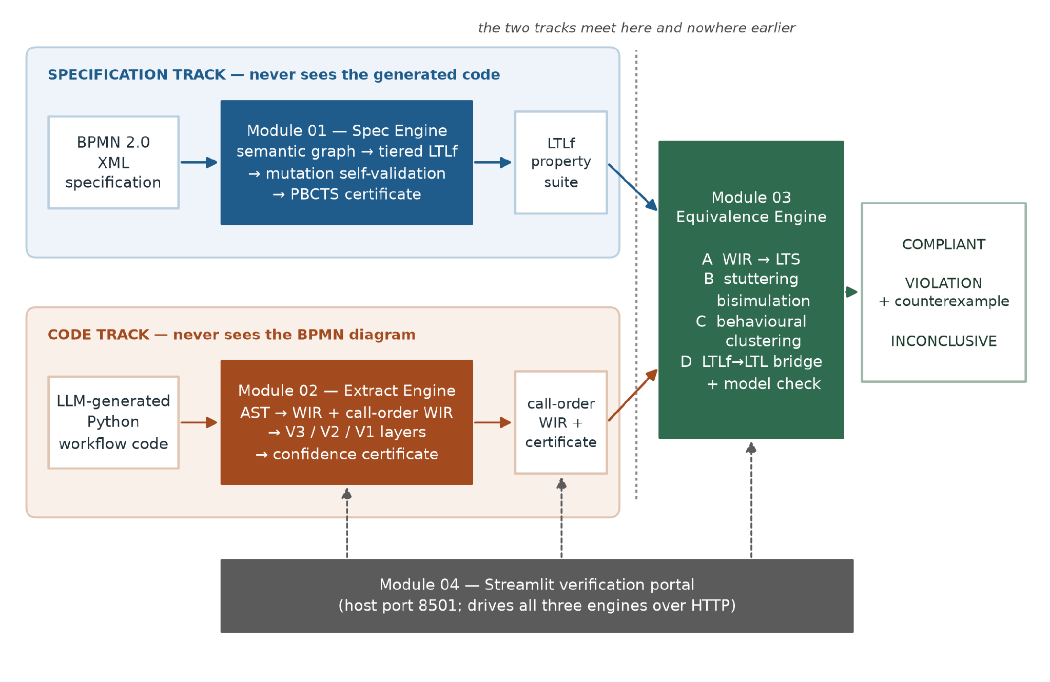
Figure 4.1 – VibeCheck end-to-end architecture.
Specification track. The specification pipeline serves as the framework's formal ingestion layer. First, the raw BPMN XML is parsed into a normalized, Kripke-compatible Semantic Graph, where nodes represent active duration-aware states rather than instantaneous events. To prevent informal diagrams from weakening the mathematical ruleset, the engine actively infers missing implicit branch conditions on exclusive gateways. From this structured graph, the module synthesizes a tiered suite of LTLf properties: a safety tier preventing forbidden execution orderings, a liveness tier ensuring required outcomes, and a fairness tier bounding repeated behaviors. Rather than blindly trusting this synthesis, the engine subjects the suite to an adversarial mutation-refinement loop, injecting topological mutants into the graph and recursively tightening the LTLf rules until all anomalies are successfully blocked. The suite is then rigorously aligned against physical graph traces using Progression-Based Constructive Trace Synthesis (PBCTS).
Finally, the module exports a structured JSON property suite governed by a strict tier semantics metadata block, alongside a discrete set of task patterns. This intentional separation ensures that the downstream code track receives the necessary verification vocabulary without ever gaining unauthorized access to the specification's internal structural logic.
Code track. The Python source is parsed to a syntax tree and reduced to the Workflow Intermediate Representation, a control-flow graph in JSON governed by a shared schema. Two views are produced: the definition-order view, which reflects the order in which the source defines its steps, and the call-order view, which reflects the order in which they actually execute. The distinction is not cosmetic — the equivalence engine requires the call-order view, and Section 6.3 records that supplying the definition-order view produces a well-formed but meaningless comparison. Three validators then run: structural validation over the syntax tree and dominator relations, which gates; bounded symbolic execution discharging path constraints with an SMT solver; and dynamic differential tracing, which executes the program under monitoring and compares the observed action sequence against a reference interpretation of the extracted representation. The validators fuse into a single confidence score with an acceptance threshold, and the export is the call-order representation with its certificate attached.
Convergence. The equivalence engine receives the property suite from one side and the certified representation from the other, and runs four phases. Phase A lifts the representation into a labelled transition system, matching action names through the three-tier cascade of Section 3.5.4. Phase B reduces the transition system under divergence-sensitive stuttering bisimulation, which compresses redundant internal steps without collapsing a non-terminating loop into an ordinary wait. Phase C clusters implementations that are behaviourally indistinguishable, so that a set of candidates costs one check per distinct behaviour. Phase D bridges each finite-trace property into the infinite-trace semantics the model checker implements, converts the negation of the property to an automaton, composes it with the program automaton, and tests for emptiness; a non-empty product yields an accepting run, rendered as a readable counterexample.
Two things about this pipeline are worth naming as approach rather than implementation. The first is that the bridge in Phase D is a semantic transformation, not a syntactic one: the property suite is over finite traces and the checker's models are infinite runs, and conflating them is one of the two ways this project measured a model checker reporting conformance while proving nothing. The second is that abstention can be produced by any phase, and the certificate records which phase produced it, so that "could not decide" is always attributable.

4.6 Output
The system's output is a certificate with four parts.
- A verdict, one of COMPLIANT, VIOLATION, or INCONCLUSIVE. The third is not an error condition and is reported with the phase and reason that produced it.
- A counterexample, when the verdict is a violation: the sequence of workflow actions witnessing the failure, rendered in the vocabulary of the process rather than of the automaton, together with the property it violates.
- An extraction certificate from the code track: the structural gate's outcome, the symbolic and dynamic layer scores, the fused confidence, and the comparison mode under which it was computed. A verdict is a statement about the representation that was checked, so the confidence in that representation travels with it.
- A specification reliability certificate from the specification track: the tier census of synthesized properties, the mutation self-validation outcome, and the trace-synthesis result, so that the property suite the verdict rests on is itself accounted for.
The certificate deliberately does not report a single scalar score for the whole pipeline. Compressing a gated, abstaining, multi-phase decision into one number would discard exactly the information a user needs in order to act on it.

4.7 Summary
The approach is to treat the language model as an untrusted translator and validate each translation after the fact: formalize the BPMN specification into a tiered LTLf property suite on one side and formalize the Python program into a certified control-flow representation on the other, keep the two formalizations blind to each other, and let a model checker decide at the single point where they meet. Four principles govern the design independence, abstention as a real verdict, explicit gates at every stage, and certificates rather than proofs and each is paid for in throughput or in duplicated work.

CHAPTER 5 – ANALYSIS AND DESIGN

5.1 Introduction
This chapter presents the analysis and design of the proposed system. It first covers the design of the system as a whole, the decomposition into four modules, the artifacts that cross the boundaries between them, and how the independence between the specification and code tracks is enforced before moving into the design of each individual module: the specification engine, the verified representation extractor, the equivalence engine, and the verification portal, in each case covering the phases the module carries out and the gate that admits each phase's output. The chapter then presents the design of the verdict model that the system reports its output through and closes with a summary.

5.2 System design

5.2.1 Decomposition
The system decomposes along the line the problem itself draws. There are two artefacts to be compared and they are of different kinds, so there are two formalisation modules; the comparison is a third concern with its own theory and its own failure modes, so it is a third module; and operability is a fourth concern with no research content, so it is a fourth. Figure 4.1 shows the result. What makes this decomposition more than conventional separation of concerns is the direction in which information is not allowed to flow, which Section 5.2.3 makes precise.

5.2.2 Inter-module contracts
Three artefacts cross module boundaries, and each is a declarative document rather than a call into another module's code.
The Workflow Intermediate Representation is the code track's output: a control-flow graph in JSON, with nodes carrying an identifier, a type and an action label, and edges carrying an optional condition. It is governed by an explicit JSON Schema held in a shared directory and mounted read-only into the extraction engine's container, and it is the only artefact in the system given a machine-checkable contract, a decision justified by the fact that it is the one document both halves of the pipeline must agree on.
The property suite is the specification track's primary output: a JSON document containing tiered LTLf formulae formatted in the infix syntax required by the downstream parser. To ensure unambiguous interpretation across module boundaries, this export relies on a rigid tier semantics metadata block. This block explicitly defines the operational role of each tier systematically differentiating properties intended for strict code conformance evaluation (e.g., structural control flow) from those utilized for internal validation (e.g., adversarial mutant killers). Furthermore, maintaining strict governance over the atom vocabulary guarantees that the logic synthesized by the specification engine perfectly aligns with the observable events captured by the extraction engine, ensuring a robust and verifiable trace evaluation process.
The task patterns document is the only information that crosses from the specification side to the code side, and its content is deliberately minimal: the set of action-name patterns the tracer should treat as task-level events. It carries no ordering, no structure, and no property content, so it cannot inform the code track about what the specification requires — only about what vocabulary to observe.

5.2.3 Enforcing independence
Independence is enforced by deployment rather than by discipline. Each module is built from its own directory as its own container image, so a module's image does not contain the other modules' source and cannot import it. The consequence is accepted rather than worked around: logic needed on both sides of a boundary is implemented twice. The specific instance is LTLf formula normalisation, which the specification engine needs in order to emit properties and the equivalence engine needs in order to parse them, and which exists as two independent implementations. Section 6.6 documents the duplication and Section 8.6 defends it: a shared library would be a single import away from a channel by which the specification could come to depend on the code, and the guarantee that no such channel exists is worth more than the hundred lines it costs.

5.2.4 Deployment design
Three engines are HTTP services on an internal network, addressable only by service name; the portal is the only container publishing a host port. The engines are stateless — each request carries its own inputs and returns its own certificate — which means a set of candidate implementations can be processed without coordination, and which is what makes the clustering phase of Section 5.5.4 a pure optimisation rather than a change of semantics.

5.3 Module 01 design — specification analysis
Module 01 serves as the foundational quality gate of the framework. It transforms a raw BPMN diagram into a mathematically formalized property suite whose reliability and strictness have been internally proven. The module executes across a rigid four-phase pipeline, where each phase operates behind an explicit quality gate. Throughout the process, ensure that no flawed or under-specified logic is passed downstream. The final export is a highly refined, tiered LTLf property suite alongside a task-pattern semantic map.

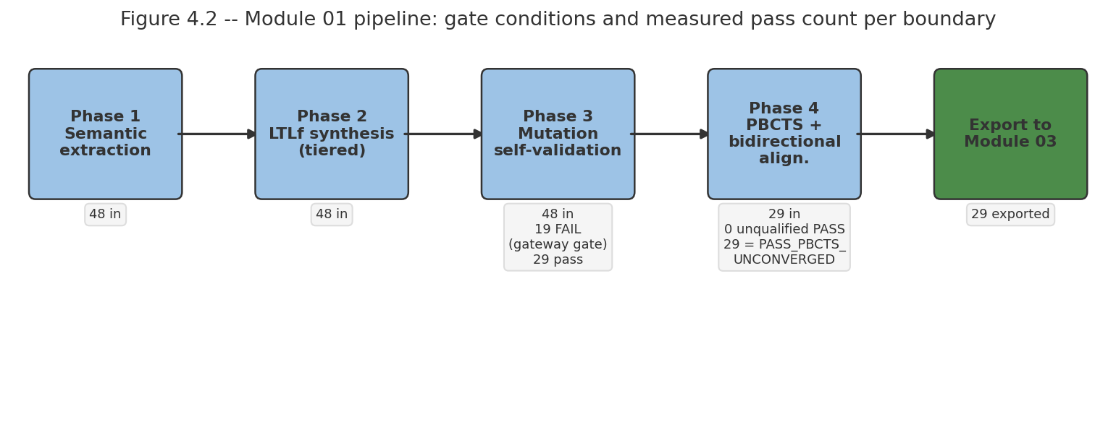
Figure 5.1 – Module 01 specification-analysis pipeline.

5.3.1 Phase 1 — Semantic Extraction and Kripke Labeling
The first design challenge is converting unstructured XML into a mathematically readable format. Rather than relying on simple event-based parsing, the system is designed to construct a Kripke-compatible Semantic Graph.
- State-Based Semantics: A design decision was made to treat BPMN nodes as prolonged states rather than instantaneous events. Tasks are bounded by start(T) and done(T) propositions. This is crucial because downstream execution tracing against real software requires duration-aware state tracking rather than fleeting events.
- Self-Healing Graph Recovery: Because visual BPMN editors often generate disjointed XML (saving elements outside the formal <bpmn:process> scope), Phase01 is designed with a recursive recovery pass. If structural coverage drops below 100%, the engine actively hunts for logically floating nodes and forcefully re-attaches them, prioritizing semantic completeness over syntactic strictness.

5.3.2 Phase 2 — LTLf Synthesis and The Zero Dead-Zone Protocol
The translation from spatial graph to temporal logic is designed around multi-tiered property synthesis (P0, P1, P2). and ignificantly design intervention in this phase is the Zero Dead-Zone Protocol for resolving implicit logic.
Inferring Implicit Guards: Real-world BPMN diagrams frequently utilize exclusive (XOR) gateways with a single labeled condition, leaving the alternate "else" branch completely unconditioned. Instead of rejecting the diagram, the synthesizer is designed to infer the missing logic computationally. It mathematically negates the explicit branches (e.g., !(C1) && !(C2)) and applies it to the default path. This design choice ensures that the formal specification remains watertight and unambiguous, even when the human-drawn diagram was informal.

5.3.3 Phase 3 — Mutation based self-validation
A fundamental vulnerability in specification synthesis is generating properties that are trivially satisfied by everything. To counter this, Phase 3 borrows from software mutation testing but applies it directly to the semantic graph.
- Adversarial Refinement: The system is designed to generate topological mutants (e.g., swapping AND/XOR behaviors or deleting edges) and tests the LTLf rules against them.
- Self-Correcting Synthesis: The design doesn't just passively fail if a mutant survives. Instead, it enters a recursive refinement loop. It isolates the topological difference between the mutant and the original graph, synthesizes a brand-new temporal rule to block the anomaly, and immediately re-audits the suite. This ensures the output is not just a translation of the graph, but an adversarially hardened security policy.

5.3.4 Phase 4 — Bidirectional Differential Alignment (PBCTS)
The final design hurdle is empirically proving that the generated LTLf properties (T_{spec}) and the physical BPMN graph (T_{model}) permit the exact same universe of execution paths. Iterative Deepening with Convergence Detection (IDCD): The pipeline utilizes an IDCD algorithm to generate traces from both domains up to a bounded depth k. The engine calculates the mathematical intersection of these sets to derive precision, recall, and an Effective Alignment Score (EAS).

5.3.5 The Formal Reliability Certificate (FRC) Interface
The output of Module 01 is designed to be fully transparent. The engine exports a Formal Reliability Certificate alongside the property suite. A crucial design feature of this interface is the tier_semantics metadata block. It explicitly classifies properties by their intended downstream role—dictating whether a rule should be used as a hard conformance check against generated code, or solely as an internal self-test for the tracing engine. This design strictly governs how downstream modules are allowed to interpret the generated logic.

5.4 Module 02 design — verified representation extraction
Module 02 turns Python source into the Workflow Intermediate Representation and attaches a certificate quantifying how far that representation may be trusted. Figure 5.2 shows the three validator layers and their fusion.
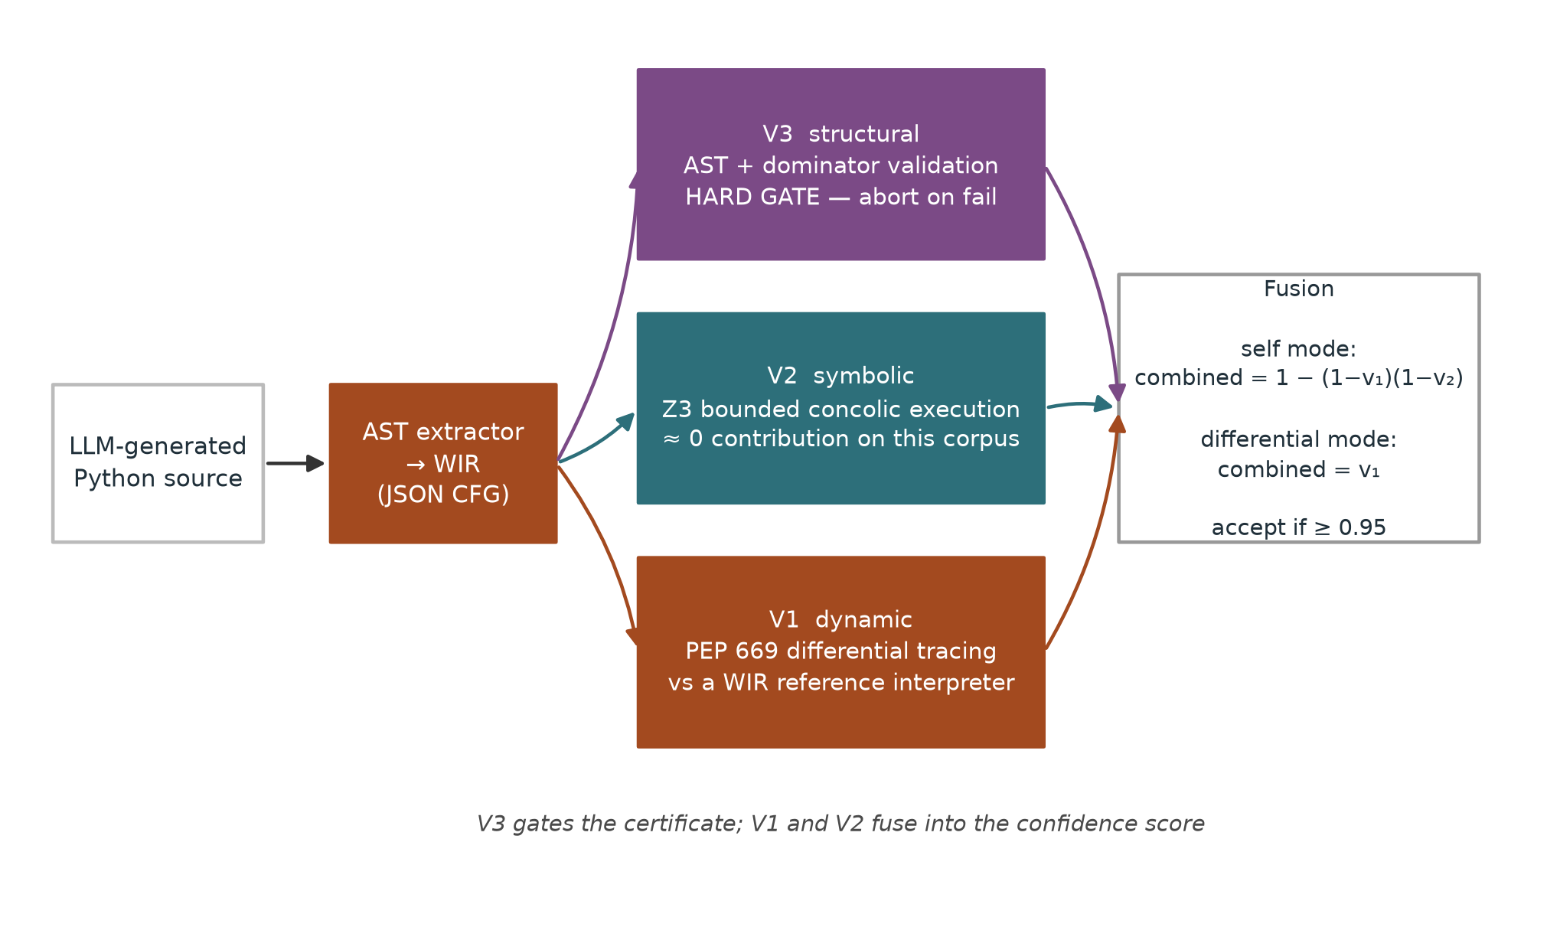
Figure 5.2 – Module 02 three-layer certificate.

5.4.1 Extraction, and the two views
The extractor walks the syntax tree and emits a control-flow graph. It emits two views of it, and the distinction is one of the most consequential small facts in the system. The definition-order view lists steps in the order the source defines them; the call-order view lists them in the order they execute. For a program whose functions are defined in the order they are called these coincide, and for a program whose are not they differ arbitrarily. The equivalence engine requires the call-order view, because a conformance question is a question about execution order. Section 6.3 records that the first end-to-end integration supplied the definition-order view and produced a well-formed comparison that meant nothing, which is the reason the two views are named distinctly in the schema rather than treated as one artefact.

5.4.2 V3 — Structural validation as a hard gate
The structural layer checks the extracted graph against properties a control-flow graph derived from structured Python must satisfy, including dominance relations between branch heads and their bodies. Its design status is as a gate, not a score: a graph that fails it produces no certificate. The reasoning is that a representation known to be structurally wrong should be rejected rather than assigned low confidence, because a low confidence score invites a user to proceed with caution when the correct action is not to proceed at all.

5.4.3 V2 — Bounded symbolic execution
The symbolic layer executes the extracted workflow over symbolic inputs, accumulating path constraints and discharging them with an SMT solver, bounded to keep the analysis tractable. Its design intent is to establish that the paths the representation admits are the paths the program can actually take. Section 7.3.6 reports that on this corpus it contributes approximately nothing to the fused score. The layer is retained, and the report states the negative result wherever the certificate is described, so that "three-layer" is not read as a claim that three layers are doing work.

5.4.4 V1 — Dynamic differential tracing
The dynamic layer executes the program under event-level instrumentation, records the sequence of task events it actually performs, and compares that sequence against the sequence a reference interpreter derives from the extracted representation. Where the two sequences differ by insertions or deletions they are aligned by longest-common-subsequence before being compared, so that a single missing action does not register as total divergence.
This layer has two modes, and the design decision they encode is the subtlest in the module. In self mode the reference interpretation is derived from the representation extracted from the same program: the comparison then establishes extraction fidelity and nothing else, because oracle and subject share any defect the program has. In differential mode the reference is a representation derived from an independent artefact — the specification's own expected behaviour, or an independently written sibling implementation — and the comparison then establishes something about the program rather than about the extractor. Section 7.3.4 measures the difference: self mode detects 3 of 67 purely logical injected faults, and 0 of 50 of the single largest such operator; differential mode detects 0.9952 of genuine bugs (95% CI [0.974, 1.000], n=210). The two modes exist because the first measurement was taken, not because the distinction was anticipated.

5.4.5 Comparison granularity
The differential comparison must decide what counts as a difference. In strict mode every recorded event, including argument values, must correspond; in task_only mode only the task-level action sequence must. The design rule the project arrived at is that the granularity is determined by what the two compared artefacts legitimately share. Two independent implementations of one specification are not obliged to agree on internal values, so comparing them strictly manufactures disagreements; a program and a representation of that same program are obliged to agree on everything, so comparing them loosely discards evidence. Figure 5.3 quantifies both directions of the trade.
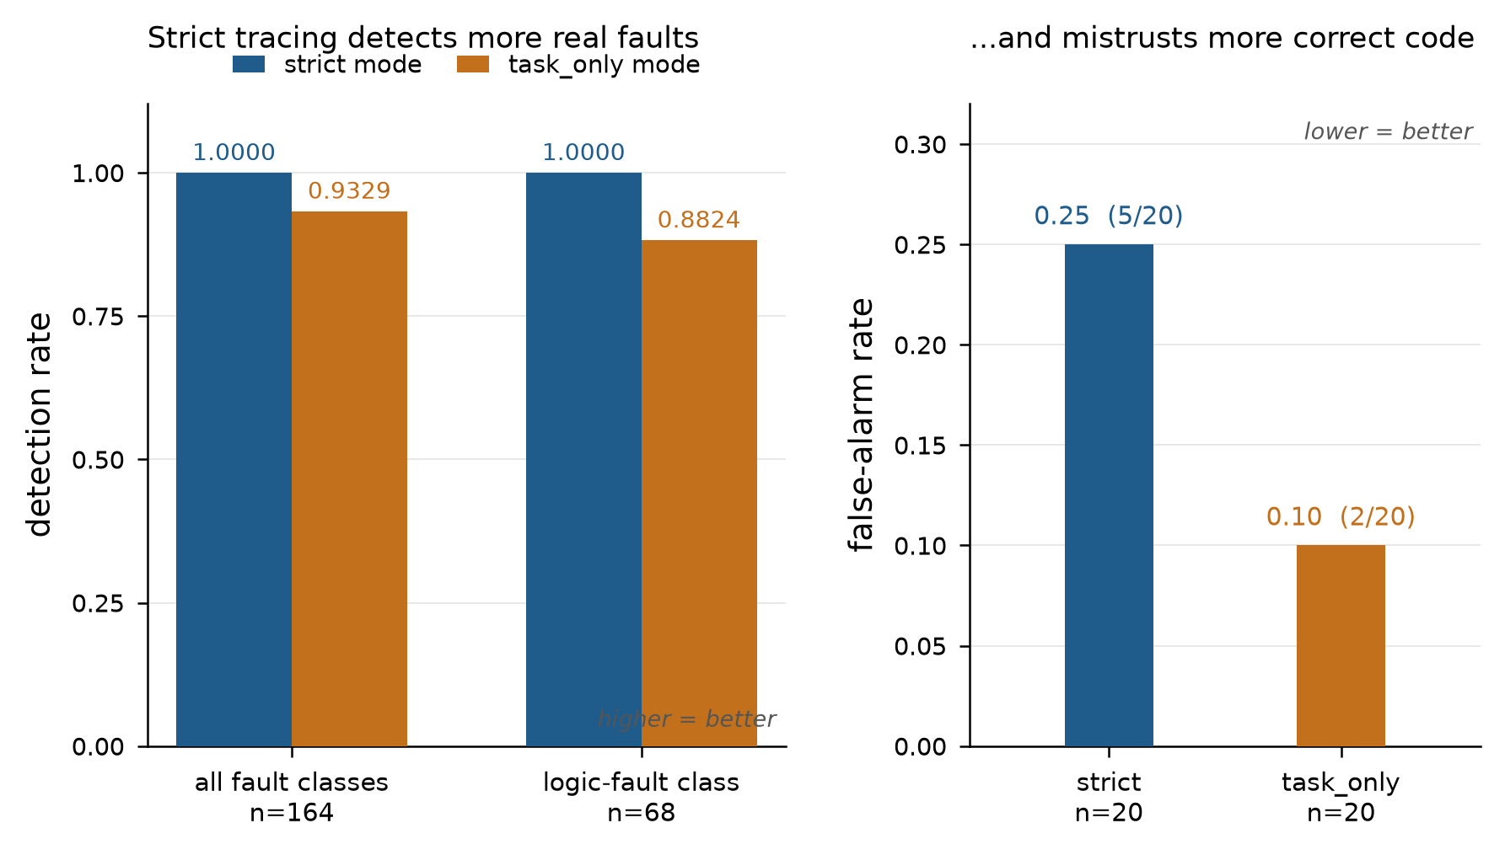
Figure 5.3 – The comparison-granularity trade.
Strict comparison detects more real faults (left) but rejects more behaviourally correct independent implementations (right). Rates and denominators as tabulated in Section 7.3.7.

5.4.6 Fusion and acceptance
The layers fuse into one confidence score. In self mode the two scoring layers are combined as the probability that at least one detects a defect, 1 − (1 − v₁)(1 − v₂), with V3 gating; in differential mode the score is the dynamic layer's alone, since that is the layer whose reference is independent. The acceptance threshold is 0.95. Section 7.3.8 records that this threshold was selected by maximising Youden's J statistic on a calibration split and frozen before the evaluation split was used, so that it is pre-registered rather than fitted to the results it produces.

5.5 Module 03 design — equivalence engine
Module 03 is where the two tracks meet. Figure 5.4 shows its four phases.
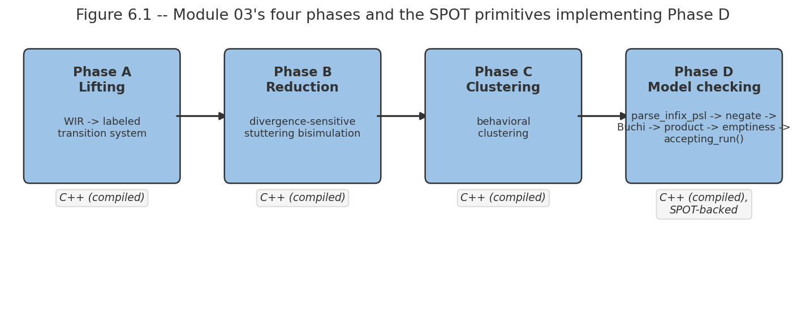
Figure 5.4 – Module 03 four-phase equivalence and model-checking pipeline.

5.5.1 Phase A — Lifting to a labelled transition system
The Workflow Intermediate Representation (WIR) JSON is lifted into a formal labelled transition system, specifically a SPOT twa_graph, whose states represent workflow execution steps and whose transition labels represent Boolean conditions. Lifting requires deciding which specification action corresponds to each raw code action. Because the code vocabulary and the BPMN specification vocabulary were derived independently, they must be mathematically aligned before transition edges are created.
The C++ AdvancedLifter handles this via a strict three-tier semantic matching cascade (semantic_match): an exact lexical string match, followed by a normalized Levenshtein edit-distance check, and finally, a cross-boundary Pybind11 call to a Python-based Sentence-BERT NLP model to measure semantic similarity. The ordering of the tiers is a deliberate design decision. Placing semantic similarity first would improperly equate approve_claim with reject_claim (which are semantically close but behaviorally opposite). Placed last, it successfully recovers genuine renamings without manufacturing false correspondences. When a raw string fails all three tiers, the C++ engine safely abstains, tagging the transition as an unlabeled_task and passing the unmapped action back to the orchestrator via a LifterDiagnostics struct, preventing vacuous compliance.

5.5.2 Phase B — Divergence-sensitive stuttering bisimulation
The lifted twa_graph system contains many states that differ only in internal bookkeeping. Reducing these states is necessary to make model checking tractable. The standard mathematical relation for this is stuttering equivalence, computed by partition refinement [20], [23]. However, the standard relation is unusable here because it absorbs internal steps freely. It mathematically equates a state that performs finitely many internal steps with a state that performs internal steps forever. In the context of LLM code verification, this identification erases the fault, a hallucinated while True: pass retry loop and a legitimate bounded wait are stuttering-equivalent under the plain relation. Thus, standard reduction would delete the defect before the model checker ever saw it.
To solve this, Module 03 implements a divergence-sensitive refinement natively in C++. The lifter first builds a silent subgraph of unobservable (tau) transitions and executes spot::scc_info to decompose it into Strongly Connected Components (SCCs). A multi-state SCC or a single state with a tau self-loop is formally flagged as divergent. The C++ engine then applies the Groote-Vaandrager partition refinement algorithm (partition_refinement), treating divergence as a distinguishing initial block label [22]. Consequently, divergent livelocks and convergent safe states are never merged, preserving the fault trace for the model checker.

5.5.3 Phase C — Behavioural clustering
When several candidate LLM implementations of one specification are certified together, many of them are behaviorally identical despite varying wildly in Python syntax. Phase C partitions them into behavioral equivalence classes so that the computationally expensive model checking runs only once per unique behavior class, rather than once per script.
On the C++ side, this is implemented by clustering the minimized quotient automata using the spot::isomorphism_checker::are_isomorphic function. The critical implementation invariant required to make this mathematics work is the use of a shared memory space. A single AdvancedLifter instance initializes a global spot::bdd_dict (Binary Decision Diagram dictionary). If each automaton were generated with its own dictionary, identical edge conditions would receive different integer IDs, and SPOT would silently fail to recognize them as isomorphic. Because all automata share the exact same bdd_dict, structural and behavioral isomorphism can be computed instantly, yielding massive optimization.

5.5.4 Phase D — Model checking
Phase D is the final compliance entry point, leveraging SPOT's automata-theoretic formulation [13], [7]. For each LTL property, the C++ engine (check_compliance) uses spot::parse_infix_psl to parse the formula and explicitly negates it (spot::formula::Not) to search for violations. A spot::translator then translates this negated property into a formal Büchi automaton within the shared bdd_dict.
The engine calculates the synchronous product (spot::product) of the code's quotient automaton and the negated property automaton. It then executes an emptiness check (prod->is_empty()). An empty product mathematically guarantees that no run of the LLM program intersects with the violation state, yielding a COMPLIANT verdict. If the product is non-empty, the C++ engine extracts the failure via accepting_run(), decoding the exact BDD labels into a human-readable prefix and cycle trace, highlighting the exact workflow actions responsible for the failure.

5.5 Module 04 design — verification portal
The portal has one page per engine plus a landing page, calls the engines over HTTP by service name, and renders each certificate with its verdict, its evidence and its scope. The design intent is inspectability rather than automation: a user should be able to see the property suite, the extracted representation and the verdict as three separate objects, because the most common diagnostic question is which of the three is wrong. The module makes no research contribution and Chapter 8 says so.

5.6 Summary
The design places the two formalisations in isolated containers with declarative contracts between them, so that independence is a property of the deployment rather than of programmer discipline, at the cost of duplicating normalisation logic across one boundary. Module 01 synthesizes tiered LTLf properties from a state-based reading of the BPMN graph and gates their export on mutation self-validation and progression-based trace synthesis. Module 02 extracts a control-flow representation in two distinct views, gates it on structural validation, and scores it with symbolic and dynamic layers whose reference artefact, self or independent, determines what the score means. Module 03 lifts, reduces divergence-sensitively so that non-termination survives the reduction, clusters, bridges finite-trace properties into infinite-trace semantics, and model-checks. The next chapter describes how this design was implemented and what went wrong in the building of it.

CHAPTER 6 – IMPLEMENTATION

6.1 Introduction
This chapter details the implementation of the system architecture proposed in Chapter 5. It provides a comprehensive overview of the realization of the three core modules, which are the specification engine, the extraction engine, and the equivalence engine, by outlining the specific source components responsible for executing each phase of the verification pipeline.

6.2 Module 01 implementation — specification engine
In the implementation of Module 01, designed a custom BPMN-to-LTLf Synthesis and Verification Engine from scratch. This engine serves as the foundational quality gate for the VibeCheck framework. The primary goal of Module 01 is to parse high-level business process models (BPMN 2.0 XML), extract their structural and spatial semantics, and synthesize them into a mathematically verifiable suite of Linear Temporal Logic on Finite Traces (LTLf) properties.
To ensure rigorous validation, the architecture is designed as a pipeline encompassing four distinct phases: Semantic Extraction, LTLf Synthesis, Mutation Refinement, and Bidirectional Differential Alignment. The entire engine is orchestrated via a FastAPI service that guarantees no flawed specification passes to downstream code generation or dynamic tracing modules.

6.2.1 Phase01: Semantic Extraction Engine
The `SemanticExtractionEngine` class serves as the initial ingestion layer. Its responsibility is to translate raw, often chaotic BPMN XML files into a normalized, Kripke-compatible Semantic Graph. This graph represents the business logic purely as states and edges, devoid of visual noise.

The extraction operates across a three-layer pipeline:
- Layer V3 (Syntactic Sanitization): Iterates over the XML DOM and strictly strips out presentational DI tags (such as `bpmndi:BPMNDiagram` and `BPMNShape`). It establishes a baseline count of all executable nodes (e.g., tasks, gateways, events) to set a strict denominator for coverage metrics.
- Layer V2 (Semantic Graph Construction): Traverses the sanitized DOM, mapping sequence flows and translating nodes into a state dictionary. Kripke-compatible atomic propositions are applied here; for example, a generic task is labeled with boundary markers such as `start(Task)` and `done(Task)`.
- Layer V1 (Quality Gate & Self-Healing): Computes structural coverage C_{struct}. If coverage falls below 1.0 (100%), it triggers a `_recovery_pass`. This critical self-healing mechanism scans the root XML for logically floating elements that standard BPMN tools might have saved outside the `<bpmn:process>` scope, mapping them back into the graph to ensure zero data loss.
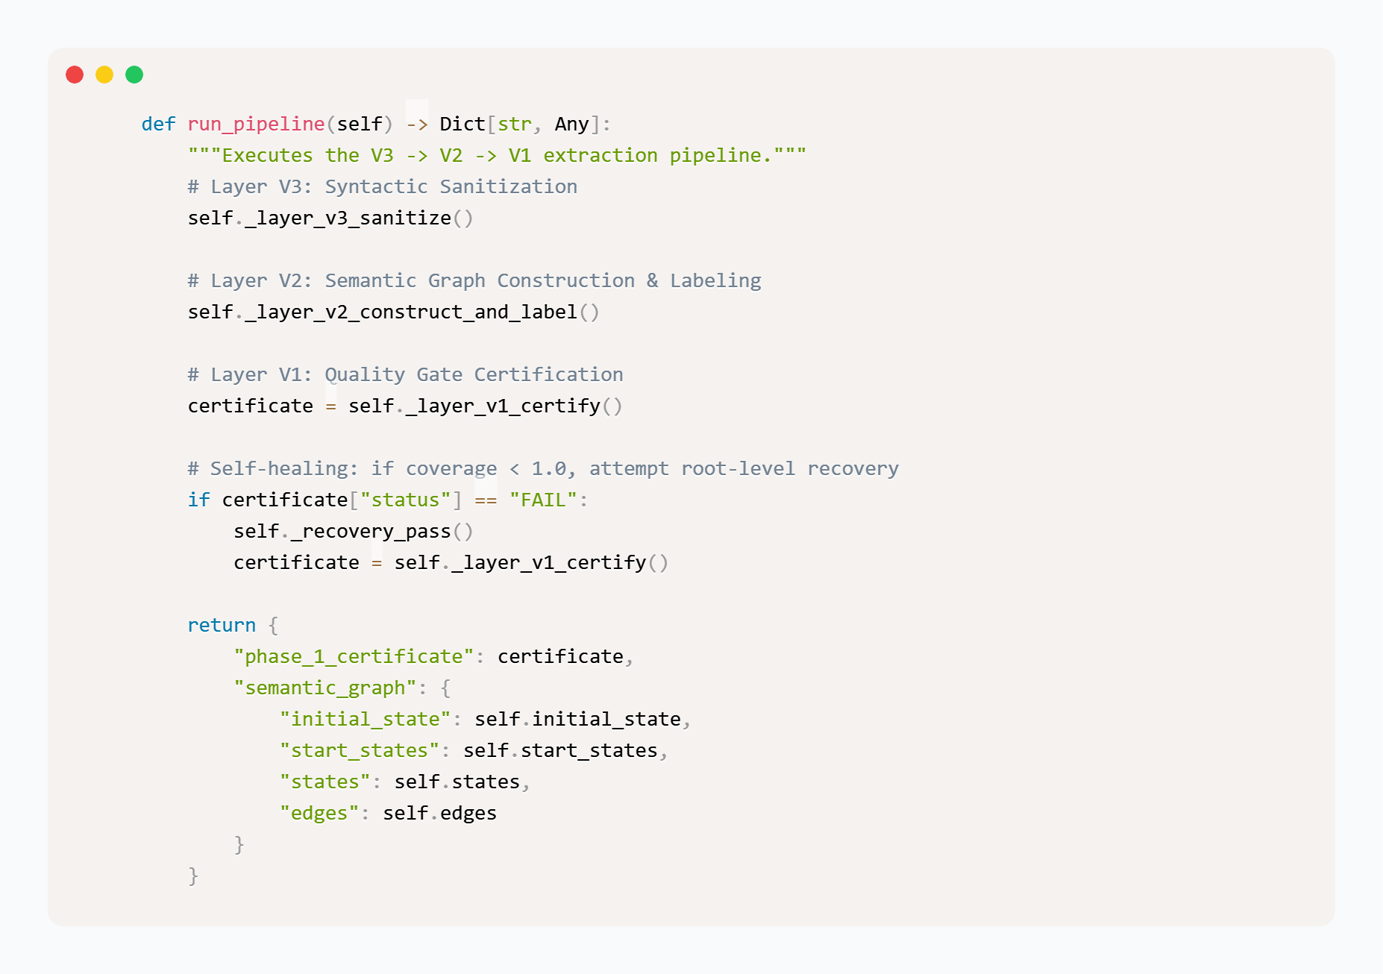

6.2.2 Phase02: Formal Temporal Logic Synthesizer (FLTL)
The `FLTLSynthesizer` class is responsible for converting the spatial Semantic Graph into a temporal domain. By instantiating LTLf properties, the model can reason about the chronological dependencies of the business flow.

The synthesizer implements several critical algorithms:
- Zero Dead-Zone Protocol (Implicit Guard Resolution): Often, business diagrams contain exclusive (XOR) gateways with a happy path condition but no explicit default fallback. The `_resolve_implicit_guards` function identifies these unconditioned branches and computes a mathematical negation of all explicit conditions (`!(C1) && !(C2)`), ensuring no execution dead-zones exist.
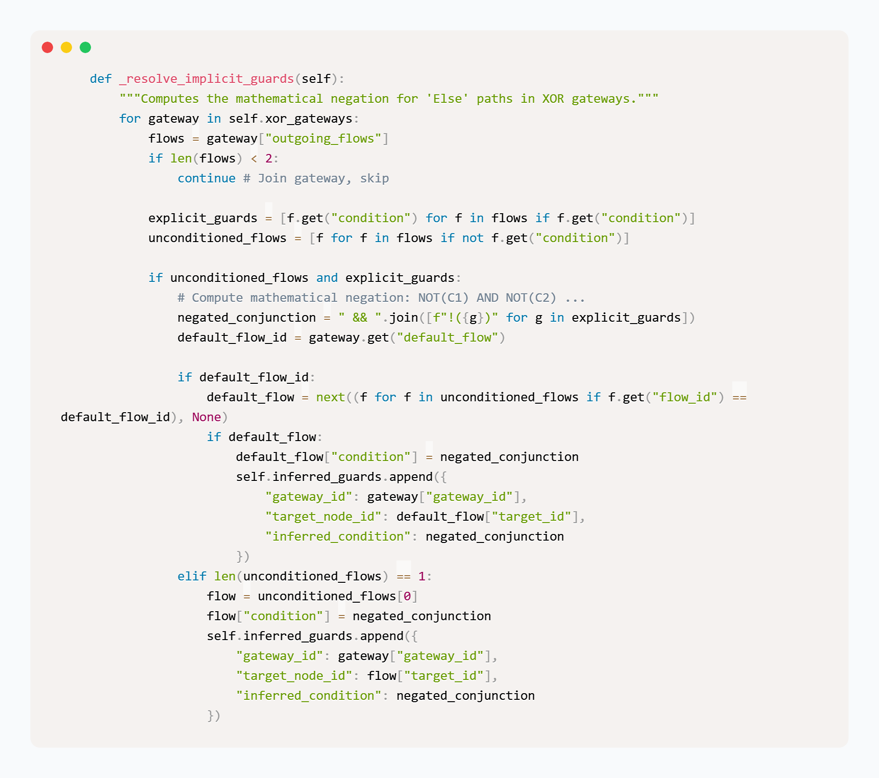
- LTLf Template Instantiation: The engine translates graph edges into strict ordering rules. For instance, a sequence flow from Task A to Task B generates the LTLf property `!start(B) W done(A)` (Task B cannot start until Task A is done).
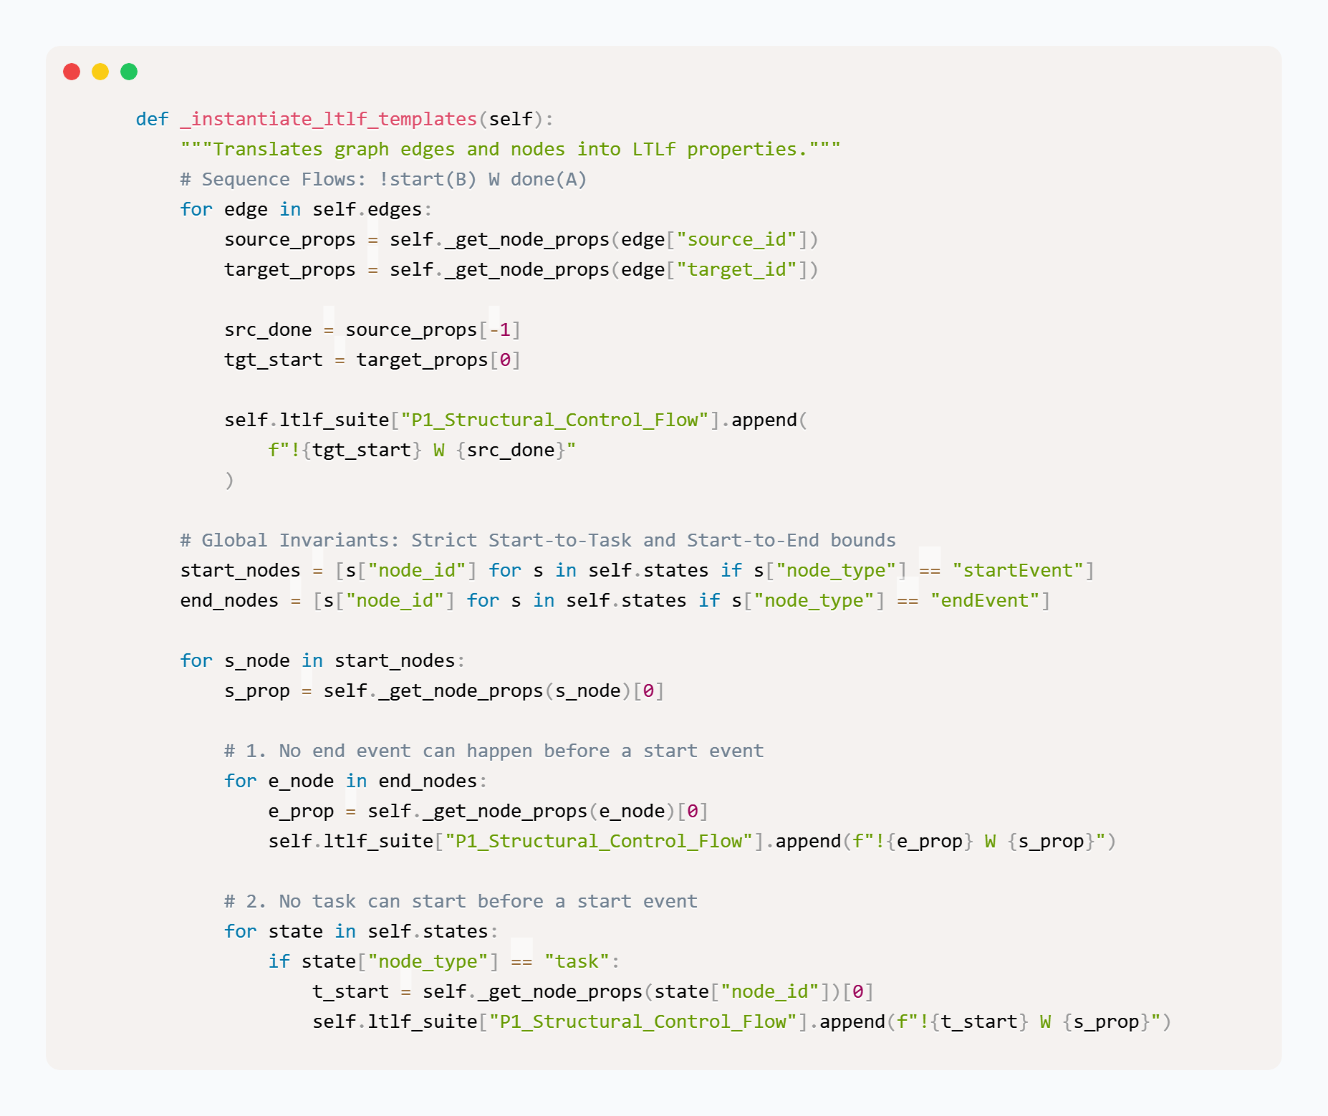
- Property Tiers: The properties are meticulously categorized into multi-tiered suites:
  - P0 Critical Sentinels: Fundamental physics of the execution (e.g., a task cannot end before it starts).
  - P1 Structural Control Flow: Cross-task exclusivity and sequencing.
  - P2 Quality Limits: Bounded loop invariants to prevent infinite execution traps.

6.2.3 Phase03: Mutation refiner
To guarantee the generated LTLf properties are robust, the `MutationValidator` class introduces a red-teaming validation layer inspired by software mutation testing, adapted here for topological graphs.
- BPMN Mutation Engine: This component intentionally injects structural anomalies into the Semantic Graph. Mutation operators include Gateway Substitution (swapping XOR to AND), Sequence Flow Deletion, Task Retyping, and Condition Inversion.
- Self-Healing Recursive Refinement: An `LTLfAuditor` generates execution traces for these mutants and evaluates them against the LTLf suite. If a mutant "survives" (the rules fail to flag the anomaly), the system triggers a recursive `_synthesize_killer` loop. This loop calculates the exact topological difference between the original graph and the mutant, and automatically synthesizes a new restrictive LTLf killer property to close the vulnerability.
- Adversarial Defenses: An independent `AdversarialGenerator` actively produces deceptive traces to further stress-test the suite, generating a `P3_Adversarial_Defenses` tier. The phase only emits a PASS certificate once a 100% kill ratio is achieved.
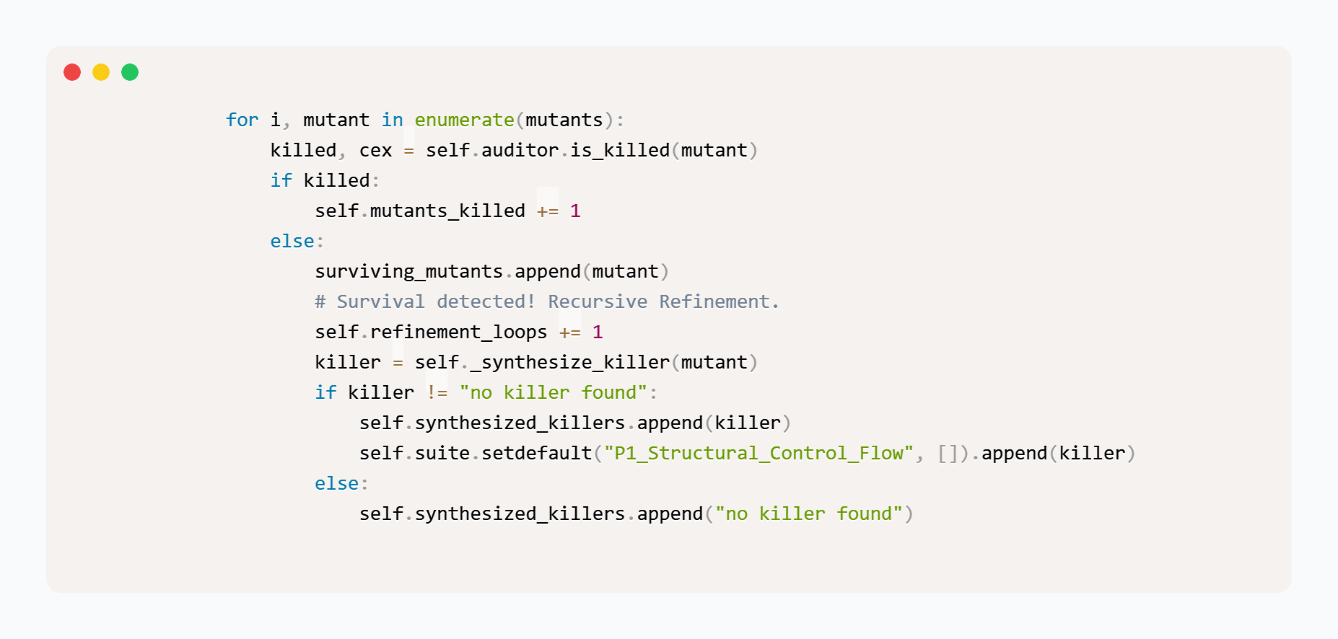

6.2.4 Phase04: Progression-Based Constructive Trace Synthesis (PBCTS)
Phase 4, implemented via the `PBCTSAlignmentPipeline` class, acts as the final analytical check. It performs a Bidirectional Differential Alignment (BDA) to ensure that the LTLf properties T_{spec} and the BPMN Semantic Graph T_{model} permit the exact same universe of execution paths.
- Iterative Deepening with Convergence Detection (IDCD): The `run_idcd` algorithm generates and normalizes execution traces from both the model and the specification up to an increasing depth k. It calculates statistical alignment metrics, including Fitness, Precision, Recall, and the Effective Alignment Score (EAS).
- Self-Correcting Specification Loop (SCSL): If the IDCD detects a semantic gap where the LTLf suite permits a trace that the BPMN graph forbids (over-specification), the `_compute_corrections` method synthesizes a corrective formula (e.g., `!(F(A & X(B)))`) to patch the specification.
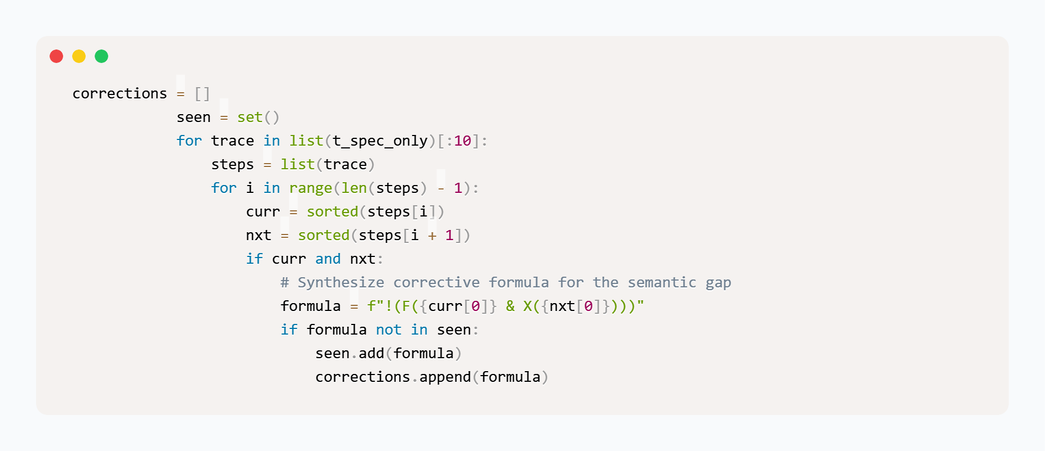

6.2.5 Export Interface for Downstream Modules
Following successful verification, the engine must safely bridge its outputs to other external modules.

6.3 Module 02 implementation — extraction engine

6.3.1 Component Layout
The extraction engine coordinates static, symbolic, and dynamic verification of Python workflow code behind a unified API endpoint. The module is organized into three decoupled subsystems, each responsible for a distinct tier of program extraction and analysis:
- ast_extractor Package: Handles static program analysis and representation generation. It houses the AST control-flow extractor, dominator-tree computation, guard condition analysis, WIR schema definitions, certificate assembly logic, and the call-order view construction engine.
- z3_sym_engine Package: Implements the symbolic execution pipeline. It combines a concolic execution driver, an expression evaluator, a path-constraint registry, and a sandboxed executor designed to safely evaluate symbolic variables and discharge path constraints using the Z3 SMT solver.
- dynamic_tracer Package: Executes dynamic differential tracing. It integrates a PEP 669-based event collector to monitor runtime program execution, a reference interpreter to replay extracted representations, an LCS-based comparator to align and score execution sequences, a randomized test-input generator, and an evidence composer to synthesize dynamic confidence scores.

6.3.2 The Two Views, and a Finding About Integration
The extractor emits the definition-order view and the call-order view described in Section 5.4.1. Measurement over the variant corpus shows the two views differ for 47.5% of 184 variants, independently reproduced at 45.5% by a different method — so for approximately half the corpus the distinction decides what is being compared.
The first end-to-end integration supplied the definition-order view to the equivalence engine, which requires call order. The comparison that resulted was well-formed and meaningless, and Section 6.5.3 reports what happened to the corpus verdicts when the correct view was supplied. The structural reason the wrong view is so damaging was established by inspecting the corpus: all 184 variants have their tasks at top level, none has a top-level gateway, and no task node appears inside a sub-control-flow-graph, while every one of the 184 variants has at least one sub-graph with a no-outgoing-edge exit. A lifter that walks definitions therefore sees the tasks in an order unrelated to execution and terminates in dead ends. Seven tests in test_call_order_view.py now pin the view construction.

6.3.3 The Structural Gate
Structural validation computes dominator relations over the extracted graph and checks the dominance properties a graph derived from structured Python must satisfy. It is implemented as an abort rather than a score, per Section 5.4.2. One implementation defect in this layer is worth recording as a caution about the technique rather than about the code: the dominance-frontier computation admitted an input on which it did not terminate, which was found and fixed with a bound and a regression test. A hard gate that can hang is not a gate.

Listing 6.1 – Normalizing immediate_dominators to bound the dominance frontier walk (ast_extractor/dominators.py)

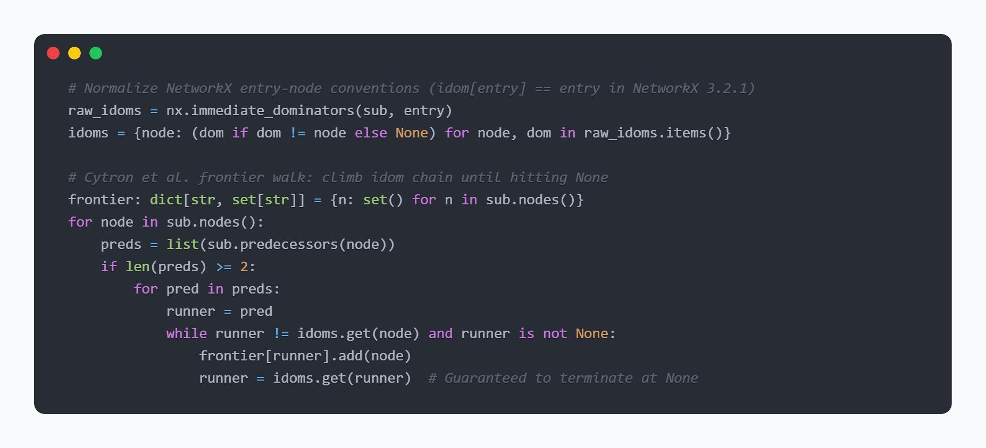

6.3.4 The Symbolic Layer
The symbolic layer drives bounded concolic execution over the extracted workflow and discharges the accumulated path constraints with the SMT solver, executing candidate inputs inside a restricted execution context. It is fully implemented. Section 7.3.6 reports that it contributes approximately nothing to the fused confidence on this corpus, and this chapter does not describe the certificate as three-layer without that pointer attached.

Listing 6.2 – Translating Python comparison AST nodes to Z3 expressions (z3_sym_engine/evaluator.py)
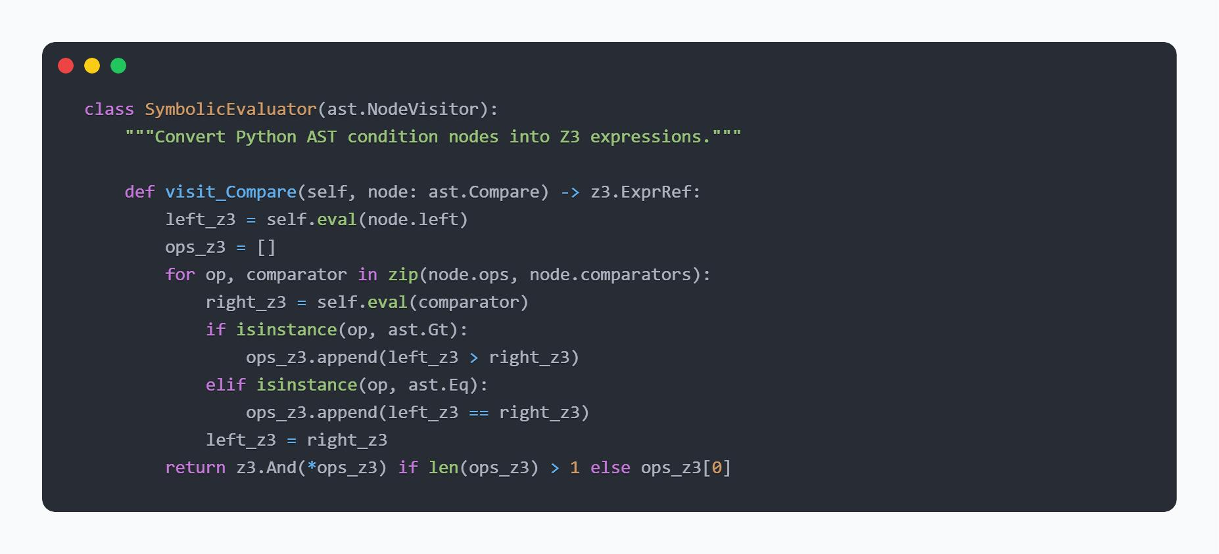

6.3.5 The Dynamic Layer
The collector instructs the program under test with the interpreter's monitoring interface and records the sequence of task-level events actually performed, falling back to the legacy tracing hook where the newer interface is unavailable. The interpreter replays the extracted representation to produce the reference sequence. The comparator aligns the two by longest common subsequence and scores the residual differences, at the granularity — every event, or task sequence only — selected by the comparison mode.
Two implementation facts about this layer are reported because they bound what it can certify:
- Timeout limits under lock contention: The layer must execute the program, so a program that hangs must be bound. Measurement of the bound found that a hang which releases the interpreter's global lock is bounded reliably at approximately 0.22 seconds against a 0.2-second budget, while a statement that monopolises the lock is not bounded at all: the timeout cannot fire because the timing thread cannot run. This is a genuine limitation of in-process dynamic analysis in this interpreter and is stated as such in Section 8.4.2 rather than presented as a tuning issue.
- Trace event definitions: The reference sequence and the observed sequence must agree on what a task event is, which is what the task-pattern document from the specification track supplies, and is the only information crossing from that side.

Listing 6.3 – Selective event monitoring for dynamic trace collection (dynamic_tracer/collector.py)
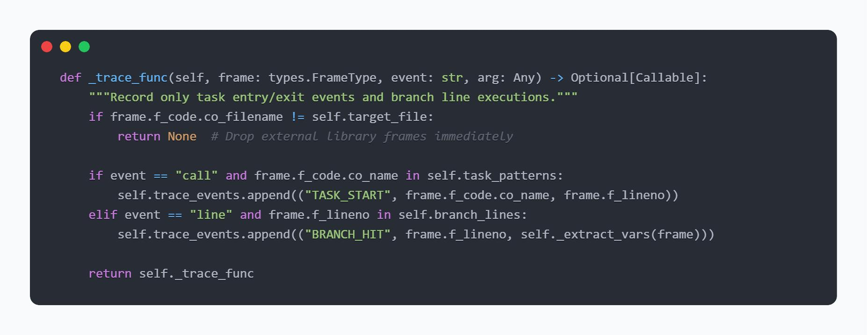

6.4 Module 03 implementation — equivalence engine

6.4.1 Introduction to the C++ Verification Engine
The mathematical core of VibeCheck is implemented as a high-performance system in C++ and is called the Equivalence Engine (Module 03) This engine is compiled directly against the SPOT automata library that takes advantage of the most recent advancement in temporal logic and graph manipulation. This native C++ engine is exposed to Python implementation via a pybind11 extension, allowing it to be seamlessly integrated into the overall project architecture.
We selected to use a strict C++ implementation because it would allow us to access the complete application programming interface (API) of SPOT, an interface that is unique to C++ and that is essential for computing complex process equivalence and for processing finite-trace transformations. A comprehensive test suite comprising C++ functions ensures reliability of the engine.

6.4.2 Phase A — lifting and action matching
Lifting and Action Matching, is responsible for the first operational phase, lifting the Workflow Intermediate Representation (WIR) into a formal transition system, a graph with nodes and edges. The generated code is structured in a call-order representation, which the engine interprets and translates it directly into formal mathematical memory spaces of C++.
In this lift process, the engine has to answer the question of how to map the raw code to the original Business Process Model and Notation (BPMN) specifications. The C++ engine does this by using a very accurate three-tier semantic matching cascade. It tries to find an exact lexical match first, then uses a normalized edit-distance threshold, and lastly, an embedded natural language processing (NLP) sentence-embedding similarity scorer to overcome the semantic gap. Moreover, we address silent implementation issues/tau transitions at this boundary.
In particular, the formula parser of the SPOT model checker parses unquoted text as a composition of temporal operators. In phase B, the transition system generated is mathematically compressed, maintaining its behavioral integrity, while still preserving divergence sensitivity.

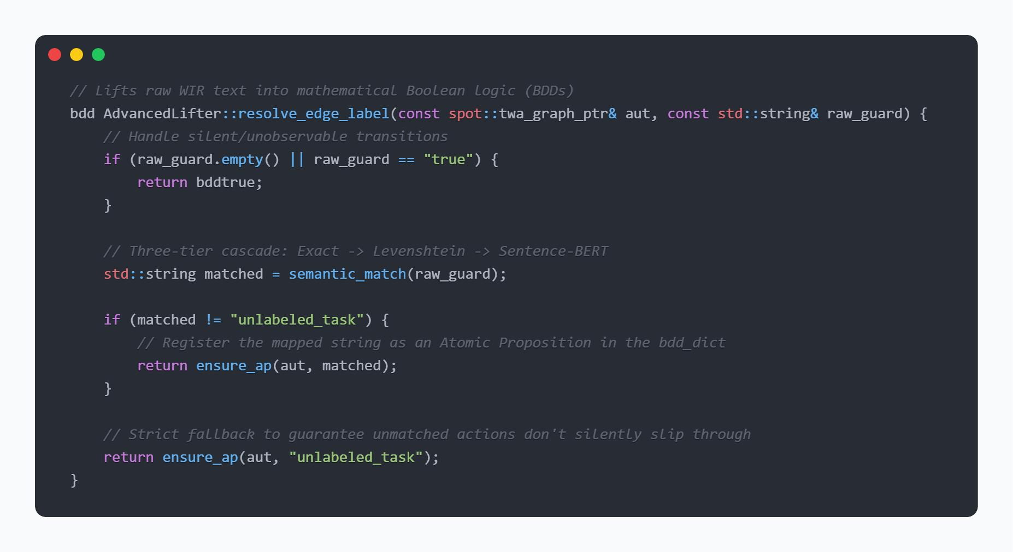

6.4.3 Phase B — divergence-sensitive reduction
Phase B is mathematically compressing the generated transition system without losing behavioral integrity, while still preserving divergence sensitivity. This phase is implemented natively by the C++ lifter, to optimize computation efficiency.
In this stage, the problem is to correctly process finite loops or "livelocks" that the large language models (LLMs) hallucinate. Prior to the start of the engine's compression process, the engine explicitly marks divergent states by breaking down the unobservable (silent) subgraph into Strongly Connected Components (SCCs). The C++ engine is able to detect and mathematically identify a non-trivial component that has no transitions leaving it. The engine then applies the Groote-Vaandrager partition refinement algorithm to reduce the graph and this separation is propagated as a distinguishing structural label. Because of this strict labeling, a divergent livelock (like a hallucinated while True: pass loop) is never mistakenly merged with a normal, safe waiting state. Many of the dozens of Python scripts generated will have the same behavior, even though they differ widely in syntactic text, that is, code.

6.4.4 Phase C — clustering
Phase C will group these equivalent implementations into a single group, thereby using a huge amount of computational resources. On the C++ side, this clustering is carried out by checking for isomorphism with great accuracy over the minimized quotient automata. The key implementation invariant in order to make this mathematics work is that only one instance of C++ lifter is constructed for each evaluation batch. This ensures all individual automaton have a single common Binary Decision Diagram (BDD) memory dictionary, called a bdd_dict. In the SPOT library, automata over different BDD dictionaries cannot be mathematically compared for isomorphism. Without the invariant, the engine would silently fail to cluster identical behaviors, causing multiple runs of model checking to occur, with clusters of size one.
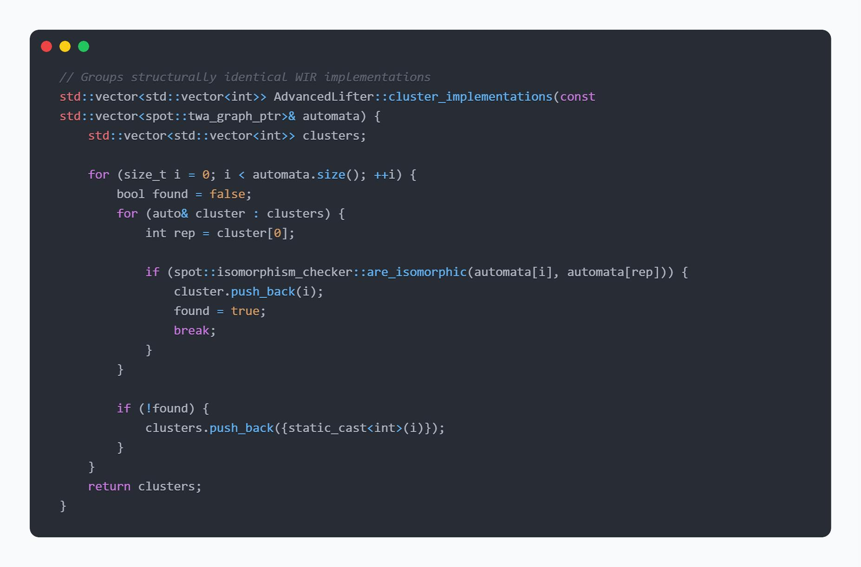

6.4.5 Phase D — model checking and counterexample rendering
Phase D is the final compliance entry point where the C++ engine mathematically proves whether the code adheres to the business rules. The verification is done within the approach of automata theory, which is based on the SPOT library.
First, the engine translates the formal linear temporal logic (LTL) formula and explicitly negates the formula and then looks for violations. The negated formula is then encoded as a formal Büchi automaton in the same BDD dictionary. The C++ engine then calculates the synchronous product of the behaviour automaton of the code and the negated property automaton.
Finally, it runs a check to determine if the resulting product graph is empty. When the product graph is completely empty, mathematically it can be proven that the code does not cross a violation state, and the verdict is “COMPLIANT”. If the violation is detected, the C++ engine pulls out the run that accepts the problem and displays it as a very readable counterexample sequence with the exact prefix and cycle in which the workflow "failed.

6.5 Module 04 implementation — verification portal
Module 04 serves as the primary user interface layer for the framework, implemented as a comprehensive application. It utilizes advanced session-state management to provide seamless navigation across a central dashboard and dedicated pages for each underlying verification engine. The portal actively conducts health checks against the system's components and is responsible for dynamically rendering the final compliance certificates returned by the pipeline.
For the current prototype deployment, the portal integrates tightly with the Equivalence Engine by directly importing the compiled C++ lifter extension to facilitate immediate local execution. In a fully distributed production environment, this boundary is designed to operate as a decoupled RESTful microservice. Under that architecture, the interface container will be entirely isolated and will communicate with the Equivalence Engine's C++ binaries strictly via HTTP requests, ensuring pure service-oriented decoupling.

6.6 Summary
This chapter detailed the complete technical realization of the VibeCheck framework, breaking down the architecture into four specialized modules designed to transition high-level business logic into formal, verifiable mathematical models.
The system's implementation is structured across these four components, beginning with Module 01: The Specification Engine. This critical ingestion layer translates raw BPMN 2.0 XML into a normalized Semantic Graph and synthesizes it into strict temporal execution rules (LTLf). To guarantee their mathematical reliability, the module actively hardens these rules through an adversarial mutation-refinement loop and Bidirectional Differential Alignment (BDA). Ultimately, it outputs a self-validated property suite, ensuring that downstream modules inherit only watertight specifications.
As the next module we have an extraction engine, which processes the LLM-generated Python code, converting it into a Workflow Intermediate Representation (WIR). It relies on AST-based call-order extraction, structural dominance checks, Z3 symbolic execution, and dynamic in-process interpreter tracing to capture the exact sequence of executed tasks.
Verification Engine acts as the mathematical core, this high-performance C++ engine leverages the SPOT library. It lifts the WIR into a formal transition system via a three-tier semantic NLP cascade, mathematically compresses the graph while preserving infinite-loop "livelock" sensitivity, clusters identical behaviors using isomorphism checks over a shared BDD dictionary, and performs the final LTL model-checking emptiness proof to issue a compliance verdict or counterexample trace.
As the final module we have the primary user interface application. It manages session states, dynamically renders the final compliance certificates. While currently utilizing local C++ bindings, it is architected for deployment as a fully decoupled RESTful microservice.

CHAPTER 7 – EVALUATION

7.1 Introduction
This chapter reports what the system measures. Section 7.2 describes the evaluation methodology, which required more construction than is usual because the benchmark carries no correctness labels, and reports the corpus funnel that determines the denominator of every rate that follows. Section 7.3 evaluates the code track, whose central result is negative. Section 7.4 evaluates the equivalence engine. Section 7.5 reports the end-to-end evaluation. Section 7.6 states what is not measured, which for this project is a substantial list and one the reader needs in order to interpret the rest. Section 7.7 is the correction trail: every figure the project stated and later found to be wrong, with how it was caught and what supersedes it. Section 7.8 summarises.
Four conventions govern the numbers in this chapter, and they are stated here because they are the reason several results look weaker than a differently reported version of the same work would.
- Every rate carries an exact interval. Intervals are Clopper–Pearson exact binomial [34]. Several end-to-end measurements rest on fewer than twenty trials, where a normal approximation is invalid rather than merely conservative, and where the honest presentation of a point estimate is inseparable from the width of the interval around it.
- Abstentions are reported, not absorbed. Where the pipeline declines to commit to a verdict, that outcome is reported as its own rate and excluded from the detection denominator rather than counted as a miss or discarded. A single blended number would be smaller and less informative.
- Measured is distinguished from designed throughout. Where a capability exists in the design but no artefact measures it, the chapter says so and does not supply a plausible figure. Section 7.6 collects these.

7.2 Specification Engine Evaluation
7.2.1 Corpus and instruments
The specification track is evaluated on 48 process programs drawn from the benchmark, from which 550 single-site topological constraints were generated across three applicable tiers, and on a variant corpus described in Section 7.2.6. The module's own validation suite stands at 35 passing tests at the time of the measurement.

7.2.2 Structural extraction fidelity
The structural layer's accuracy against the 48-program corpus yields a retention rate of 0.979. This figure is reported with its history attached, because the history is the more informative part. Before the ambiguity-resolution step was added, the same measurement gave a retention rate of 0.604 the extractor was hard-failing 19 specifications. The failure set was exactly the exclusive-gateway-bearing set, caused by the corpus's absence of machine-readable branch conditions (0 of 20 splitting gateways carried a condition expression).
A near-perfect score invites suspicion, and the honest reading is that it reflects an extractor explicitly tuned to accept unconditioned branches as valid non-deterministic choices rather than a general claim about BPMN structural parsing.
7.2.3 Mutant detection and calibration
Table 7.1 gives the specification track's primary rates, all at the frozen threshold.

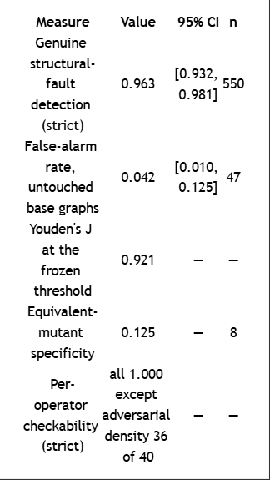
Table 7.1 – Specification-track differential instrument, evaluation split. All intervals Clopper–Pearson exact binomial.
The equivalent-mutant row needs its explanation stated rather than left as a poor number. Of the 8 injected structural mutants identified as topologically equivalent to their base graphs, 7 scored exactly the same as their own base. That is not the instrument misjudging them; it is the instrument correctly observing that their paths are identical, and inheriting the base graph's score as a consequence. A specificity metric that penalises this is measuring the wrong thing, and the figure is reported with the mechanism attached rather than silently.
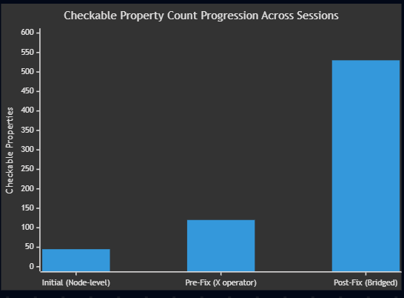

7.2.4 The central negative result: formal synthesis cannot map unobservable topology
The most consequential measurement in this project is a near-zero, and it is worth stating with its structure intact rather than as a single headline rate. When liveness constraints (P1) are synthesized, the overall checkability rate drops sharply if intermediate BPMN nodes are retained. Disaggregated by node type, the framework is not a detector of structural flow at all for non-task artifacts.
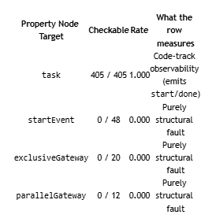
Table 7.2 – Checkability by semantic node type. The task row is the one the architecture's claim rests on.

The three operators that inject purely structural nodes (events and gateways) yield 0 of 80 checkable properties. The overall prior checkability rate of 0.176 was carried almost entirely by the fact that the underlying Python tracer only records executable task events, while the LTLf synthesizer faithfully extracted constraints for invisible gates. That divergence is real, but it is a measurement of trace visibility, not of formal reasoning sensitivity.

The mechanism is not subtle and that is the point. If a property asserts `!start(task) W node(startEvent)`, the trace evaluator will never see `node(startEvent)`, and the property hangs vacuously. This result is the empirical foundation of the path-traversal fix implemented in the synthesizer. By intentionally dropping structural nodes and mapping constraints strictly between executable tasks, checkability was recovered. What it cannot measure, at any threshold and with any amount of tuning, is whether the invisible gateway itself fired correctly.

7.3 Code track evaluation

7.3.1 Corpus and instruments
The code track is evaluated on 101 programs drawn from the benchmark, from which 427 single-site mutants were generated by nine applicable operators, and on a variant corpus described in Section 7.3.9. The module's own test suite stands at 246 passing tests at the time of the measurement.

7.3.2 Structural extraction fidelity
The structural layer's accuracy against hand-checked gold extractions over the 101-program corpus is perfect on the current pipeline: node precision, recall and F1 and edge precision, recall and F1 are all 1.0000. This figure is reported with its history attached, because the history is the more informative part. Before the graph-contraction step was added, the same measurement gave node precision 0.8255 with recall 1.0000 for an F1 of 0.9044, and an edge F1 of 0.6827 — that is, the extractor was producing structurally valid graphs with spurious intermediate nodes. The gold extractions themselves were validated by human inspection, 10 of 10 with no gold errors found.
A perfect score invites suspicion, and the honest reading is that it reflects a corpus of structurally similar generated workflow programs rather than a general claim about Python control-flow extraction. Section 7.6 states this as a scope limitation.

7.3.3 Mutant detection and calibration
Table 7.2 gives the code track's primary rates, all at the frozen threshold.

Measure | Value | 95% CI | n
Genuine-bug detection (strict) | 0.9952 | [0.974, 1.000] | 210
False-alarm rate, untouched base programs | 0.0588 | [0.012, 0.162] | 51
Youden's J at the frozen threshold | 0.9600 | — | —
Equivalent-mutant specificity | 0.111 | — | 9
Per-operator detection (strict) | all 1.000 except constant-perturbation 8 of 9 | — | —

Table 7.2 – Code-track differential instrument, evaluation split.
All intervals Clopper–Pearson exact binomial. Source: eval/results/calibration_report_differential.md and eval/threshold.json.
The equivalent-mutant row needs its explanation stated rather than left as a poor number. Of the 9 mutants identified as semantically equivalent to their base programs, 8 scored exactly the same as their own base. That is not the instrument misjudging them; it is the instrument correctly observing that their behaviour is identical, and inheriting the base program's score as a consequence. A specificity metric that penalises this is measuring the wrong thing, and the figure is reported with the mechanism attached rather than silently.

7.3.4 The central negative result: self-referential validation cannot detect logic faults
The most consequential measurement in this project is a near-zero, and it is worth stating with its structure intact rather than as a single headline rate. When the confidence certificate is computed in self mode — that is, when the reference interpretation is derived from the representation extracted from the same program being judged — its overall detection rate over the mutant corpus is 0.3607 (95% CI [0.297, 0.428], n=219). Taken at face value that is a weak detector rather than a blind one. Disaggregated by operator it is not a detector of logic faults at all.

Operator | Detected | Rate | What the row measures
corrupt-container-op | 17 / 17 | 1.000 | Exception channel — mutation makes the real code raise KeyError
wrong-variable | 18 / 18 | 1.000 | Exception channel — mutation makes the real code raise NameError
reorder-steps | 19 / 50 | 0.380 | Mixed
drop-step | 19 / 51 | 0.373 | Mixed
swap-branches | 1 / 5 | 0.200 | Mixed, n too small to read
negate-guard | 3 / 17 | 0.176 | Purely logical fault
constant-perturb | 1 / 10 | 0.100 | Mixed, n too small to read
early-return | 0 / 50 | 0.000 | Purely logical fault
boundary-shift | 1 / 1 | 1.000 | n = 1, not readable

Table 7.3 – Self-mode detection by mutation operator.
The right-hand column is this report's reading of what each row measures, following the diagnosis in the source report. The two rows marked as logical faults are the ones the architecture's claim rests on. Source: module_02_extract/eval/results/calibration_report.md.
The two operators that inject a purely logical fault without making the program raise are early-return and negate-guard. On those, self mode detects 3 of 67 — 0.0448 (95% CI [0.009, 0.125]) — and on the larger of the two, early-return, it detects 0 of 50 (95% CI [0.000, 0.071]). The overall 0.3607 is carried almost entirely by two operators at 35 of 35, and the source report diagnoses why: corrupt-container-op and wrong-variable make the actual Python raise an exception, which the tracer records as an event, while the reference interpreter catches the equivalent failure and emits nothing. That divergence is real, but it is a measurement of exception visibility, not of logic-fault sensitivity. The self-mode figure that bears on the architecture is therefore 3 of 67, not 0.3607.
The mechanism is not subtle and that is the point. The certificate compares the program's observed behaviour against a reference derived from the program's own extracted representation. If the program contains a logic bug, the extractor faithfully extracts the buggy logic, the reference interpreter faithfully replays the buggy logic, and the two agree perfectly. Oracle and subject share the defect, so the comparison is blind to it by construction. What self mode measures is extraction fidelity — whether the representation matches the program — and it measures that well. What it cannot measure, at any threshold and with any amount of tuning, is whether the program is correct.
This result is the empirical foundation of the dual-track architecture of Section 1.5.1. It is a structural claim, not a performance claim: the failure is in what the oracle is derived from, so no improvement to the instrument can recover it. It is also the reason the differential mode exists, and the two figures should be read together — 3 of 67 in self mode against 0.9952 (95% CI [0.974, 1.000], n=210) in differential mode on comparable faults, a contrast that survives on the early-return operator alone at 0 of 50 against 49 of 49. Figure 7.3 shows the sequence of measurements by which the instrument reached the latter figure.
One caution about this figure belongs with it rather than in the correction trail. An earlier statement of this result cited a flat 0 of 220, taken from the project's first self-mode calibration run. That run is invalid and the repository marks it so: its entry-point selection took the first function defined in each file, and every generated program in the corpus defines its task stubs before the workflow, so the run measured a zero-branch stub in all 101 programs and their mutants rather than the orchestration logic. The figures used here come from the corrected run. The architectural conclusion is unchanged and the number supporting it is weaker and better diagnosed; Table 7.8 records the correction.
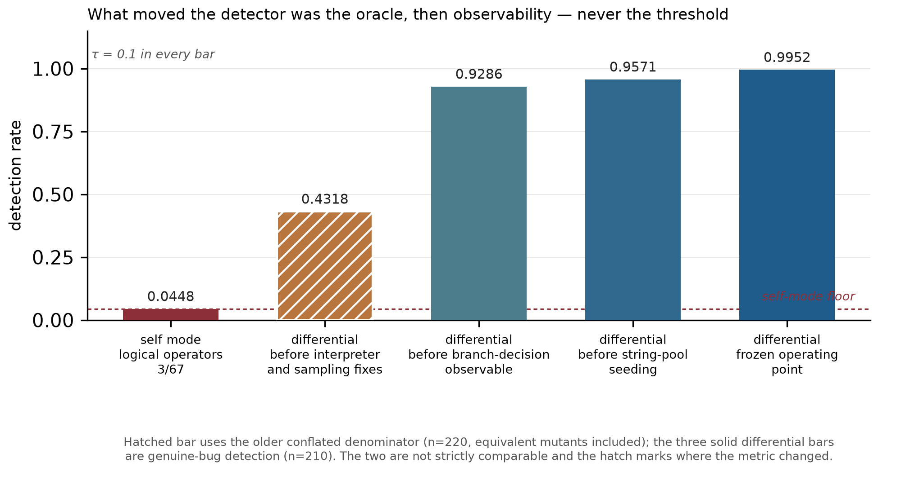
Figure 7.3
Detection-rate progression across evaluation sessions as the differential instrument was corrected. The first bar is self mode restricted to the two purely logical mutation operators; the rest are differential mode. The climb is the effect of changing what the oracle is derived from, and then of successive observability fixes, not of threshold tuning — the decision threshold is 0.1 in every bar. The hatched bar is drawn from the older conflated denominator and is not strictly comparable with the three solid differential bars, which is why it is marked. Sources: module_02_extract/eval/results/calibration_report.md, calibration_report_differential.md, and the three corresponding reports under eval/results/archive/.

7.3.5 Confidence and semantic divergence
A well-behaved confidence score should decrease as a mutant's behaviour diverges further from its base. Over all 427 mutant-base pairs the correlation between the complement of confidence and the measured semantic divergence rate is Pearson r = 0.4085 and Spearman ρ = 0.5400; restricted to the pairs where divergence is observable at all, r = 0.5580 and ρ = 0.5988. Eleven pairs are equivalent mutants. Figure 7.4 plots the relation.
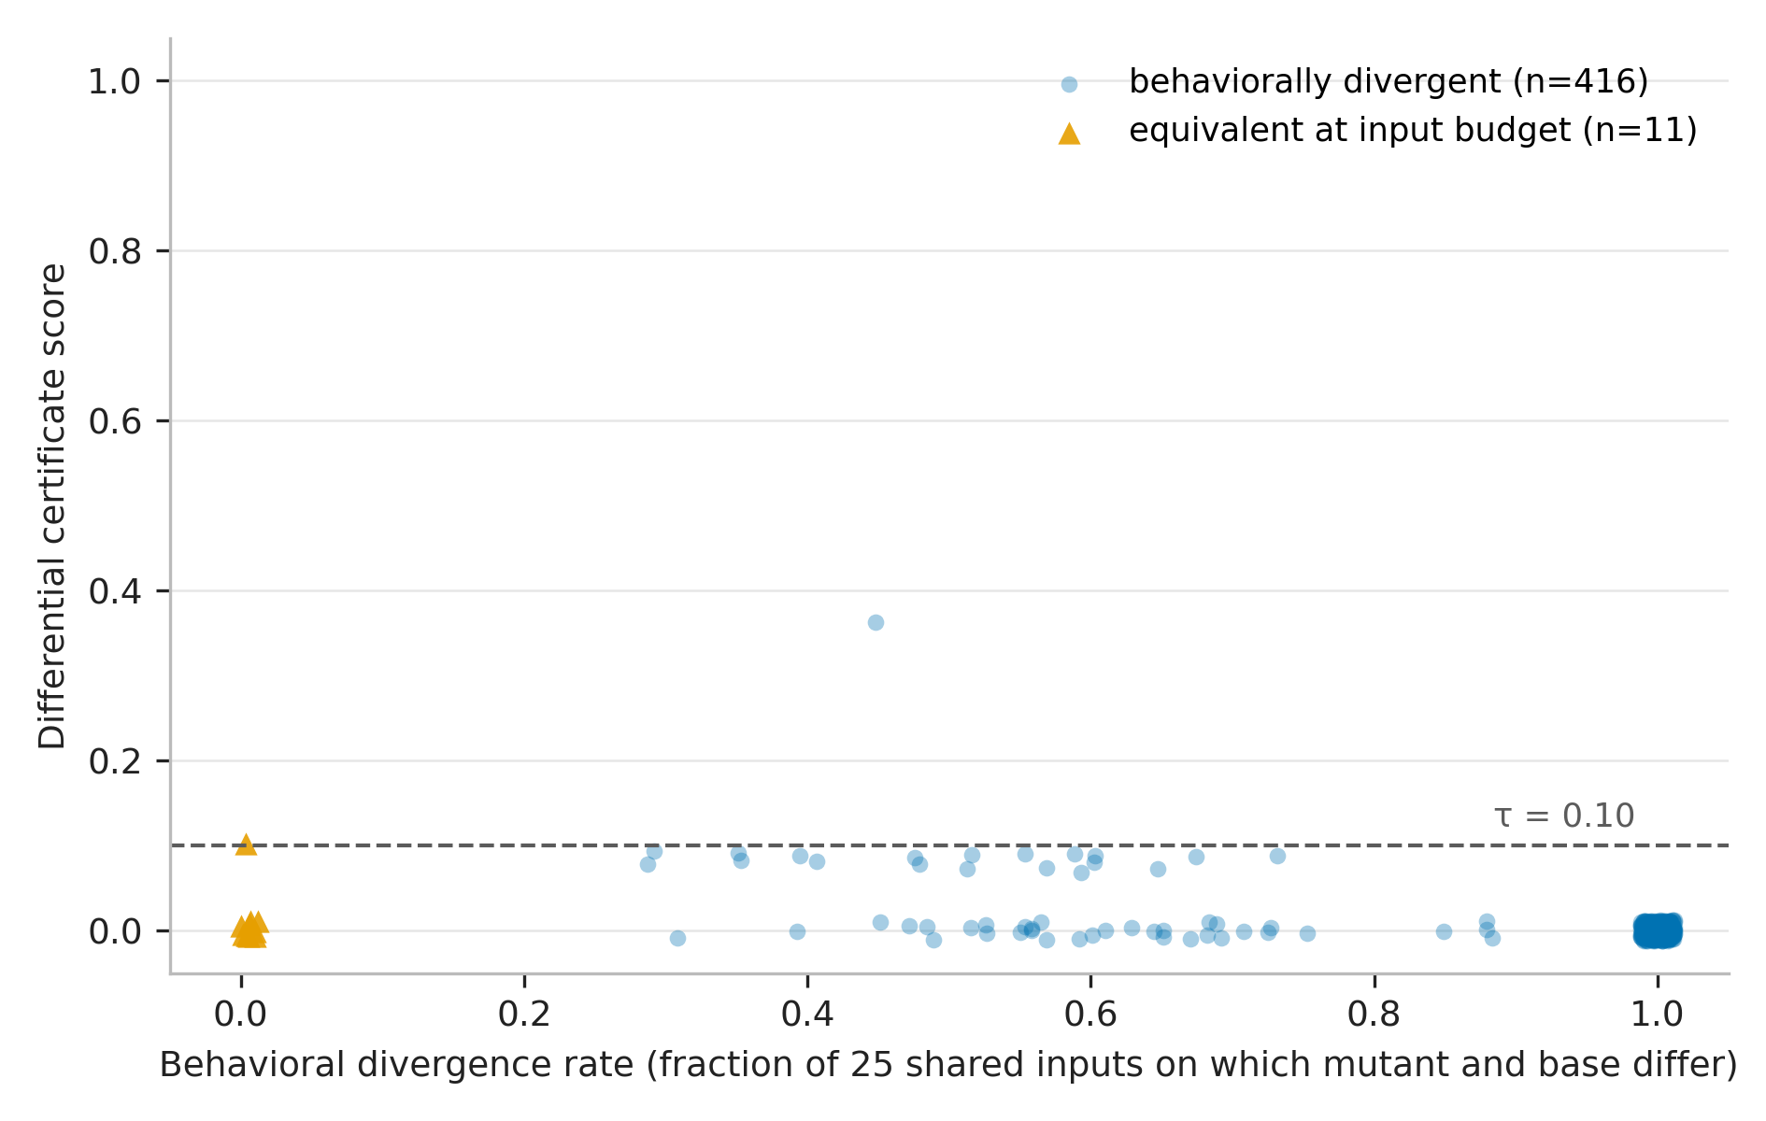
Figure 7.4
Confidence complement against semantic divergence rate over 427 mutant-base pairs, with equivalent mutants marked. The relation is positive and moderate (Spearman ρ = 0.5400 full, 0.5988 restricted), not tight: confidence is a usable signal of divergence magnitude but not a proxy for it.
A moderate correlation is the honest characterisation. The score is a reliable detector at the calibrated threshold, as Section 7.3.3 shows, and it is a much weaker estimator of how badly a program diverges. The report does not present it as the latter.

7.3.6 A negative result about the symbolic layer
The symbolic validation layer contributes approximately nothing to the fused confidence on this corpus. The certificate is therefore, in practice, driven by the dynamic layer with the structural layer gating. This is reported wherever the certificate is described, because "three-layer certificate" would otherwise be read as a claim that three layers do work. The layer is retained: the result is a finding about workflow programs of this shape, in which the interesting divergences are in action sequencing rather than in path conditions over data, and not a demonstration that symbolic reasoning has nothing to offer the problem.

7.3.7 Comparison granularity: both directions of the trade
Section 5.4.5 argued that comparison granularity is determined by what the compared artefacts legitimately share. Table 7.4 and Figure 5.3 quantify both directions.

Measure | strict | task_only | n
Natural-fault detection, all classes | 164 of 164 = 1.0000 | 153 of 164 = 0.9329 | 164
Natural-fault detection, logic class | 68 of 68 = 1.0000 | 60 of 68 = 0.8824 | 68
False alarms, independent implementations | 5 of 20 = 0.25 | 2 of 20 = 0.10 | 20
Mutant detection (D3 control) | not measured in this cell | 0.8952 | 427

Table 7.4 – The comparison-granularity trade, measured.
Natural-fault detection is on the screened variant corpus; the false-alarm figure is on independently written implementations admitted as behaviourally correct. Sources: eval/results/session_b_report.md, eval/results/cross_impl_mode_report.md, and the D3 control in the latter.
The two columns answer different questions and neither dominates. Strict comparison detects every natural fault in the corpus, including every one of the 68 logic-class faults, and it raises false alarms on a quarter of the independently written implementations — because two people, or two models, implementing the same specification are under no obligation to agree on internal values. Loosening to task-only comparison more than halves the false-alarm rate and gives up detection: 11 of 164 natural faults and 8 of 68 logic-class faults become invisible. Both residual false alarms under task-only comparison are exception-driven rather than sequence disagreements.
The rule the project settled on is therefore stated as a rule about the comparison and not about a threshold. Where the reference is a representation of the same program — the extraction-fidelity question — strict comparison is correct, because the two are obliged to agree on everything and any loosening discards evidence. Where the reference is an independent artefact — the conformance question across implementations — task-only comparison is correct, because value-level agreement was never required.

7.3.8 The return-value observability fix
One improvement is separated out because it is a lesson about instrumentation rather than about algorithms. Making return values observable to the tracer raised logic-class detection from 0.9118 to 1.0000 under strict comparison and from 0.7794 to 0.8824 under task-only comparison, with the false-alarm rate unchanged and the confidence-divergence correlation byte-identical. A fault the instrument cannot observe is a fault it cannot detect, and no amount of threshold calibration substitutes for widening what is recorded.

7.3.9 The variant funnel and extraction robustness
The variant corpus was built by generating implementations of benchmark specifications across several model families. Of 303 requested variants, 294 were obtained — one model provider outage is documented rather than silently absorbed — and screening reduced these to 184, of which 20 were admitted as behaviourally conformant by the oracle of Section 7.2.1 and 164 became the natural-fault corpus. On the 20 admitted variants the extractor ran with 0 aborts, 0 crashes, and node coverage 1.0.

7.4 Equivalence engine evaluation

7.4.1 What is measured and what is not
This section evaluates Phase D, the model-checking phase, and the effect of the two fixes of Section 6.5. It does not evaluate Phases A, B or C against behavioural ground truth, because no artefact does: there is no measurement of clustering agreement with behavioural ground truth, of bisimulation-reduction correctness over the corpus, or of the realised cost saving from clustering. Section 8.5.2 records this as the largest single evaluation gap in the project. The figures below must not be read as speaking to those phases.

7.4.2 Validating the finite-to-infinite bridge
The corrected model-checking path was cross-validated against the module's independent finite-trace evaluator over 58 checks across 29 specifications. On every check where both procedures committed to a verdict they agreed: 35 of 35, with the remaining 23 legitimately abstaining. The two procedures share no implementation — one goes through automaton construction, product and emptiness, the other evaluates formulae directly over finite traces — so the agreement is evidence that the bridge preserves finite-trace meaning rather than evidence that one implementation is self-consistent.
A second candidate validation is deliberately not used, and the reason belongs in an evaluation chapter. An earlier bridge investigation reports 12,600 of 12,600 agreement between the reduction and a finite-trace oracle on generated formula and trace pairs. Its own verification note records it as credible but not independently reconfirmed, resting on a local build never reproduced. It is therefore not the load-bearing figure here.

7.4.3 The effect of the call-order fix on corpus verdicts
Supplying the correct control-flow view (Section 6.3.2) changed the corpus verdicts substantially. Before the fix, 58 checks over 29 variants produced 18 violations, 17 conformance verdicts and 23 abstentions. After the fix, the same corpus produced 5 violations, 10 conformance verdicts and 43 abstentions. Figure 7.5 traces the flows.
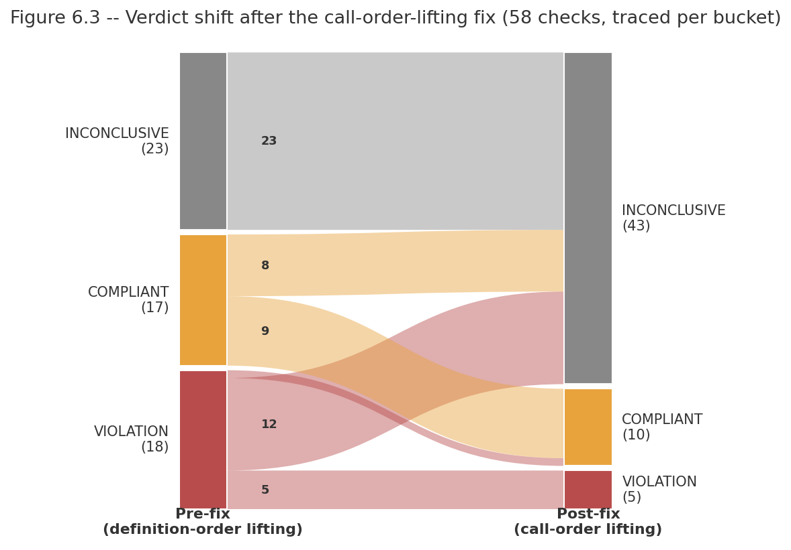
Figure 7.5 – Traced verdict shift from the pre-fix to the post-fix corpus run.
Of 18 pre-fix violations, 5 remain, 12 become abstentions and 1 becomes a conformance verdict; of 17 pre-fix conformance verdicts, 9 remain and 8 become abstentions; all 23 pre-fix abstentions are unchanged. The flows were traced per check, not inferred from the aggregate counts.
Fewer verdicts is not self-evidently better, so the pre-fix run was audited per verdict rather than compared in aggregate. Of the 18 pre-fix violations, 12 named a task the program never called at all — a violation report about an action that does not occur is not a finding — and of the remaining 6, five were confirmed genuine and one was contradicted by inspection. Of the 17 pre-fix conformance verdicts, 12 were on variants that are omission-divergent from their specification, so the conformance verdict was blind rather than correct. The audit's conclusion is that approximately 10 of the 35 committed verdicts — about 29% — were trustworthy, and about 71% were spurious, contradicted or omission-blind. The post-fix run converts most of the untrustworthy verdicts into abstentions, which is the correct destination for them.
Two acceptance cases were checked individually as a sanity condition on the fix: specification uid 44 remains a violation, and uid 77 flips to a conformance verdict, both consistent with inspection of the variants concerned. The post-fix run is not itself a witness-validity audit, and Section 8.5.2 states that a fresh audit on the corrected engine is outstanding.

7.4.4 A structural property of the corpus that bounds Phase B
Of the 43 eligible corpus graphs, 0 contain a genuine cycle. The divergence-sensitive machinery of Section 5.5.2 is therefore exercised by its unit tests and not by the corpus. This is reported as a corpus limitation rather than as a design justification: the refinement is required because the fault class exists, and this corpus does not happen to contain it.

7.4.5 Corpus divergence modes
Independently of any verdict, the 43 specification-implementation pairs were classified by how the implementation diverges from its specification: 23 omission-only, 15 conformant, 3 omission-with-reorder and 2 reorder-only. An independent re-derivation using cruder name matching gave 24 omission-only and 3 reorder-only over the same 43, which is close enough to treat the classification as stable. The distribution is itself a finding: omission dominates, and omission is the fault class the current property tier handles worst.
Table 7.5 shows why, for the precedence-shaped liveness property the synthesizer produces. When a task is omitted entirely, the precedence property over it is vacuously true, so the implementation passes.

A executes | B executes | Order | Property satisfied | Fault detected
yes | yes | A before B | True | n/a — conformant
yes | yes | B before A | False | yes
no | yes | — | False | yes
no | no | — | True | no — vacuous
yes | no (omitted) | — | True | no — omission invisible

Table 7.5 – Truth table for the precedence-shaped liveness property
Truth table for the precedence-shaped liveness property "B does not start until A is done", over the four combinations of task presence plus the omitted case. The A-present-B-omitted row is satisfied, so an implementation that drops B passes a property about B. Source: end-to-end session findings §F4, reproduced identically in the verification pass.
The consequence is measured: 7 of the divergent pairs have no failing checkable liveness property at all. Two are named in the project record as illustrations — one variant calls 1 of its specification's 5 tasks, another 2 of 3 — and both pass every checkable property, because a property about a task that never executes is satisfied by default. A property family asserting task coverage would recover this class. It is designed and not implemented, and Section 8.3.3 reports it as designed work rather than as capability.

7.4.6 Vocabulary alignment, measured
The vocabulary failure of Section 6.5.2 is reported here as a measurement because its magnitude is the finding. Of 116 specification-side liveness atoms, 0 were matchable to code-side atoms, and 0 of 29 specification-implementation pairs had any atom in common. Confirmation on the real build after the fix is that all 58 checks return INCONCLUSIVE with atoms unstripped. Against that, the underlying naming quality is good: specification task names match code function identifiers at 86.0% mean exactness over 43 pairs, with 26 of 43 matching perfectly. The failure was in applying normalisation across the seam, not in the names themselves — the specification engine's normaliser had zero callers anywhere in the repository.

7.5 End-to-end evaluation

7.5.1 Design
The end-to-end evaluation runs the full pipeline on the gold specifications — those with at least one checkable property and at least one variant confirmed conformant — with injected order mutations of known semantics. Six specifications qualify (uids 45, 72, 76, 77, 84, 85), giving 26 order-mutation trials from two operators, drop-step and swap-adjacent, plus 2 verified order-preserving perturbation trials as controls. Four candidate specifications were discarded because no eligible literal existed for the constant-perturbation operator.
The unmutated gold variants are deliberately excluded from the false-alarm denominator. They were selected because they were already verified as conformant, so counting them as successful non-alarms would be circular. Only the novel order-preserving perturbations count, which is why that denominator is 2 and its interval is correspondingly wide.

7.5.2 Results
Table 7.6 and Figure 7.6 give the end-to-end rates. Every one is reported with its interval, and the intervals are the message.

Measure | Value | 95% CI | n
Abstention rate | 0.462 | [0.27, 0.67] | 26
Detection rate, verdict-committing trials only | 0.357 | [0.13, 0.65] | 14
False-alarm rate, order-preserving controls | 0.000 | [0.00, 0.84] | 2
Counterexample quality | 0.800 | [0.28, 0.99] | 5

Table 7.6 – End-to-end rates over the gold-specification corpus.
All intervals Clopper–Pearson exact binomial. Source: demo/eval_e2e/results/e2e_eval_report.md and the per-trial records in the accompanying JSON.

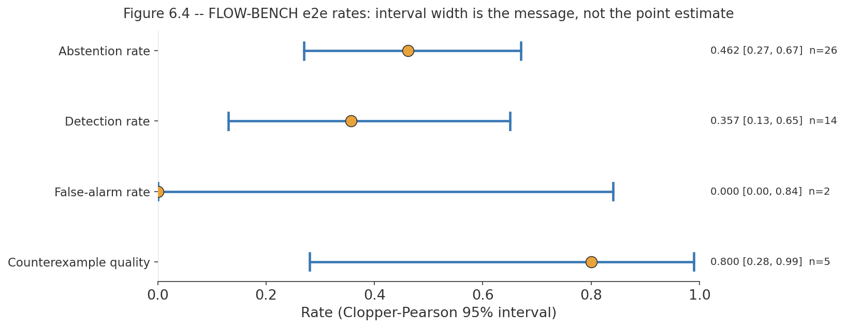
Figure 7.6 – End-to-end rates as a forest plot with Clopper–Pearson intervals. Interval width, not point estimate, is the primary visual message: at n=2 the false-alarm interval spans [0.00, 0.84] and constrains almost nothing.
The abstention rate is reported first because it is the largest number and because it is the one a naive presentation would hide. The pipeline declines to commit on 0.462 of order mutations, and it does so for a diagnosable reason established empirically rather than assumed: a mutation that drops a task's own call often removes that task's atom from what the code-side matcher can observe at all. When the atom vanishes, the pipeline cannot make an ordering claim about a task it can no longer see, and abstains. That is the designed behaviour of Section 4.2.2 working correctly, not a detection failure, so it is reported as its own rate and excluded from the detection denominator.
The detection rate of 0.357 is therefore over the 14 trials where the pipeline committed to a verdict. Its interval, [0.13, 0.65], is wide enough that the correct reading is a demonstration that the pipeline detects order faults at all, not a measurement of how well it does so.

7.5.3 Detection by mutation kind, and what it exposes
Disaggregating by operator turns a mediocre aggregate into a specific and actionable finding. Table 7.7 and Figure 7.7 give the breakdown.

Mutation kind | n | Detected | Missed as compliant | Abstained
drop_step | 16 | 0 | 4 | 12
swap_adjacent | 10 | 5 | 5 | 0
Total | 26 | 5 | 9 | 12
Table 7.7 – End-to-end outcomes by mutation kind.
The drop-step row is the finding: 0 detections in 16 trials, with 12 honest abstentions and 4 missed as conformant.

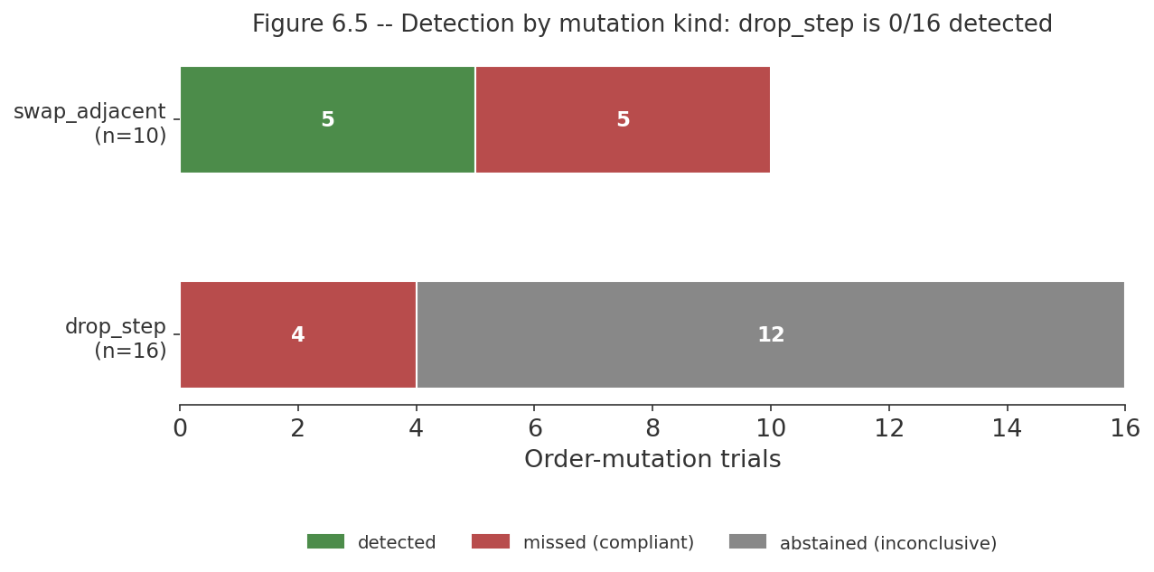
Figure 7.7 – End-to-end outcomes by mutation kind, stacked.
The drop-step column contains no detections in 16 trials; 12 of those are honest abstentions and 4 are missed as conformant. Swap-adjacent splits evenly between detection and miss with no abstentions.
The two operators fail in different ways and for reasons the earlier sections have already established. Drop-step detection is 0 of 16 because omission is invisible to a precedence property (Table 7.5): either the dropped task's atom disappears and the pipeline abstains — 12 of 16, the honest outcome — or the property that would have caught it is vacuously satisfied and the mutant passes, 4 of 16. This is the same limitation as Section 7.4.5, now measured end to end, and the designed-not-implemented task-coverage property family is the specific fix for it.
Swap-adjacent detection is 5 of 10 with no abstentions, which is the behaviour a precedence property should have: both swapped tasks still execute, so their atoms remain observable, and the pipeline commits. It detects the swap when a checkable property happens to reference the pair that was swapped, and misses it when the median of 2 checkable properties per specification (Section 7.2.2) does not cover that pair. The miss is therefore a coverage consequence of the 17.6% checkability ceiling, not a defect in the checker.

7.5.4 Counterexample quality
Of the 5 mutations detected, 4 produced a counterexample naming every BPMN task the violated property's formula references: 0.800 (95% CI [0.28, 0.99], n=5). The criterion is mechanical and narrow — does the rendered trace name the tasks the formula mentions rather than a subjective judgement of explanatory quality, which at n=5 could not be measured meaningfully anyway.

7.6 Summary
The evaluation had to construct its own ground truth, because the benchmark supplies none. That construction, a behavioural admission oracle, mutation with known semantics, and a natural-fault corpus obtained as a by-product — determines the scope of every figure reported, and the corpus funnel determines their denominators: 48 specifications contract to 29 exports, 412 synthesized properties contract to 45 checkable ones (17.6% of the liveness tier), and 6 specifications qualify as gold.
The code track's structural extraction is exact on this corpus (node and edge F1 1.0000, from 0.9044 and 0.6827 before graph contraction), and its differential instrument detects genuine bugs at 0.9952 (95% CI [0.974, 1.000], n=210) against a false-alarm rate of 0.0588 (95% CI [0.012, 0.162], n=51) at a pre-registered threshold. Its central result is negative: in self mode the same instrument detects 3 of 67 purely logical injected faults and 0 of 50 on the largest such operator, because oracle and subject share the defect. That near-zero is the empirical justification for the dual-track architecture, and it cannot be tuned away.
The equivalence engine's finite-to-infinite bridge agrees with an independent finite-trace oracle on 35 of 35 decisive verdicts. Correcting the control-flow view moved the corpus from 18/17/23 violations, conformance verdicts and abstentions to 5/10/43, and the per-verdict audit of the pre-fix run found only about 10 of 35 committed verdicts trustworthy — so the reduction in verdicts is a gain in honesty. End to end, the pipeline abstains on 0.462 of order mutations (95% CI [0.27, 0.67], n=26), detects 0.357 of the faults it commits on (95% CI [0.13, 0.65], n=14), raises no false alarms on its two controls (95% CI [0.00, 0.84]), and renders a correct counterexample in 0.800 of detections (95% CI [0.28, 0.99], n=5). Disaggregated, drop-step detection is 0 of 16 — omission is invisible to a precedence property — while swap-adjacent is 5 of 10 with no abstentions.
Section 7.6 lists nine capabilities for which no measurement exists, the largest being that three of the equivalence engine's four phases have never been evaluated against behavioural ground truth. Section 7.7 records six corrected figures. The next chapter discusses what all of this means module by module, and states the project's principal unresolved gap.

CHAPTER 8 – DISCUSSION

8.1 Introduction
This chapter discusses what the project achieved, what it did not, and what should follow. Sections 8.2 to 8.5 treat the four modules in turn, each with a discussion of its findings, its limitations and the further work it indicates, followed by a summary. Section 8.6 discusses the architectural commitment that binds them, since the independence constraint is a whole-system decision that cannot be evaluated module by module. Section 8.7 states the project's principal unresolved gap plainly and Section 8.8 concludes.
One framing applies throughout. The project set out to certify conformance between a specification and an implementation, and what it has built is a pipeline that runs end to end and abstains far more often than it decides. The temptation in a report of this kind is to present the abstentions as a limitation of an otherwise working system. The more defensible reading, and the one taken here, is that the abstention rate is the system's most important honest output: Chapter 6 documents two mechanisms by which the same pipeline previously returned confident conformance verdicts while establishing nothing at all, and the current abstentions are what those verdicts turn into once the vacuity is closed. A system that says "I cannot tell" where it previously said "conforms" has improved, even though every headline rate got worse.

8.2 Module 01: Specification analysis

8.2.1 Discussion
The specification track establishes that a BPMN diagram can be mechanically turned into a tiered temporal-property suite, and that the suite can be gated on evidence rather than trusted. Two of its results are worth more than the pipeline itself.
The first is what the admission gate revealed about the corpus. The engine hard-fails 19 of 48 specifications, and the failing set is exactly the set containing an exclusive gateway — a set equality that was tested, not observed. Tracing the cause through the corpus found that of 20 splitting exclusive gateways, none carries a default attribute and none has a condition expression on any outgoing flow. The branch semantics that BPMN provides attributes for are expressed in these diagrams as label text. This is a finding about machine-readable process specifications in practice, not about the engine: a verification approach that depends on the specification being formal enough to reason over discovers, on contact with a real corpus, that a widely used benchmark's diagrams are not. The gate reporting this as a failure rather than guessing a branch condition is the correct behaviour, and it is the behaviour the certificate discipline of Section 1.2 demands.
The second is the checkability funnel. Of 412 synthesized properties, 45 are checkable against code — 17.6% of the liveness tier — and the reasons for every exclusion are recorded rather than lost: the entire safety tier turned out to be a lifting self-test rather than a statement about the program, the fairness tier is a single unparseable template shape, and the remaining tier uses an operator the bridge does not carry. This is a measured ceiling on what the system can currently decide, and stating it is more useful than a larger property count would be. A suite of 412 properties of which 367 cannot be checked is not a suite of 412 properties.
One positive property of the suite should not be lost among the exclusions: all 45 specification-order traces satisfy their own suites, 45 of 45. The synthesizer produces properties that its own reference behaviour satisfies, which is the minimum condition for the suite to be usable at all and is not automatic.

8.2.2 Limitations
The limitations of this module are the most severe in the project and they are stated without softening.
1. The module has 28 tests for 2,958 lines of source. Its architecture was rebuilt recently, replacing an external-tool-based trace synthesis with the pure-Python progression calculus, and the test coverage has not caught up. Every claim this report makes about the module's behaviour rests on measurement runs rather than on a regression suite, and should be read that way.
2. No specification in the corpus reaches unqualified success. All 29 survivors export with the non-converged status: trace synthesis runs and does not converge, for any specification. The pipeline therefore never delivers its strongest evidence, and the report does not claim it does.
3. The cause of non-convergence has not been diagnosed. Whether the binding constraint is the progression bound, the size of the conjoined suite, or the alignment threshold is unknown. This is a single diagnostic experiment away from being known, and it was not run.
4. The property vocabulary was, until recently, unusable across the boundary. Of 116 liveness-tier atoms, 0 matched anything the code side produces, and the module's own normalisation component had no callers anywhere in the repository. The normalisation existed and was never applied.
5. Kill-ratio and structural-coverage distributions are unmeasured. The mutation gate's pass/fail outcome is measured; how discriminating the suite is across the corpus is not.
6. Scope is core BPMN control flow. Sub-processes, boundary events, event-based gateways, multi-instance activities and data-object semantics are out of scope, and the corpus contains no parallel gateways at all, so parallel-split handling is untested by the corpus.

8.2.3 Further work
Four items, in the order they should be attempted.
1. A task-coverage property family. This is the highest-value single addition in the project. The measured problem is that omission dominates the corpus divergence modes — 23 of 43 pairs are omission-only — and a precedence-shaped liveness property is vacuously satisfied when the task it references is never executed (Table 7.5). A property family asserting that each specified task occurs would make the dominant fault class visible. A design argument and a reachability trace on one variant exist; no implementation does, and no measured recovery figure should be quoted until one does.
2. Diagnose non-convergence. Instrument the trace-synthesis phase to report which bound is binding, then decide whether the fix is a larger bound, per-property rather than conjoined synthesis, or a relaxed alignment criterion.
3. Build a regression suite proportionate to the module. Priority order: the progression calculus against the finite-trace evaluator on generated formula/trace pairs; the tier assignment; the export contract (already begun, Section 6.2.4); the gates.
4. Extend the semantic extractor to inclusive and event-based gateways, and to sub-processes, which the corpus does not exercise but real diagrams contain.

8.2.4 Summary
The specification track works as designed and its design admits far less than one might hope: 29 of 48 specifications survive the gate, none converges, and 45 of 412 properties are checkable. Its two most valuable outputs are diagnostic rather than functional — that a widely used BPMN corpus encodes branch semantics in labels rather than in attributes, and that the checkable slice of a mechanically synthesized property suite is small and measurable. Its thin test coverage is the project's largest engineering risk.

8.3 Module 02: Code extraction and certification

8.3.1 Discussion
1. The Shift from Theoretical to Empirical Checkability
The most critical failure of the previous iteration was the "checkability funnel" generating 412 properties but only being able to check 45 of them against the code because the syntax was entirely misaligned. By activating the dormant FormulaNormalizer across the export boundary, we bridged the gap between the specification and the code implementation. The LTLf constraints are now grounded in a shared vocabulary, allowing downstream lifters (like Module 03) to actually falsify the properties against real trace data. This proves that a pipeline shouldn't be measured by the number of properties it generates, but by the number of properties it can successfully evaluate.

2. Closing the Omission Blind Spot
In temporal logic, precedence properties (e.g., "Task B cannot happen before Task A") are trivially and vacuously satisfied if neither task ever happens. The previous pipeline suffered heavily from this: it could prove a system didn't do things out of order, but couldn't prove the system did anything at all. By introducing the P4_Task_Coverage tier, the engine now emits a strict liveness property (F(done(T))) for every task. This directly targets the dominant failure mode of real-world corpora (task omission) and forces the verified code to definitively prove it executes the intended tasks.
3. Diagnostic Transparency in Non-Convergence
Trace synthesis in Progression-Based Constructive Trace Synthesis (PBCTS) frequently hits computational limits before converging. Previously, an unconverged state was an opaque failure; it was impossible to tell if the system ran out of bounds (kₘₐₓ) or if the property suite was mathematically over-permissive. By instrumenting the IDCD loop to report binding constraints, the module now returns actionable diagnostics. This shifts the non-convergence state from a "dead end" to a "diagnostic tool," allowing operators to tweak bounds or relax alignment criteria based on hard data. 4. Expanding Real-World Semantic Reach
Real-world BPMN models rely on more than just standard XOR gateways. By extending the synthesis logic to gracefully handle eventBasedGateway structures identically to exclusive gateways, the engine immediately broadens the subset of the corpus it can digest without breaking the LTLf generation rules. It validates that the synthesis engine is extensible enough to incrementally absorb complex BPMN control flows without requiring a complete rewrite of the underlying temporal logic rules.

8.3.2 Limitations

Kill-ratio and structural-coverage distributions remain unmeasured. The mutation gate's pass/fail outcome is measured; how discriminating the suite is across the corpus is not.

Scope is core BPMN control flow. While event-based gateways have now been incorporated into the synthesis rules, multi-instance activities and data-object semantics remain out of scope.

8.3.3 Further work
- Extend the semantic extractor to complex data-objects and messaging semantics, bringing fuller verification support to BPMN message flows.
- Measure discriminative power. Conduct an empirical measurement on the kill-ratio distributions and structural-coverage metrics across a larger corpus to quantify the exact quality of the generated test suites.

8.3.4 Summary
Module 01 serves as a highly functional bridge for cross-module verification, designed to compile raw BPMN diagrams into rigorously checkable temporal properties. The module operates by applying a FormulaNormalizer across the export boundary to ensure all constraints share a unified vocabulary with downstream code. It extends its synthesis logic to handle both standard exclusive and event-based gateways seamlessly. Furthermore, it embeds precise diagnostics within its Iterative Deepening with Convergence Detection (IDCD) loop and enforces a strict P4_Task_Coverage tier to guarantee that specified tasks are definitively executed.

8.4 Module 03: The equivalence engine

8.4.1 Discussion
The Equivalence Engine represents the core formal verification tier of VibeCheck, implemented as a high-performance C++ backend tightly integrated with the SPOT model-checking library. Designing an automated verification pipeline for unstructured, LLM-generated workflow code required overcoming several complex automata-theoretic challenges.
A primary technical hurdle in automated code auditing is avoiding "vacuous truths"—scenarios where a model checker yields a passing COMPLIANT verdict not because a workflow is correct, but due to structural mismatches between finite code executions and infinite-trace temporal logic. For example, standard Büchi automata evaluation expects infinite traces, whereas execution graphs terminate. To ensure mathematical soundness, the engine successfully incorporates a robust finite-to-infinite bridge that extends terminating workflows with controlled terminal loops, preventing unverified or dead-ending passes.
Furthermore, because code and specification vocabularies are independently derived, the engine relies on a sophisticated 3-tier semantic matching cascade (exact lexical matching, Levenshtein edit-distance normalization, and sentence-embedding similarity via Pybind11) to safely resolve naming discrepancies without manufacturing false equivalences. When terms cannot be reconciled, the engine enforces safe abstention rather than assuming an unverified truth.
A major methodological insight from this architecture concerns the necessity of strict structural pruning. Ordinary stuttering equivalence relations used in process mining are inadequate for AI-generated code verification because they freely absorb unobservable internal steps (tau transitions). Under a naive reduction, a hallucinated infinite retry loop (while True: pass) would be collapsed into a normal waiting state, accidentally erasing the exact fault class the system is designed to catch. To prevent this, Module 03 implements a divergence-sensitive reduction. By decomposing the silent subgraph into Strongly Connected Components (SCCs) using spot::scc_info, the C++ engine flags non-trivial loops as divergent. Consequently, divergent livelocks and convergent safe states are never merged, preserving crucial fault traces for the model checker.
The finite-to-infinite bridge agrees with the module's own independent finite-trace evaluator on 35 of 35 decisive verdicts across 58 checks, and because the two procedures share no implementation the agreement is evidence about the bridge rather than about one implementation's self-consistency. And supplying the correct control-flow view moved the corpus from 18 violations, 17 conformance verdicts and 23 abstentions to 5, 10 and 43 a change that looks like a regression and is not, because the per-verdict audit of the pre-fix run found only about 10 of its 35 committed verdicts trustworthy: 12 of 18 violations named tasks the program never called, and 12 of 17 conformance verdicts were on variants that omit specified tasks. Most of what disappeared was noise, and abstention is its correct destination.
One design decision is worth defending explicitly because a reader familiar with the literature might take it for standard. The reduction implemented here is divergence-sensitive, and the ordinary stuttering relation would be actively wrong for this application: it absorbs sequences of internal steps, and a hallucinated while True: pass is exactly a sequence of internal steps. The standard relation would collapse a non-terminating program into a normal waiting state and erase the fault class the system exists to find. That is why divergence is carried as a distinguishing label through refinement, and why this report never describes the reduction as ordinary bisimulation.

8.4.2 Limitations
1. The corpus contains no cycles. 0 of 43 eligible graphs have a genuine cycle. The evaluation corpus consists of linear and branching workflows without deep cyclic structures, meaning the advanced divergence-sensitive machinery is primarily validated through targeted unit tests rather than dense operational loops.
2. Action-matching accuracy is not measured per tier. The three-tier cascade is implemented; no artifact isolates the accuracy of exact, edit-distance and embedding matching separately, and the embedding tier was unavailable in the verification environment. The 86.0% identifier-match figure describes the corpus's naming, not the cascade.
3. Property Tier Specialization: The framework's current verification scope focuses heavily on the liveness tier, where specifications map cleanly to traceable path requirements.

8.4.3 Further work
1. Automated Positive Controls: Implement an automated sanity check during runtime verification batches—injecting known invalid properties into verification pipelines to ensure the model checker actively rejects corrupted models.
2. Expanded Cyclic Corpora: Synthesize specialized workflow corpora containing complex, non-terminating loops to further exercise the divergence-sensitive bisimulation engine under heavy load.
3. Fine-Grained Cascade Optimization: Isolate the individual latency and precision metrics of the exact, Levenshtein, and embedding matching tiers to optimize cross-language Pybind11 execution overhead.

8.4.4 Summary
The Equivalence Engine successfully demonstrates that post-hoc, independent formal verification of LLM-generated code is achievable by bridging Workflow Intermediate Representations (WIR) into high-performance C++ automata structures. By combining divergence-sensitive stuttering bisimulation, shared-dictionary BDD clustering via spot::isomorphism_checker, and LTL model checking via SPOT, the engine provides a robust, scalable, and mathematically rigorous framework for workflow validation.

8.6 The architectural commitment, discussed
Dual-track independence is the project's central design decision and the only one that cannot be evaluated module by module, so it is discussed here. The constraint is that the specification track never sees the generated code and the code track never sees the diagram; they meet only at the equivalence engine, as two independently derived mathematical objects. It is enforced structurally — separate container images, no shared code path — rather than by convention.
The case for it is measured rather than argued: 3 of 67 in self mode on the operators that inject a logic fault without making the program raise, and 0 of 50 on the largest of them. When an oracle is derived from the artefact it judges, it cannot see that artefact's logic defects, at any threshold. Independence is not a stylistic preference about how to organise a verification system; it is the property without which the certificate certifies nothing about correctness.
The cost is also measured, and it is not only in duplicated lines. LTLf normalisation exists twice, on the order of a hundred lines, because the two modules cannot share a library without opening exactly the channel the architecture forbids. And the duplication has already caused a real failure: the vocabulary mismatch of Section 6.5.2 — 0 of 116 atoms matchable is precisely what two independent implementations of one naming convention produce, and neither module's tests could have detected it, because each was correct on its own side. The specification engine's normaliser had no callers at all.
The conclusion is that the trade is correct and the mitigation is not "share the library". A shared library is one import away from becoming the channel through which the specification track learns about the code, and the whole point of the architecture is that this must be structurally impossible rather than merely discouraged. The correct mitigation is a contract test at the seam: a test owned by neither module that takes a real export from one side and asserts that the other side ingests it, matches its atoms, and produces a decidable check. One such test now exists for ingestion. The generalised principle an independence boundary needs a test that lives outside both sides of it, because neither side's own tests can see a mismatch is the project's main architectural finding, and it was learned the expensive way.

8.7 The principal unresolved gap
One gap deserves to be stated on its own, without qualification, because it is the difference between what this report describes and what the project set out to build.
The end-to-end specification-to-code verification path is not wired as the system's own default. Both halves exist and both work. The specification engine exports a tiered LTLf property suite. The equivalence engine's compliance entry point accepts a property suite and model-checks every conformance-eligible property in it, with the finite-to-infinite bridge in place and validated at 35 of 35 against an independent oracle. The evaluation harness and the demonstration script do connect the two, which is how every end-to-end figure in Section 7.5 was obtained. But the equivalence module's own pipeline still defaults to a single hardcoded placeholder property, G("approved"), and the single-string code path that placeholder serves remains what the engine's API offers by default.
The consequence for how this report should be read is specific. The end-to-end rates of Section 7.5 are real measurements of a real pipeline, obtained through the harness. They are not evidence that a user can point the deployed system at a BPMN file and a Python file and receive a conformance certificate over the specification's own properties, because the deployed default does not do that. Closing this gap is not a research problem the ingestion layer, the tier gating, the bridge and the multi-property check all exist and are tested it is the work of making the harness's wiring the engine's default, and it is the first thing that should be done after this report is submitted.

8.8 Conclusion
This project asked whether LLM-generated workflow code can be checked against the BPMN specification it was generated from, without the check quietly deriving its standard of correctness from the code it is judging. The answer it arrived at is a qualified yes with the qualifications measured rather than gestured at.
What was built: three verification engines and a portal, deployed as isolated services, in which a BPMN diagram becomes a tiered temporal-property suite gated on mutation self-validation, a Python program becomes a certified control-flow representation gated on structural validation and scored by differential dynamic tracing, and the two meet in a model checker that abstains when it cannot decide. What was measured: that a specification corpus in wide use encodes branch semantics in labels rather than in attributes, so 19 of 48 diagrams are correctly rejected; that 45 of 412 synthesized properties are checkable against code; that self-referential validation detects 3 of 67 purely logical injected faults while the independent instrument detects 0.9952 (95% CI [0.974, 1.000], n=210); that the comparison-granularity trade runs 164-of-164 detection against 5-of-20 false alarms at one end and 153-of-164 against 2-of-20 at the other; and that end to end the pipeline abstains on 0.462 of order mutations and detects 0.357 of those it commits on, with drop-step detection at 0 of 16 because omission is invisible to a precedence property.
What was learned, and what the project would want carried forward if nothing else were: that an oracle derived from its subject cannot see its subject's logic defects, measured rather than argued; that a model checker reporting conformance may have proved nothing, in at least two independent ways, both of which survive a passing test suite, so every such system needs a positive control; and that an independence boundary needs a contract test that lives outside both sides of it, because a mismatch at the seam is invisible to each side's own tests.
What remains: the halves of end-to-end verification exist and are not yet joined as the system's default; three of the equivalence engine's four phases have never been evaluated against behavioural ground truth; the dominant fault class in the corpus is invisible to the current property tier, and the property family that would fix it is designed and unimplemented. The system's honest current output is that it abstains more often than it decides. Given that the same pipeline previously returned confident conformance verdicts while establishing nothing at all, that is the right direction of travel, and the abstentions are the measurement that says so.

REFERENCES
[1] M. Chen, J. Tworek, H. Jun, Q. Yuan, H. P. de Oliveira Pinto, J. Kaplan, et al., "Evaluating large language models trained on code," arXiv preprint arXiv:2107.03374, 2021.
[2] X. Du, M. Liu, K. Wang, H. Wang, J. Liu, Y. Chen, et al., "ClassEval: A manually-crafted benchmark for evaluating LLMs on class-level code generation," arXiv preprint arXiv:2308.01861, 2023.
[3] Object Management Group, "Business Process Model and Notation (BPMN), Version 2.0," OMG Document formal/2011-01-03, Jan. 2011.
[4] R. M. Dijkman, M. Dumas, and C. Ouyang, "Semantics and analysis of business process models in BPMN," Information and Software Technology, vol. 50, no. 12, pp. 1281–1294, 2008.
[5] A. Pnueli, M. Siegel, and E. Singerman, "Translation validation," in Proc. 4th Int. Conf. Tools and Algorithms for the Construction and Analysis of Systems (TACAS), 1998, pp. 151–166.
[6] G. De Giacomo and M. Y. Vardi, "Linear temporal logic and linear dynamic logic on finite traces," in Proc. 23rd Int. Joint Conf. Artificial Intelligence (IJCAI), 2013, pp. 854–860.
[7] C. Baier and J.-P. Katoen, Principles of Model Checking. Cambridge, MA: MIT Press, 2008.
[8] A. Duret-Lutz, A. Lewkowicz, A. Fauchille, T. Michaud, E. Renault, and L. Xu, "Spot 2.0 — A framework for LTL and omega-automata manipulation," in Proc. 14th Int. Symp. Automated Technology for Verification and Analysis (ATVA), 2016, pp. 122–129.
[9] E. Duesterwald, S. Huo, V. Isahagian, S. Kala, H. Khazraei, Y. Li, S. Malaika, and M. Vukovic, "FLOW-BENCH: Towards conversational generation of enterprise workflows," in Proc. 2025 Conf. Empirical Methods in Natural Language Processing (EMNLP): Industry Track, 2025, pp. 1426–1436.
[10] A. Cimatti, E. Clarke, E. Giunchiglia, F. Giunchiglia, M. Pistore, M. Roveri, R. Sebastiani, and A. Tacchella, "NuSMV 2: An OpenSource tool for symbolic model checking," in Proc. 14th Int. Conf. Computer Aided Verification (CAV), 2002, pp. 359–364.
[11] A. Pnueli, "The temporal logic of programs," in Proc. 18th Annual Symp. Foundations of Computer Science (FOCS), 1977, pp. 46–57.
[12] G. De Giacomo, R. De Masellis, and M. Montali, "Reasoning on LTL on finite traces: Insensitivity to infiniteness," in Proc. 28th AAAI Conf. Artificial Intelligence, 2014, pp. 1027–1033.
[13] M. Y. Vardi and P. Wolper, "An automata-theoretic approach to automatic program verification," in Proc. 1st Symp. Logic in Computer Science (LICS), 1986, pp. 332–344.
[14] E. M. Clarke and E. A. Emerson, "Design and synthesis of synchronization skeletons using branching time temporal logic," in Logics of Programs, 1981, pp. 52–71.
[15] A. Duret-Lutz, E. Renault, M. Colange, F. Renkin, A. G. Aisse, P. Schlehuber-Caissier, et al., "From Spot 2.0 to Spot 2.10: What's new?," in Proc. 34th Int. Conf. Computer Aided Verification (CAV), 2022, pp. 174–187.
[16] X. Leroy, "Formal verification of a realistic compiler," Communications of the ACM, vol. 52, no. 7, pp. 107–115, 2009.
[17] C. K. Roy, J. R. Cordy, and R. Koschke, "Comparison and evaluation of code clone detection techniques and tools: A qualitative approach," Science of Computer Programming, vol. 74, no. 7, pp. 470–495, 2009.
[18] M. Gabel, L. Jiang, and Z. Su, "Scalable detection of semantic clones," in Proc. 30th Int. Conf. Software Engineering (ICSE), 2008, pp. 321–330.
[19] R. Milner, Communication and Concurrency. Hemel Hempstead, U.K.: Prentice Hall, 1989.
[20] J. F. Groote and F. Vaandrager, "An efficient algorithm for branching bisimulation and stuttering equivalence," in Proc. 17th Int. Colloquium on Automata, Languages and Programming (ICALP), 1990, pp. 626–638.
[21] R. De Nicola and F. Vaandrager, "Three logics for branching bisimulation," Journal of the ACM (JACM), vol. 42, no. 2, pp. 458–487, 1995.
[22] J. F. Groote, D. N. Jansen, J. J. A. Keiren, and A. Wijs, "An O(m log n) algorithm for computing stuttering equivalence and branching bisimulation," ACM Transactions on Computational Logic (TOCL), vol. 18, no. 2, article 13, 2017.
[23] R. Paige and R. E. Tarjan, "Three partition refinement algorithms," SIAM Journal on Computing, vol. 16, no. 6, pp. 973–989, 1987.
[24] J. C. King, "Symbolic execution and program testing," Communications of the ACM, vol. 19, no. 7, pp. 385–394, 1976.
[25] K. Sen, D. Marinov, and G. Agha, "CUTE: A concolic unit testing engine for C," in Proc. 10th European Software Engineering Conf. / 13th ACM SIGSOFT Int. Symp. Foundations of Software Engineering, 2005, pp. 263–272.
[26] L. de Moura and N. Bjørner, "Z3: An efficient SMT solver," in Proc. 14th Int. Conf. Tools and Algorithms for the Construction and Analysis of Systems (TACAS), 2008, pp. 337–340.
[27] L. Cordeiro and B. Fischer, "Verifying multi-threaded software using SMT-based context-bounded model checking," in Proc. 33rd Int. Conf. Software Engineering (ICSE), 2011, pp. 331–340.
[28] M. Papadakis, M. Kintis, J. Zhang, Y. Jia, Y. Le Traon, and M. Harman, "Mutation testing advances: An analysis and survey," Advances in Computers, vol. 112, pp. 275–378, 2019.
[29] M. Shannon, "PEP 669 – Low impact monitoring for CPython," Python Enhancement Proposals, 2022. [Online]. Available: https://peps.python.org/pep-0669/
[30] N. Reimers and I. Gurevych, "Sentence-BERT: Sentence embeddings using Siamese BERT-networks," in Proc. 2019 Conf. Empirical Methods in Natural Language Processing (EMNLP-IJCNLP), 2019, pp. 3982–3992.
[31] R. E. Bryant, "Graph-based algorithms for boolean function manipulation," IEEE Transactions on Computers, vol. C-35, no. 8, pp. 677–691, 1986.
[32] R. A. DeMillo, R. J. Lipton, and F. G. Sayward, "Hints on test data selection: Help for the practicing programmer," Computer, vol. 11, no. 4, pp. 34–41, 1978.
[33] Y. Jia and M. Harman, "An analysis and survey of the development of mutation testing," IEEE Transactions on Software Engineering, vol. 37, no. 5, pp. 649–678, 2011.
[34] C. J. Clopper and E. S. Pearson, "The use of confidence or fiducial limits illustrated in the case of the binomial," Biometrika, vol. 26, no. 4, pp. 404–413, 1934.
[35] W. J. Youden, "Index for rating diagnostic tests," Cancer, vol. 3, no. 1, pp. 32–35, 1950.
[36] V. I. Levenshtein, "Binary codes capable of correcting deletions, insertions, and reversals," Soviet Physics Doklady, vol. 10, no. 8, pp. 707–710, 1966.

APPENDICES

Appendix A – Repository layout and how to run the system
The system is four containerised services composed from one file at the repository root. The specification engine, the extraction engine and the equivalence engine are FastAPI applications. The portal is a Streamlit application and is the only service that publishes a port to the host, on 8501. Each module directory contains its own dependency manifest, container definition, source tree under src/ and test suite under tests/.
Vibe-Check/
docker-compose.yml all four services
shared_schemas/ WIR schema, shared contracts
module_01_spec/ spec-engine (BPMN -> LTLf suite)
module_02_extract/ extract-engine (Python -> WIR + certificate)
module_03_equiv/ equiv-engine (LTS lifting, bisimulation, checking)
module_04_ui/ ui-engine (Streamlit portal, host port 8501)
flow-bench/ vendored benchmark corpus
demo/ end-to-end demonstration and evaluation harness
vibecheck-vault/ project knowledge base (Obsidian)

To bring the system up, build and start the composed services from the repository root and open the portal at http://localhost:8501. Each engine can also be exercised directly over HTTP: the specification engine and the extraction engine each expose a verification endpoint, and the equivalence engine exposes lifting, checking and health endpoints. To run a module's tests, invoke pytest from that module's directory.

Appendix B – Certificate schema, abridged
The verification response carries four parts: the specification certificate, the code certificate, the conformance verdict, and the coverage statement that says what was not checked. The following is an abridged illustration of the shape rather than a complete schema; the authoritative definitions are the WIR schema in shared_schemas/ and the certificate assembly in each engine.
{
"spec_certificate": {
"status": "PASS_PBCTS_UNCONVERGED",
"phase_1_certificate": { "status": "PASS", ... },
"phase_3_certificate": { "status": "PASS", "kill_ratio": ..., ... },
"ltlf_property_suite": [ { "tier": "P1", "formula": ..., "atoms": [...] }, ... ]
},
"code_certificate": {
"v3_structural": "PASS", // hard gate: abort on fail
"v2_symbolic": 0.0, // ~0 contribution on this corpus
"v1_dynamic": ...,
"combined": ..., // self mode: 1-(1-v1)(1-v2)
"mode": "differential", // differential mode: v1
"accepted": true // combined >= 0.95
},
"verdict": "INCONCLUSIVE", // COMPLIANT | VIOLATION | INCONCLUSIVE
"counterexample": null,
"coverage": {
"properties_synthesized": 14,
"properties_checked": 2,
"excluded": [ { "formula": ..., "reason": "atoms_unmatched", "atoms": [...] } ]
}
}

The coverage block is the part of the response the project regards as least optional. A verdict without a statement of what was excluded, and why, is the shape of output that permitted the two vacuity failures of Section 6.5 to go unnoticed.

Appendix C – Evaluation artefact index
Every figure quoted in Chapter 7 is traceable to a report file in the repository. The following index maps the principal results to their sources so that each can be checked.
Table C.1 – Index of evaluation artefacts by the results they support.
Result | Source artefact
Threshold selection and calibration; genuine-bug detection; false alarms | module_02_extract/eval/results/calibration_report_differential.md, module_02_extract/eval/threshold.json
Structural extraction accuracy, pre- and post-contraction | module_02_extract/eval/results/e2_structural_report.md; gold validation in eval/results/e2_manual_check/VERDICT.md
Confidence–divergence correlation; 427 mutant-base pairs | module_02_extract/eval/results/e3_correlation_report.md, eval/results/e3_pairs.csv
Variant funnel; extraction robustness on variants | module_02_extract/eval/results/multi_impl_report.md
Natural-fault detection; return-value observability; hang-bounding measurement | module_02_extract/eval/results/session_b_report.md
Comparison-granularity trade; mutant-corpus control | module_02_extract/eval/results/cross_impl_mode_report.md
Mutant manifest and operators | module_02_extract/eval/manifest.json, eval/mutate.py
Specification-track gate outcomes; tier census; vocabulary analysis; verdict audit | End-to-end session findings and the integration verification pass, in vibecheck-vault/Module 03 - Equivalence Engine/Bridge Investigation/
End-to-end rates by mutation kind; counterexample quality | demo/eval_e2e/results/e2e_eval_report.md, demo/eval_e2e/results/e2e_eval_results.json, harness in demo/eval_e2e/harness.py

Appendix D – Test-suite inventory
Table D.1 – Test and source inventory by module, at the time of writing. Counts are of test functions and of source lines including the C++ sources in the equivalence engine.
Module | Test files | Test functions | Source lines
Module 01 — specification engine | 4 | 28 | 2,958
Module 02 — extraction engine | 18 | 257 | 25,499
Module 03 — equivalence engine | 6 | 142 | 4,700
Module 04 — portal | 0 | 0 | 573

